Hey there, it's great to see how far

you've come in this Google Data Analytics certificate.

First of, I want to say congrats on your achievement.

Second, welcome to your next course.

It's all about the art of

data storytelling through visualization.

As a data analyst,

you can do all the necessary work of planning,

collecting, cleaning, and analysis.

But you also need to show stakeholders what your data

means in a compelling way using visuals.

We're here to show you how that's done.

With my experience as Director of Analytics at Google,

I hope I'll be a pretty good guide.

My name's Kevin, and I'll

be your instructor for this course.

This part of your training is particularly meaningful

to me because I love data storytelling.

I can't think of anything in

today's business world that's more vibrant,

more exciting, and more rewarding.

With the amount of data we have around us,

data analytics plays a key role

in pretty much every part of business.

In my opinion, there

isn't a skill that's more important to you

as an analyst than being able to effectively

communicate the stories you

want to covered to stakeholders.

Stakeholders usually lack the time,

access to data, or expertise

needed to find those stories by themselves.

That's why we'll focus on visualizing

data to help you better share Data Stories.

Which means we're now at

the share phase of the data analysis process.

We'll start with the basic concepts

of visualization and why

visualizing your analysis is

such an important part of Data Analytics.

From there, we'll discuss how to plan for and

start building effective visualizations

that are inclusive,

accessible, and consider the audience first.

Afterwards, we'll explore one possible tool

you can use for data visualization, Tableau.

Tableau helps us create visualizations from

our analysis so that we can

share our findings more effectively.

We'll show you how data visualizations,

including visual dashboards,

can help bring your data to life.

We'll also explore how you can use visualizations in

your presentations and slide shows

to continue telling a story with data.

We'll discuss the art and

science behind effective presentations.

Finally, you'll learn how to anticipate and

answer questions from stakeholders

and respond to their feedback.

Throughout the course, I'll

guide you through what I think is

the most exciting part of the data analysis process.

By the end, you'll have everything you need to plan,

create, and present

an effective and compelling data visualization.

Now that we've gotten to know each other little,

it's time to get down to business. Coming up,

we'll talk a bit about the history of data visualization

and why visualizations mattered so much today.

We'll also discuss the methods

for using imagery effectively

and what you can do to make the most

out of your visuals. See you there.

**Course 6 overview: Set your expectations**

Welcome to the sixth course in the Google Data Analytics Certificate! In this course, you’ll learn how to create data visualizations. Visualizations, along with compelling data storytelling, will help you communicate the meaning of a dataset to your audience. Sharing the results of an analysis is one of the most important parts of an analyst’s job.

This course starts with the basics: learning principles and best practices for data visualization in spreadsheets. You’ll get hands-on experience creating data visualizations in Tableau, a specialized data visualization tool. Beyond the basics, there’s a focus on professional tips for creating exciting visualizations, presentations, and talking points about your data. This course also covers how to prepare and deliver effective presentations, so you can confidently handle the most challenging questions about your data analysis. Once you’ve completed this course, you’ll be on your way to becoming a talented data storyteller!

**Certificate program progress**

The Google Data Analytics Certificate program has eight courses. Share data through the art of visualization is the sixth course.

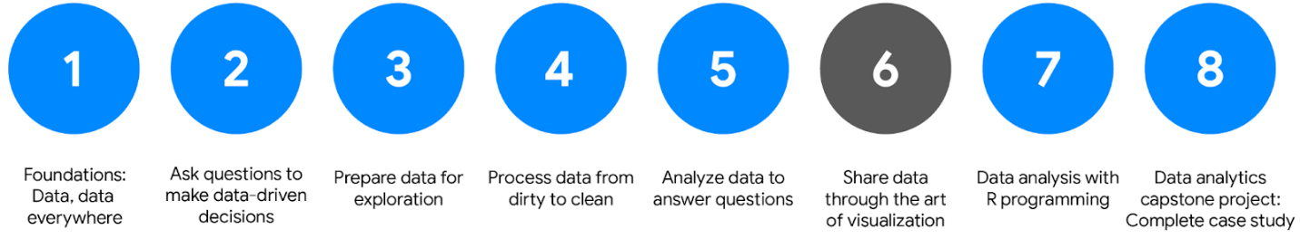Course 1: Foundations: Data, data, everywhere; Course 2: Ask questions to make data-driven decisions; Course 3: Prepare data for exploration; Course 4: Process data from dirty to clean; Course 5: Analyze data to answer questions; Course 6: Share data through the art of visualization; Course 7: Data analysis with R programming; Course 8: Data analytics capstone project: Complete a case study.

1. [Foundations: Data, Data, Everywhere](https://www.coursera.org/learn/foundations-data/home/welcome)
2. [Ask Questions to Make Data-Driven Decisions](https://www.coursera.org/learn/ask-questions-make-decisions/home/welcome)
3. [Prepare Data for Exploration](https://www.coursera.org/learn/data-preparation/home/welcome)
4. [Process Data from Dirty to Clean](https://www.coursera.org/learn/process-data/home/welcome)
5. [Analyze Data to Answer Questions](https://www.coursera.org/learn/analyze-data/home/welcome)
6. **Share Data Through the Art of Visualization** (this course)
7. [Data Analysis with R Programming](https://coursera.org/learn/data-analysis-r/home/welcome)
8. [Google Data Analytics Capstone: Complete a Case Study](https://coursera.org/learn/google-data-analytics-capstone/home/welcome)

**Course 6 content**

This course is broken into four modules. Here’s an overview of the skills you’ll gain in each module:

**Module 1: Visualize data**

In this module, you’ll delve into the various types of data visualizations and explore what makes an effective visualization. You'll also learn about accessibility, design thinking, and other factors that will help you use data visualizations to effectively communicate data insights.

**Module 2: Create data visualizations with Tableau**

Tableau is a business intelligence and analytics platform that helps people visualize, understand, and make decisions with data. In this part of the course, you’ll become well-versed in Tableau’s dynamic capabilities and learn to inject creativity and clarity into your visualizations, ensuring that your findings are easy to understand.

**Module 3: Craft data stories**

Connecting your objective with your data through insights is essential to data storytelling. In this part of the course, you’ll get acquainted with the principles of data-driven storytelling and learn to craft compelling narratives using Tableau's dashboard and filtering capabilities, giving life to your data insights.

**Module 4: Develop presentations and slideshows**

In this part of the course, you’ll discover how to give an effective presentation about your data analysis. This final module teaches you to construct insightful presentations that resonate with your audience. You'll learn to anticipate and address potential questions and to articulate the limitations of your data, ensuring a robust and credible narrative for your stakeholders.

**What to expect**

Each course offers many types of learning opportunities:

* **Videos** for instructors to teach new concepts and demonstrate the use of tools
* **In-video questions** that pop up from time to time to help you to check your understanding of key concepts and skills
* **Step-by-step guides** you can use to follow along with instructors as they demonstrate tools
* **Readings** to explore topics more in-depth and build on the concepts from the videos
* **Discussion forums** to share, explore, and reinforce lesson topics
* **Discussion prompts** to promote thinking and engagement in the discussion forums
* **Practice quizzes** to prepare you for graded quizzes
* **Graded quizzes** to measure your progress and give you valuable feedback

This program was designed to let you work at your own pace—your personalized deadlines are just a guide. There is no penalty for late assignments. To earn your certificate, you simply need to complete all of the work.

If you miss two assessment deadlines in a row, or if you miss an assessment deadline by two weeks, you'll see a **Reset deadlines** option on the **Grades** page. Click it to switch to a new course schedule with updated deadlines. You can use this option as many times as you need—it won’t remove any progress you’ve already made in the course, but you may find new course content if the instructor updated the course after you started. If you cancel a subscription and then reactivate it, your deadlines will automatically reset.

In this course, you'll be assessed with quizzes that are based on the wide variety of learning materials and activities that reinforce the important skills you’ll develop. Both types of quizzes can be taken more than once.

**Tips for success**

* It is strongly recommended that you go through the items in each lesson in the order they appear because new information and concepts build on previous knowledge.
* Participate in all learning opportunities to gain as much knowledge and experience as possible.
* If something is confusing, don’t hesitate to replay a video, review a reading, or repeat a self-review activity.
* Use the additional resources that are referenced in this course. They are designed to support your learning. You can find all of these resources in the [**Resources**](https://www.coursera.org/learn/ask-questions-make-decisions/resources/xW7lI)tab.
* When you encounter useful links in this course, bookmark them so you can refer to the information later for study or review.
* Understand and follow the [**Coursera Code of Conduct**](https://www.coursera.support/s/article/208280036-Coursera-Code-of-Conduct?) to ensure that the learning community remains a welcoming, friendly, and supportive place for all members.

**Updates to the course**

As you complete this course, you may notice updates to the content, like new practice materials and additional examples. These updates ensure the program provides up-to-date skills and guidance that will help you in your data analytics career. If you previously completed a graded activity, you *may* need to repeat the assessment in order to complete this course.  For more information, check out [the course discussion forum.](https://www.coursera.org/learn/visualize-data/discussions)

[MUSIC] Data Analytics is the collection and

analysis and then use of data to tell stories, using charts and

visualizations, so that businesses can make better decisions.

So I've always loved numbers and have always enjoyed math and

calculus and those sorts of things.

So data came really easy to me.

I was working at a consultancy before and using lots of numbers,

and I enjoyed it for sure.

But it wasn't until I worked at an advertising agency where I saw

the creative expression of numbers and how data could drive that creativity.

That it really all fell into place for me and I realized that doing analytics in

a marketing and in an advertising setting was exactly what I wanted to do.

And I found that I just really enjoyed when we put those two things together.

I think the visuals that come out of data analysis and

data analytics are really beautiful, but what is even more interesting for

me are the stories behind them.

If you look at a big block of text or a big block of numbers,

those stories are in there, but they really have to be found.

And so it takes certain skill to pull those things out.

And I find that skill, that analysis really exciting and interesting.

But it ultimately then ends in a beautiful visualization,

which I find very gratifying.

There are great data visualization thinkers, and

you see these visuals all over the place.

You can find inspiration from looking at news outlets today and

seeing the visuals that they present and how they tell stories that way.

Visualizations have become so important that you can find them everywhere, and

you could take great inspiration from that.

But I also take inspiration from unlikely sources like photography and

art and others and seeing how composition is created, how color is used.

I think that's really important.

And I try hard to bring those sorts of elements and

those sorts of influences into the visualizations I create.

So I know this course is pretty intense.

We're throwing a lot at you.

Your brain is probably overloaded.

You're probably fried.

Just stick with it.

It is all going to start to piece together and make sense.

The biggest thing that I think you can think of is just how important these

skills really are.

This is the new way of doing business, involving data, using the analytics tools

and techniques that we're talking about to make decisions.

So there's a great big reward waiting for you at the end of this course.

I'm Kevin.

I'm director of analytics here at Google.

[SOUND]

Welcome back, future data analyst.

As a budding analyst, you'll be exposed to a lot of data.

People learn and absorb data in so many different ways, and

one of the most effective ways that this can happen is through visualization.

Data visualization is the graphic representation and presentation of data.

In reality, it's just putting information into an image to make it easier for

other people to understand.

If you've ever looked at any kind of map, whether it's paper or online,

then you know exactly how helpful visuals could be.

Data visualizations are definitely having a moment right now.

Online we are surrounded by images that show information in all kinds of ways,

but the history of data visualization goes back way further than the Web.

Visualizing data began long ago with maps,

which are the visual representation of geographic data.

This map of the known world is from 1502. Map makers continued to improve

their visualizations as new lands were charted.

New data was collected about those locations,

and new methods for visualizing the data were created.

Scientists and mathematicians began to truly embrace the idea of arranging data

visually in the 1700s and 1800s.

This bar graph is from 1821 and

it doesn't look too different from bar graphs that we see today.

But since the beginning of the digital age of data analytics in the 1990s,

the scope and

reach of visualizations have grown along with the data they graphically represent.

As we keep learning how to more efficiently communicate with visuals,

the quality of our insights continue to grow too.

Today we can quantify human behavior through data, and

we've learned to use computers to collect, analyze and visualize that data.

As an analyst in today's world,

you'll probably split your time with data visuals in two ways:

looking at visuals in order to understand and draw conclusions about data or

creating visuals from raw data to tell a story.

Either way, it's always good to keep in mind that data visualizations will be your

key to success.

This is especially true once you reach the point where you're ready to present

the results of your data analysis to an audience.

Getting people to understand your vision and thought process can feel challenging.

But a well-made data visualization has the power to change people's minds.

Plus, it can help someone who doesn't have the same technical background or

experience as you form their own opinions.

So here's a quick rule for creating a visualization.

Your audience should know exactly what they're looking at within the first five

seconds of seeing it.

Basically, this means the visual should be clear and easy to follow.

In the five seconds after that,

your audience should understand the conclusion your visualization is making.

Even if they aren't totally familiar with the research you've been doing.

They might not agree with your conclusion, and that's okay.

You can always use their feedback to adjust your visualization and

go back to the data to do further analysis.

So now let's talk about what we have to do to create a visualization that's

understandable, effective and, most importantly, convincing.

Let's start from the beginning.

Data visualizations are a helpful tool for

fitting a lot of information into a small space.

To do this, you first need to structure and organize your thoughts.

Think about your objectives and

the conclusions you've reached after sorting through data.

Then think about the patterns you've noticed in the data, the things that

surprised you and, of course, how all of this fits together into your analysis.

Identifying the key elements of your findings help set the stage for

how you should organize your presentation.

Check out this data visualization made by David McCandless,

a well-known data journalist.

This graphic includes four key elements:

the information or data, the story, the goal and the visual form.

It's arranged in a four-part Venn diagram,

which tells us that all four elements are needed for a successful visualization.

So far, you've learned a lot about the data used in visualizations.

That's important because it's a key building block for your visualization.

The story or concept adds meaning to the data and makes it interesting.

We'll talk more about the importance of data storytelling later, but for now,

just remember that the story and

the data combined provide an outline of what you're trying to show.

The goal or function makes the data both useful and usable, and

the visual form creates both beauty and structure.

With just two elements, you can create a rough sketch of a visual.

This could work if you're at an early stage, but won't give you a complete

visualization because you'd be missing other key elements.

Even using three elements gets you closer, but you're not quite finished.

For example, if you combine information, goal, and

visual form without any story, your visual will probably look fine,

but it won't be interesting. On their own,

each element has value, but visualizations only become truly powerful and effective

when you combine all four elements in a way that makes sense. And

when you think about all of these elements together,

you can create something meaningful for your audience.

At Google I make sure to develop visualizations

to tell stories about data that include all four of these elements, and

I can tell you that each element is a key to a visualization success.

That's why it's so important for

you as the analyst to pay close attention to each element as we move forward.

Other people might not know or

understand the exact steps you took to come to the conclusions you've made, but

that shouldn't stop them from understanding your reasoning.

Basically, an effective data visualization should lead viewers to reach the same

conclusion you did, but much more quickly.

Because of the age we live in,

we're constantly being shown different ways to view and absorb information.

This means that you've already seen lots of visuals you can reference as you design

your own visualizations.

You have the power to tell convincing stories that could change opinions and

shift mindsets.

That's pretty cool. But you also have the responsibility to pay attention to

the perspectives of others as you create these stories.

So it's important to always keep that in mind.

Coming up, we'll start drawing connections between data and

images to create a strong foundation for your visual masterpieces.

I can't wait to get started.

**Effective data visualizations**

It can be difficult to understand data insights by examining individual data points or a table of information. Often, insights become more obvious when presented in an effective visual format. You can use data visualization (often called  “data viz”) techniques to help your audience interpret data in a concise, visual manner.

When creating data visualizations, you must strike a balance between presenting enough information for your audience to understand the meaning of the visualization and not overwhelming them with too much detail. In this reading, you’ll learn tips and techniques for crafting visualizations that are both impactful and effective. You’ll explore:

* Two frameworks for organizing data
* Pre-attentive attributes

**Frameworks for organizing your thoughts about visualization**

Frameworks help organize your thoughts about data visualization and give you a useful checklist to reference as you plan and evaluate your data visualization. Here are two frameworks that employ slightly different techniques. Both are intended to improve the quality of your visuals.

[The McCandless method](https://www.informationisbeautiful.net/visualizations/what-makes-a-good-data-visualization/)

You learned about the David McCandless method earlier in the course; as a refresher, the McCandless method lists four elements of good data visualization:

1. **Information:** the data with which you’re working
2. **Story:** a clear and compelling narrative or concept
3. **Goal:** a specific objective or function for the visual
4. **Visual form:** an effective use of metaphor or visual expression

The McCandless method provides terminology that isolates the specific elements of a graphic, allowing the person making a visual the ability to evaluate how well those criteria have been met. The aim when crafting a visualization is to incorporate all four elements effectively. Visualizations that fail to incorporate all four elements can be ineffective at communicating insights in various ways. For example, visual form without a goal, story, or data could be a sketch or even art. Data in visual form without a goal or function is just a pretty picture. Data with a goal but no story or visual form can be boring. All four elements need to be present to create an effective visual.

[Kaiser Fung’s Junk Charts trifecta checkup](https://junkcharts.typepad.com/junk_charts/junk-charts-trifecta-checkup-the-definitive-guide.html)

This approach is a set of questions that can help consumers of data visualization critique what they are consuming and determine how effective it is. You can also use these questions to determine if your data visualization is effective:

1. What is the practical question?
2. What does the data say?
3. What does the visual say?

Each of these questions offers an opportunity to investigate a given problem with a slightly different context. A well-designed visual effectively answers all three of those questions at once. Moreover, this framework helps you think about your data viz from the perspective of your audience.

**Pre-attentive attributes**

In addition to the frameworks mentioned above, several standard building blocks can help you construct your data visualizations. Creating effective visuals means leveraging what is known about how the brain works, and then using specific visual elements to communicate the information effectively. Pre-attentive attributes are the elements of a data visualization that people recognize automatically and without conscious effort. The essential, basic building blocks that make visuals immediately understandable are called marks and channels.

**Marks**

**Marks** are basic visual objects such as points, lines, and shapes. Every mark can be broken down into four qualities:

1. **Position:** Where is a specific mark in space relative to a scale or to other marks?

For example, if you’re looking at two different trends, position allows you to compare the pattern of one element relative to another.

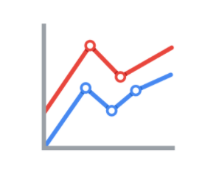

2. **Size:** How big, small, long, or tall is a mark?

The comparison of object sizes can be an easy visual interpretation for humans. This can be very useful for conveying the relationship between categories or data points. However, this also presents a potential problem: The human eye can inadvertently interpret comparisons that aren’t intended to convey meaning. For example, sometimes objects that appear to be the same size when they are not. Controlling the scale of a visual is important even when comparative sizes are not intended to offer information.

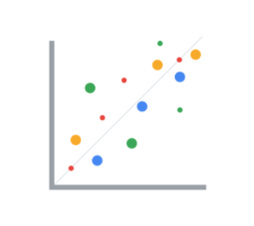

3. **Shape:** Does the shape of a specific object communicate something about it?

Rather than using simple dots or lines, a bit of creativity can enhance how quickly people are able to interpret a visual by using shapes that align with a given application. In the example below, it is immediately obvious that numbers of people are represented because the bars are person-shaped.

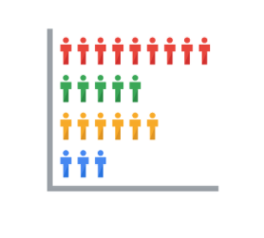

4. **Color:** What color is a mark?

Colors can be used both as a simple differentiator of groupings or as a way to communicate other concepts such as profitable versus unprofitable, or hot versus cold.

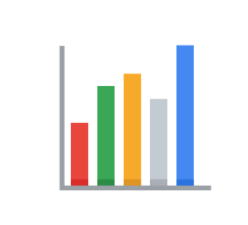

**Channels**

**Channels** are visual aspects or variables that represent characteristics of the data in a visualization. They are basically specialized marks that have been used to visualize data. It’s important to understand that channels vary in terms of how effective they are at communicating data based on three elements:

1. **Accuracy:** Are the channels helpful in accurately estimating the values being represented?

For example, color is very accurate when communicating categorical differences, such as apples and oranges. But it is much less effective when distinguishing quantitative data, such as 5 from 5.5.

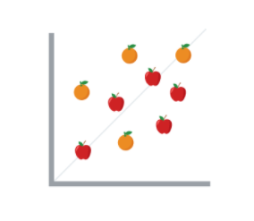

2. **Popout:** How easy is it to distinguish certain values from others?

There are many ways of drawing attention to specific parts of a visual, and lots of them leverage pre-attentive attributes including line length, size, line width, shape, enclosure, hue, and intensity.

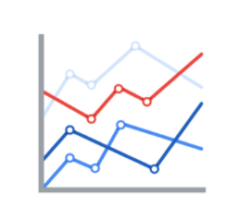

3. **Grouping:** How effective is a channel at communicating groups that exist in the data?

Consider the proximity, similarity, enclosure, connectedness, and continuity of the channel.

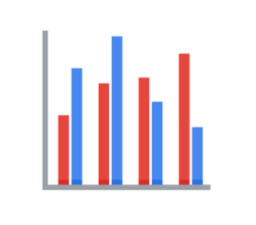

But, remember: The more you emphasize one single thing, the more that counts. Emphasis diminishes with each item you emphasize because the items begin to compete with one another.

**Key takeaways**

Throughout your career as an analyst, you will use different techniques and types of data visualizations to present data and insights in a concise, impactful manner. This will include organizing your data, selecting the right type of data visualizations, and designing them  in such a way that they are easy to understand and highly communicative while avoiding any visuals that are misleading or inaccurate.

Keep in mind that data visualization is an art form, and it takes time to develop these skills. Over your career as a data analyst, you will  learn how to design and evaluate data visualizations. Use these tips to think critically about data visualization—both as a creator and as an audience member.

**Resources**

* [The beauty of data visualization](https://www.ted.com/talks/david_mccandless_the_beauty_of_data_visualization?language=en#t-150183): In this video, David McCandless explains the need for design to not just be beautiful, but for it to be meaningful as well. Data visualization must be able to balance function and form for it to be relevant to your audience.
* [‘The McCandless Method’ of data presentation](https://artscience.blog/home/the-mccandless-method-of-data-presentation): At first glance, this blog appears to be written by a David McCandless fan, and it is. However, it contains very useful information and provides an in-depth look at the 5-step process that McCandless uses to present his data.
* [Information is beautiful](https://informationisbeautiful.net/): Founded by McCandless himself, this site serves as a hub of sample visualizations that make use of the McCandless method. Explore data from the news, science, the economy, and so much more and learn how to make visual decisions based on facts from all kinds of sources.
* [Beautiful news](https://informationisbeautiful.net/beautifulnews/): In this McCandless collection, explore uplifting trends and statistics that are beautifully visualized for your creative enjoyment. A new chart is released every day so be sure to visit often to absorb the amazing things happening all over the world.
* [The Wall Street Journal Guide to Information Graphics: The Dos and Don'ts of Presenting Data, Facts, and Figures](https://www.amazon.com/Street-Journal-Guide-Information-Graphics/dp/0393072959): This is a comprehensive guide to data visualization, including chapters on basic data visualization principles and how to create useful data visualizations even when you find yourself in a tricky situation. This is a useful book to add to your data visualization library, and you can reference it over and over again.

Hello again. Earlier we talked about why

data visualizations are so

important to both analysts and stakeholders.

Now we'll discuss the connections you can make

between data and images in your visualizations.

Visual communication of data is important to

those using the data to help make decisions.

To better understand the connection

between data and images,

let's talk about some examples of

data visualizations and how

they can communicate data effectively.

You maybe come across lots of these in your daily life.

We'll explore them a little bit more here.

A good place to start is a bar graph.

Bar graphs use size contrast to

compare two or more values.

The horizontal line of

a bar graph usually placed at the bottom,

is called the x-axis,

and bar graphs with vertical bars,

the x-axis is used to represent categories,

time periods, or other variables.

The vertical line of a bar graph usually

placed to the left is called the y-axis.

The y-axis usually has

a scale of values for the variables.

In this example, the time of day is compared to

someone's level of motivation

throughout the whole workday.

Bar graphs are a great way to clarify trends.

Here, it's clear this person's motivation is low at

the beginning of the day and gets higher

and higher by the end of the workday.

This type of visualization makes it

very easy to identify patterns.

Another example is a line graph.

Line graphs are a type of visualization that can help

your audience understand shifts or changes in your data.

They're usually used to track

changes through a period of time,

but they can be paired with other factors too.

In this line graph,

we're using two lines to compare

the popularity of cats and dogs over a period of time.

With two different line colors,

we can immediately tell that

dogs are more popular than cats.

We'll talk more about using colors and patterns to make

visualizations more accessible to audiences later too.

Even as a line moves up and down,

there's a general trend upwards and the line

for dogs always stays higher than the line for cats.

Now let's check out another visualization

you'll probably recognize.

Say hello to the pie chart.

Pie charts show how much each part

of something makes up the whole.

This pie chart shows us

all the activities that make up someone's day.

Half of it's spent working,

which is shown by the amount of

space that the blue section takes up.

From a quick scan,

you can easily tell

which activities make up a good chunk of

the day in this pie chart

and which ones take up less time.

Earlier, we learned how maps

help organize data geographically.

The great thing about maps is they can hold a lot of

location-based information and they're

easy for your audience to interpret.

This example shows survey data

about people's happiness in Europe.

The borderlines are well-defined and the colors

added make it even easier to tell the countries apart.

Understanding the data represented here,

which we'll come back to again later,

can happen pretty quickly.

So data visualization is an excellent tool for making

the connection between an image

and the information it represents,

but it can sometimes be misleading.

One way visualizations can be

manipulated is with scaling and proportions.

Think of a pie chart. Pie charts show

proportions and percentages between categories.

Each part of the circle or

pi should reflect its percentage to the whole,

which is equal to 100 percent.

So if you want to visualize your sales analysis to show

the percentage of your company sales

that come from online transactions,

you could use a pie chart.

The size of each slice would be

the percentage of total sales that it represents.

So if your online sales accounted for 60 percent,

the slice would be 60 percent of the whole pie.

Now here's a misleading pie chart.

It's supposed to show opinions about pizza toppings,

but each slice or

segment represents more than one option.

They all add up to well over 100 percent.

There is lots of ingredients listed below

the image that are not even included in the visual data.

All of the segments are the same size,

even though they're supposed to

be showing different values.

If a visualization looks

confusing then it probably is confusing.

Let's explore another example where

the size of the graphic components comes into play.

This time with a bar chart.

In a truncated bar chart like this one,

the values on the y-axis don't start at zero.

The data points start at 9,100 and at intervals of 100.

This makes it seem like the data, let's say,

it's for novel clicks per day on

different website links, is fairly wide-ranging.

In this view, website E

seems to clearly receive way more clicks than website D,

which receives more clicks than website C and so on.

While the graph is clear and

the elements are easy to understand,

the way the data is presented is misleading.

Let's try to fix this by changing the graph's y-axis,

so that it starts at zero instead.

Now, the difference between the website

clicks per day don't look nearly as drastic.

By making the y-axis start at zero,

we're changing the visual proportions to be

more accurate and more honest.

Some platforms always start their y-axis at zero,

but other programs like

spreadsheets might not fix the y-axis.

So it's important to keep this in

mind when creating visualizations.

By following the conventions of data analysis,

you'll be able to avoid misleading visualizations.

You always want your visualization to be

clear and easy to understand,

but never at the expense of

communicating ideas that are true to the data.

So we've talked about

some effective data-driven visualizations

like bar graphs,

line graphs, and pie charts,

and when to use them.

On top of that, we've discussed some things to avoid in

your visualizations to keep them from being misleading.

Coming up, we'll check out how to make

those visualizations reach

your target audience. See you then.

**The beauty of visualizing**

You will find that organizing your data and communicating your results are significant parts of a data analyst’s role. In this reading, you are going to navigate different resources for effective data visualization that will allow you to choose the best model to present your data.

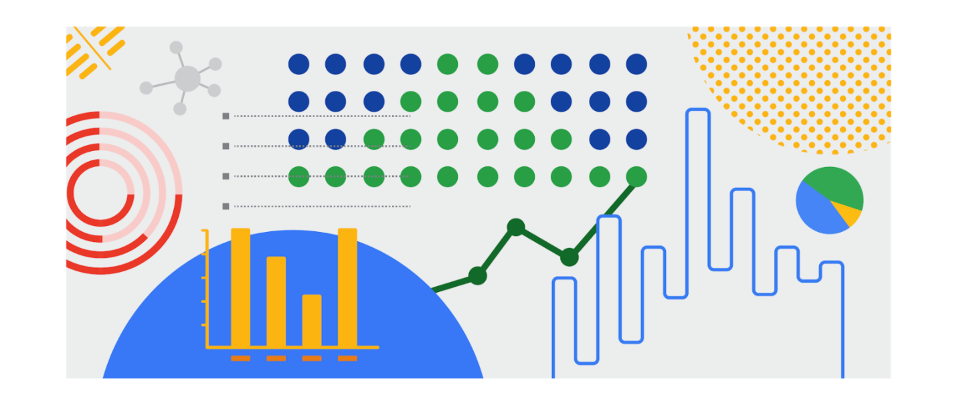

**Inspiration is in the air**

**Data visualization** is the graphical representation of data. But why should data analysts care about data visualization? Well your audience won’t always have the ability to interpret or understand the complex information that you relay to them so your job is to inform them of your analysis in a way that is meaningful, engaging, and easy to understand. Part of why data visualization is so effective is because people’s eyes are drawn to colors, shapes, and patterns, which makes those visual elements perfect for telling a story that goes beyond just the numbers.

Of course, one of the best ways to understand the importance of data visualization is to go through different examples of it. As a junior data analyst, you want to have several visualization options for your creative process whenever you need. Below is a list of resources that can inspire your next data-driven decisions, as well as teach you how to make your data more accessible to your audience:

* [The data visualization catalogue](https://datavizcatalogue.com/#google_vignette): Not sure where to start with data visualization? This catalogue features a range of different diagrams, charts, and graphs to help you find the best fit for your project. As you navigate each category, you will get a detailed description of each visualization as well as its function and a list of similar visuals.
* [The 25 best data visualizations](https://visme.co/blog/best-data-visualizations/): In this collection of images, explore the best examples of data that gets made into a stunning visual. Simply click on the link below each image to get an in-depth view of each project, and learn why making data visually appealing is so important.
* [10 data visualization blogs](https://www.tableau.com/learn/articles/best-data-visualization-blogs): Each link will lead you to a blog that is a fountain of information on everything from data storytelling to graphic data. Get your next great idea or just browse through some visual inspiration.
* [Information is beautiful](https://informationisbeautiful.net/wdvp/gallery-2019/): Founded by David McCandless, this gallery is dedicated to helping you make clearer, more informed visual decisions based on facts and data. These projects are made by students, designers, and even data analysts to help you gain insight into how they have taken their own data and turned it into visual storytelling.
* [Data studio gallery](https://datastudio.google.com/gallery?category=visualization): Information is vital, but information presented in a digestible way is even more useful. Browse through this interactive gallery and find examples of different types of data communicated visually. You can even use the data studio tool to create your own data-driven visual.

**Engage your audience**

Remember: an important component of being a data analyst is the ability to communicate your findings in a way that will appeal to your audience. Data visualization has the ability to make complex (and even monotonous) information easily understood, and knowing how to utilize data visualization is a valuable skill to have. Your goal is always to help the audience have a conversation with the data so your visuals draw them into the conversation. This is especially true when you have to help your audience engage with a large amount of data, such as the flow of goods from one country to other parts of the world.

Hey, there. You're back and ready to

learn how to create powerful data visualizations.

Coming up, we'll explore how to take

our findings and turn them into compelling visuals.

Earlier, we discussed the relationship

between data and images.

Now we'll build on that to explore

what visualizations can reveal to

your audience and how to make

your graphics as effective as possible.

One of your biggest considerations when creating

a data visualization is where

you'd like your audience to focus.

Showing too much can be

distracting and leave your audience confused.

In some cases, restricting data can be a good thing.

On the other hand, showing too little can

make your visualization unclear and less meaningful.

As a general rule,

as long as it's not misleading,

you should visually represent only the data that

your audience needs in order to understand your findings.

Now let's talk about what you

can show with visualizations.

Change over time is a big one.

If your analysis involves how

the data has changed over a certain period,

which could be days, weeks, months, or years.

You can set your visualization to show

only the time period relevant to your objective.

This visualization shows the search interests in

news story topics like

environment and science and social issues.

The viz is set up to show how

the search entries change day to day.

The bubbles represent the most popular topic

on each day in a given part of the US.

As new stories come up,

the data changes to reflect the topic of those stories.

If we wanted the data for weekly or monthly news cycles,

we change the interactive feature

to show changes by week or month.

Another situation is when you need to

show how your data is distributed.

A histogram resembles a bar graph,

but it's a chart that shows how often

data values fall into certain ranges.

This histogram shows a lot of data and how it's

distributed on a narrow range

from a negative one to a positive one.

Each bin or bucket,

as the bar is called,

contains a certain number of values that fall

into one small part of the range.

If you don't need to show that much data,

other histograms would be more effective,

like this one about the length of dinosaurs.

Here the bins or buckets of data values are segmented.

You can show each value that falls

into each part of the range.

If your data needs to be ranked,

like when ordering the number of

responses to survey questions.

You should first think about what you

want to highlight in your visualization.

Bar charts with horizontal bars

effectively show data that are ranked,

with bars arranged in ascending or descending order.

A bar chart should always be ranked by value,

unless there's a natural order to

the data like age or time, for example.

This simple bar chart shows metals

like gold and platinum ranked by density.

An audience would be able to clearly see the ranking and

quickly determine which metals had the highest density,

even if this database included a lot more metals.

Correlation charts can show relationships among data,

but they should be used with

caution because they might lead

viewers to think that the data shows causation.

Causation or a cause-effect relationship

occurs when an action directly leads to an outcome.

Correlation and causation are often mixed up because

humans like to find patterns even when they don't exist.

If two variables look

like they're associated in some way,

we might assume that one is dependent on the other.

That implies causation, even

if the variables are completely independent.

If we put that data into a visualization,

then it would be misleading.

But correlation charts that do

show causation can be effective.

For example, this correlation chart has one line

of data showing the average traffic for

Google searches on Tuesdays in Brazil.

The other lines for a specific date

of search traffic, June 15th.

The data is automatically correlated because

both lines are representing the same basic information.

But the chart also shows one big difference.

When a football match or soccer match for

Americans began on June 15th,

the search traffic showed a significant drop.

This implies causation.

Football is a very popular and

important sport for Brazilians,

and the data in this chart verifies that.

We've now talked about time series charts,

histograms, ranked bar charts, and correlation charts.

Each of these charts can

visualize a different type of analysis.

Your business objective and audience will

help figure out which of

these common visualizations to choose.

Or you may want to check

some other kinds of visualizations out there.

There are also glossary visualizations

that you'll be able to reference later.

That wraps up our lesson on creating visualizations.

Coming up next, we'll add some more layers to

your planning and execution of visuals. Hang on tight.

**Correlation and causation**

In this reading, you will examine correlation and causation in more detail. Let’s review the definitions of these terms:

* **Correlation** in statistics is the measure of the degree to which two variables move in relationship to each other. An example of correlation is the idea that “As the temperature goes up, ice cream sales also go up.” It is important to remember that correlation doesn’t mean that one event causes another. But, it does indicate that they have a pattern with or a relationship to each other. If one variable goes up and the other variable also goes up, it is a positive correlation. If one variable goes up and the other variable goes down, it is a negative or inverse correlation. If one variable goes up and the other variable stays about the same, there is no correlation.
* **Causation** refers to the idea that an event leads to a specific outcome. For example, when lightning strikes, we hear the thunder (sound wave) caused by the air heating and cooling from the lightning strike. Lightning causes thunder.

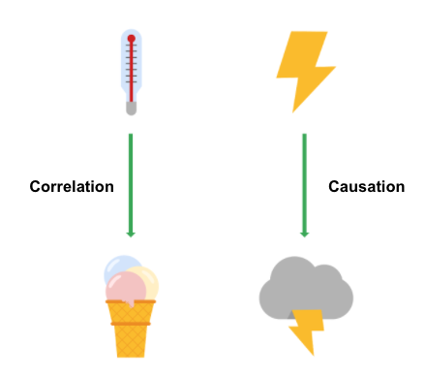

**Why is differentiating between correlation and causation important?**

When you make conclusions from data analysis, you need to make sure that you don’t assume a causal relationship between elements of your data when there is only a correlation. When your data shows that outdoor temperature and ice cream consumption both go up at the same time, it might be tempting to conclude that hot weather **causes** people to eat ice cream. But, a closer examination of the data would reveal that every change in temperature doesn’t lead to a change in ice cream purchases. In addition, there might have been a sale on ice cream at the same time that the data was collected, which might not have been considered in your analysis.

Knowing the difference between correlation and causation is important when you make conclusions from your data since the stakes could be high. The next two examples illustrate the high stakes to health and human services.

**Cause of disease**

For example, pellagra is a disease with symptoms of dizziness, sores, vomiting, and diarrhea. In the early 1900s, people thought that the disease was caused by unsanitary living conditions. Most people who got pellagra also lived in unsanitary environments. But, a closer examination of the data showed that pellagra was the result of a lack of niacin (Vitamin B3). Unsanitary conditions were related to pellagra because most people who couldn’t afford to purchase niacin-rich foods also couldn’t afford to live in more sanitary conditions. But, dirty living conditions turned out to be a correlation only.

**Distribution of aid**

Here is another example. Suppose you are working for a government agency that provides SNAP benefits. You noticed from the agency’s Google Analytics that people who qualify for the benefits are browsing the official website, but they are leaving the site without signing up for benefits. You think that the people visiting the site are leaving because they aren’t finding the information they need to sign up for SNAP benefits. Google Analytics can help you find clues (correlations), like the same people coming back many times or how quickly people leave the page. One of those correlations might lead you to the actual cause, but you will need to collect additional data, like in a survey, to know exactly why people coming to the site aren’t signing up for SNAP benefits. Only then can you figure out how to increase the sign-up rate.

**Key takeaways**

In your data analysis, remember to:

* Critically analyze any correlations that you find
* Examine the data’s context to determine if a causation makes sense (and can be supported by all of the data)
* Understand the limitations of the tools that you use for analysis

**Further information**

You can explore the following article and training for more information about correlation and causation:

* [**Correlation is not causation**](https://towardsdatascience.com/correlation-is-not-causation-ae05d03c1f53)**:** This article describes the impact to a business when correlation and causation are confused.
* [**Correlation and causation**](https://www.khanacademy.org/test-prep/praxis-math/praxis-math-lessons/gtp--praxis-math--lessons--statistics-and-probability/a/gtp--praxis-math--article--correlation-and-causation--lesson) **(Khan Academy lesson):** This lesson describes correlation and causation along with a working example. Follow the examples of the analysis and notice if there is a positive correlation between frostbite and sledding accidents.

Hey, great to see you again.

So far we've shown that there's lots of choices you'll

make as a data analyst when creating visualizations.

Each of your choices should help make sure that

your visuals are meaningful and effective.

Another choice you'll need to make is whether you want

your visualizations to be static or dynamic.

Static visualizations do not

change over time unless they're edited.

They can be useful when you want to control

your data and your data story.

Any visualization printed on

paper is automatically static.

Charts and graphs created in

spreadsheets are often static too.

For example, the owner of this spreadsheet might have

to change the data in

order for the visualization to update.

Now, dynamic visualizations are

interactive or change over time.

The interactive nature of these graphics means that

users have some control over what they see.

This can be helpful if

stakeholders want to adjust what they're able to view.

Let's check out a visualization about

happiness that we've created in Tableau.

Tableau is a business intelligence and analytics platform

that helps people see,

understand, and make decisions with data.

Visualizations in Tableau are automatically interactive.

We'll go into the dashboard to

see how the happiness score has

changed from 2015 to 2017.

We can check this out in

our 12th slide, yearly happiness changes.

On the left are

the country level changes in happiness score.

The countries are sorted by

largest increase to largest decrease.

On the right, there's a map

with overall happiness scores.

The color scale moves from blue for

the countries with the highest happiness score,

to red for those with the lowest.

If you look below the map,

you'll notice a year to view slider where people can

choose which year's happiness scores

to display on the map.

It's currently set for 2016,

but if someone wants to know the scores for 2015 or 2017,

they can adjust the slider.

They could then make note of how

the color-coding and score labels

change from year to year.

Other dynamic visualizations

upload new data automatically.

These bar graphs continually

update data by the minute and second.

Other data visuals can do the same by day, week or month.

If you need to,

you can show trends in real-time.

Having an interactive visualization can be

useful for both you and the audience you share it with.

But it's good to remember that

the more power you give the user,

the less control you have over

the story you want the data to tell.

It's something to keep in mind as you learn

how to create your own visualizations.

You want to find the right balance

between interactivity and control.

Something else to consider is,

a choice between using a static or dynamic visualization.

This will usually depend on the data you're visualizing,

the audience you're presenting to,

and how you're giving your presentation.

Now that we've made some decisions about

what kind of data vis we want to create,

we can start thinking about the design,

which is exactly where we're going to start

talking about next time. See you there.

**The wonderful world of visualizations**

As a data analyst, you will often be tasked with relaying information and data that your audience might not readily understand. Presenting your data visually is an effective way to communicate complex information and engage your stakeholders. One question to ask yourself is: “what is the best way to tell the story within my data?” This reading includes several options for you to choose from (although there are many more).

**Line chart**

A **line chart** is used to track changes over short and long periods of time. When smaller changes exist, line charts are better to use than bar graphs. Line charts can also be used to compare changes over the same period of time for more than one group.

Let’s say you want to present the graduation frequency for a particular high school between the years 2008-2012. You would input your data in a table like this:

| **Year** | **Graduation rate** |
| --- | --- |
| 2008 | 87 |
| 2009 | 89 |
| 2010 | 92 |
| 2011 | 92 |
| 2012 | 96 |

From this table, you are able to present your data in a line chart like this:

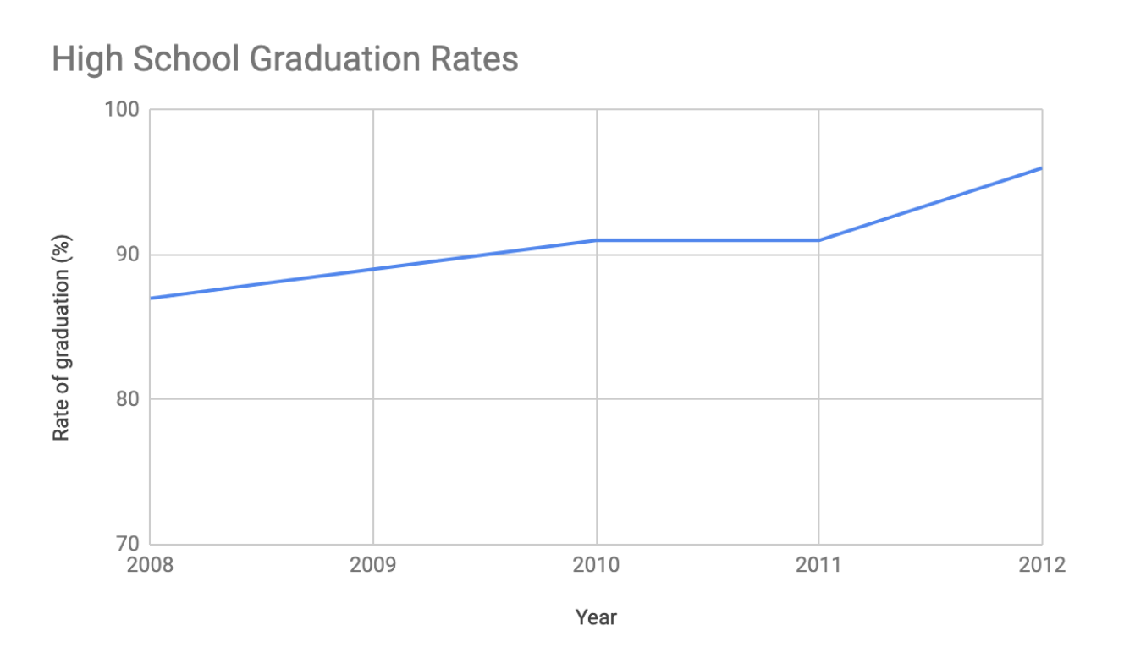

Maybe your data is more specific than above. For example, let’s say you are tasked with presenting the difference of graduation rates between male and female students. Then your chart would resemble something like this:

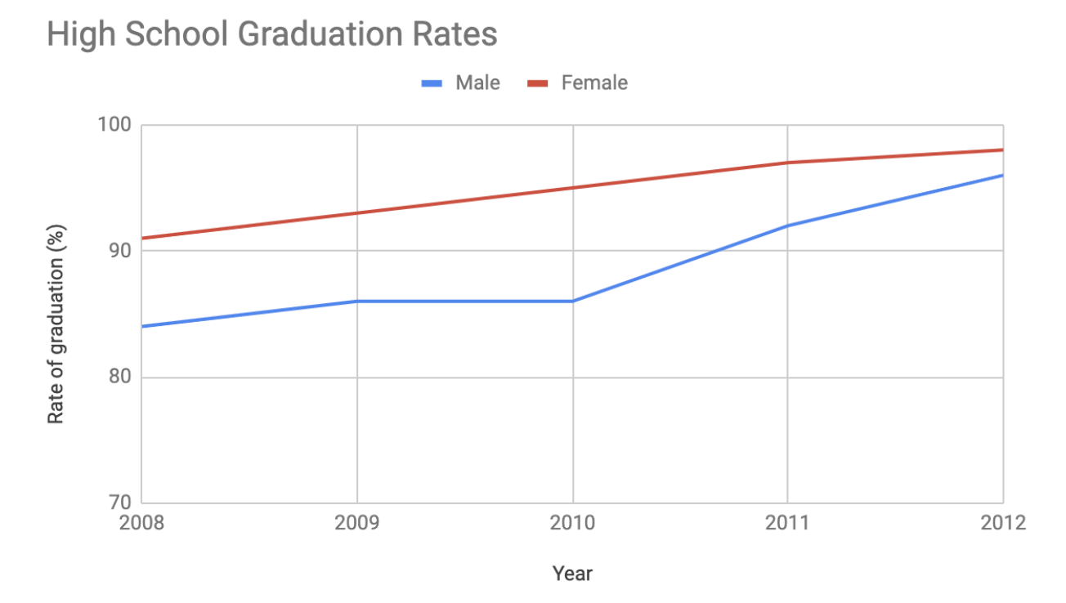

**Column chart**

**Column charts** use size to contrast and compare two or more values, using height or lengths to represent the specific values.

The below is example data concerning sales of vehicles over the course of 5 months:

| **Month** | **Vehicles sold** |
| --- | --- |
| August | 2,800 |
| September | 3,700 |
| October | 3,750 |
| November | 4,300 |
| December | 4,600 |

Visually, it would resemble something like this:

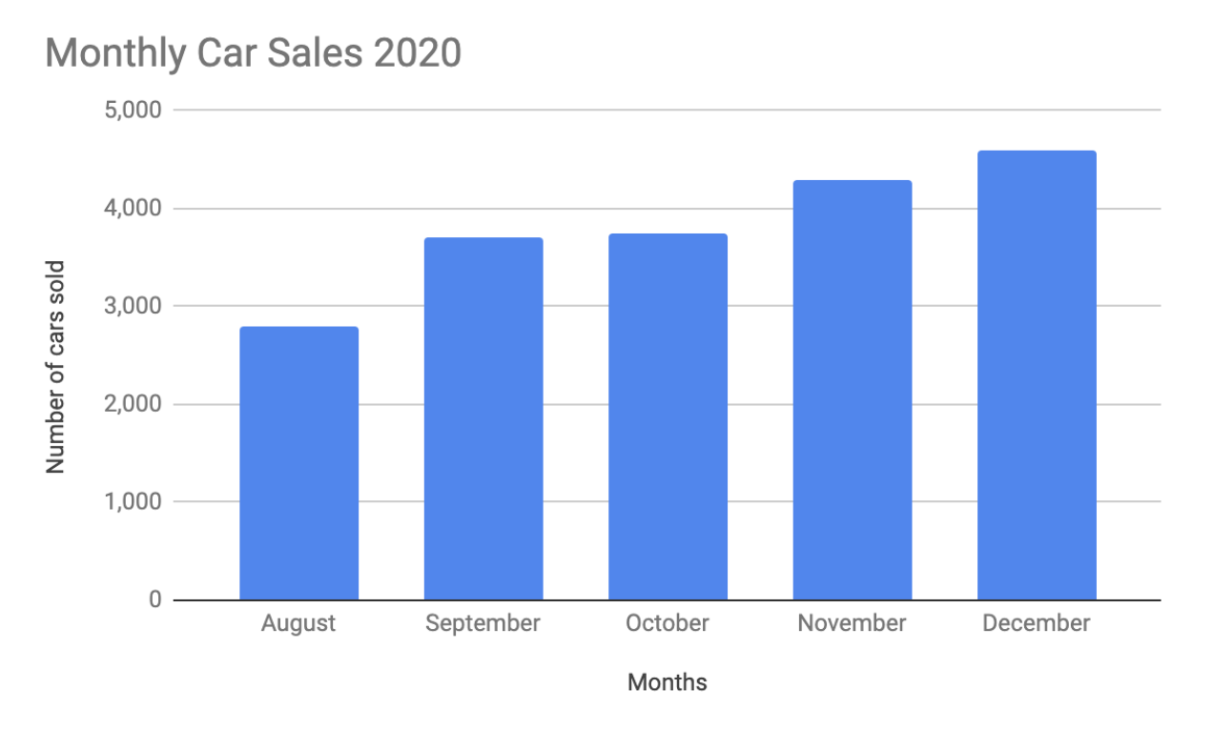

What would this column chart entail if we wanted to add the sales data for a competing car brand?

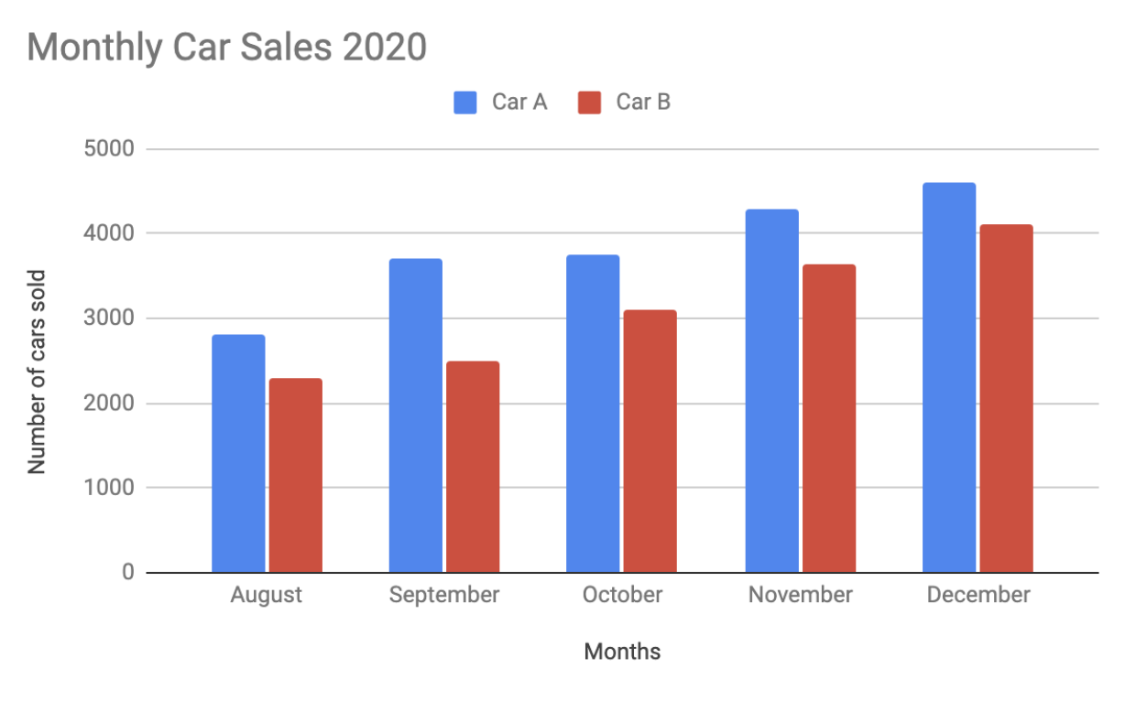

**Heatmap**

Similar to bar charts, **heatmaps** also use color to compare categories in a data set. They are mainly used to show relationships between two variables and use a system of color-coding to represent different values. The following heatmap plots temperature changes for each city during the hottest and coldest months of the year.

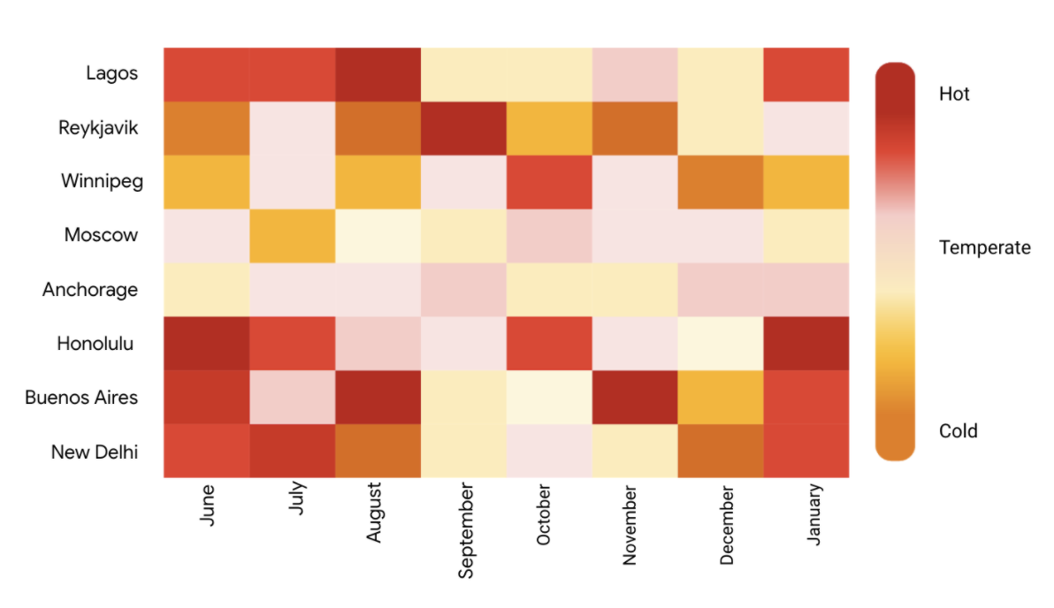

**Pie chart**

The **pie chart** is a circular graph that is divided into segments representing proportions corresponding to the quantity it represents, especially when dealing with parts of a whole.

For example, let’s say you are determining favorite movie categories among avid movie watchers. You have gathered the following data:

| **Movie category** | **Preference** |
| --- | --- |
| Comedy | 41% |
| Drama | 11% |
| Sci-fi | 3% |
| Romance | 17% |
| Action | 28% |

Visually, it would resemble something like this:

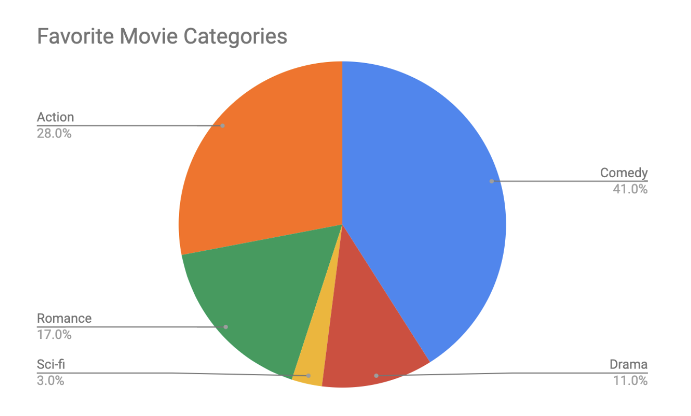Action- 28% Comedy- 41% Romance- 17% Sci-fi- 3% Drama- 11%

**Scatterplot**

**Scatterplots** show relationships between different variables. Scatterplots are typically used for two variables for a set of data, although additional variables can be displayed.

For example, you might want to show data of the relationship between temperature changes and ice cream sales. It would resemble something like this:

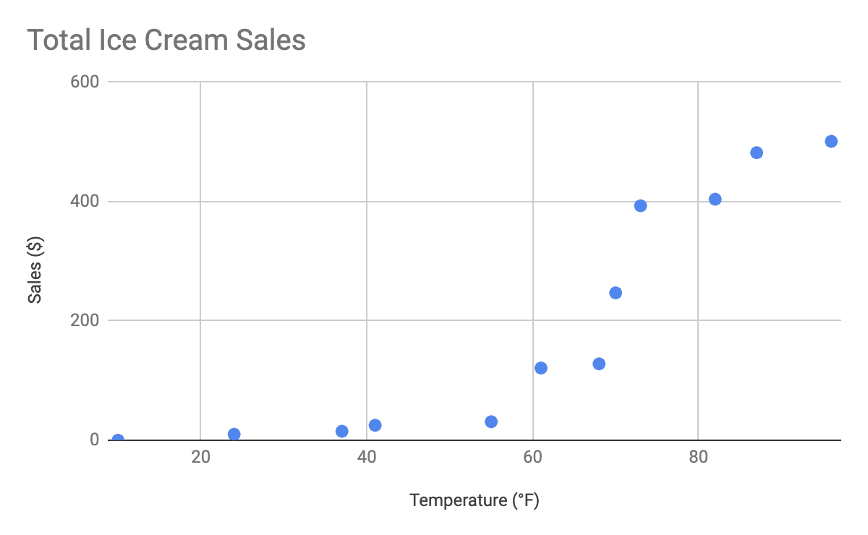

As you may notice, the higher the temperature got, the more demand there was for ice cream—so the scatterplot is great for showing the relationship between the two variables.

**Distribution graph**

A **distribution graph** displays the spread of various outcomes in a dataset.

Let’s apply this to real data. To account for its supplies, a brand new coffee shop owner wants to measure how many cups of coffee their customers consume, and they want to know if that information is dependent on the days and times of the week. That distribution graph would resemble something like this:

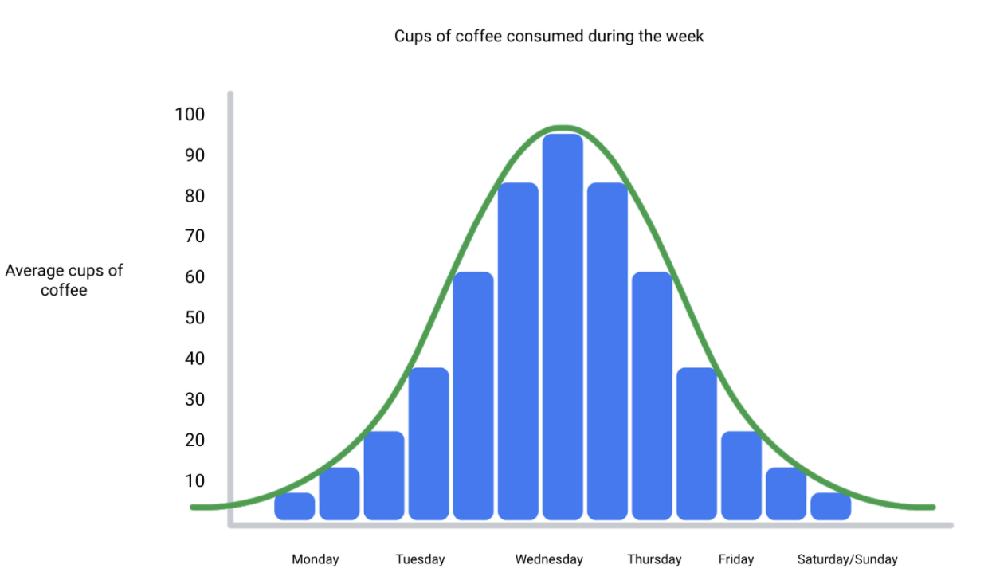

From this distribution graph, you may notice that the amount of coffee sales steadily increases from the beginning of the week, reaching the highest point mid-week, and then decreases towards the end of the week.

If outcomes are categorized on the x-axis by distinct numeric values (or ranges of numeric values), the distribution becomes a **histogram**. If data is collected from a customer rewards program, they could categorize how many customers consume between one and ten cups of coffee per week. The histogram would have ten columns representing the number of cups, and the height of the columns would indicate the number of customers drinking that many cups of coffee per week.

Reviewing each of these visual examples, where do you notice that they fit in relation to your type of data? One way to answer this is by evaluating patterns in data. Meaningful patterns can take many forms, such as:

* **Change:** This is a trend or instance of observations that become different over time. A great way to measure change in data is through a line or column chart.
* **Clustering:** A collection of data points with similar or different values. This is best represented through a distribution graph.
* **Relativity:** These are observations considered in relation or in proportion to something else. You have probably seen examples of relativity data in a pie chart.
* **Ranking:** This is a position in a scale of achievement or status. Data that requires ranking is best represented by a column chart.
* **Correlation:** This shows a mutual relationship or connection between two or more things. A scatterplot is an excellent way to represent this type of data pattern.

**Studying your data**

Data analysts are tasked with collecting and interpreting data as well as displaying data in a meaningful and digestible way. Determining how to visualize your data will require studying your data’s patterns and converting it using visual cues. Feel free to practice your own charts and data in spreadsheets. Simply input your data in the spreadsheet, highlight it, then insert any chart type and view how your data can be visualized based on what you choose.

**Data grows on decision trees**

With so many visualization options out there for you to choose from, how do you decide what is the best way to represent your data?

A **decision tree** is a decision-making tool that allows you, the data analyst, to make decisions based on key questions that you can ask yourself. Each question in the visualization decision tree will help you make a decision about critical features for your visualization. Below is an example of a basic decision tree to guide you towards making a data-driven decision about which visualization is the best way to tell your story. Please note that there are many different types of decision trees that vary in complexity, and can provide more in-depth decisions.

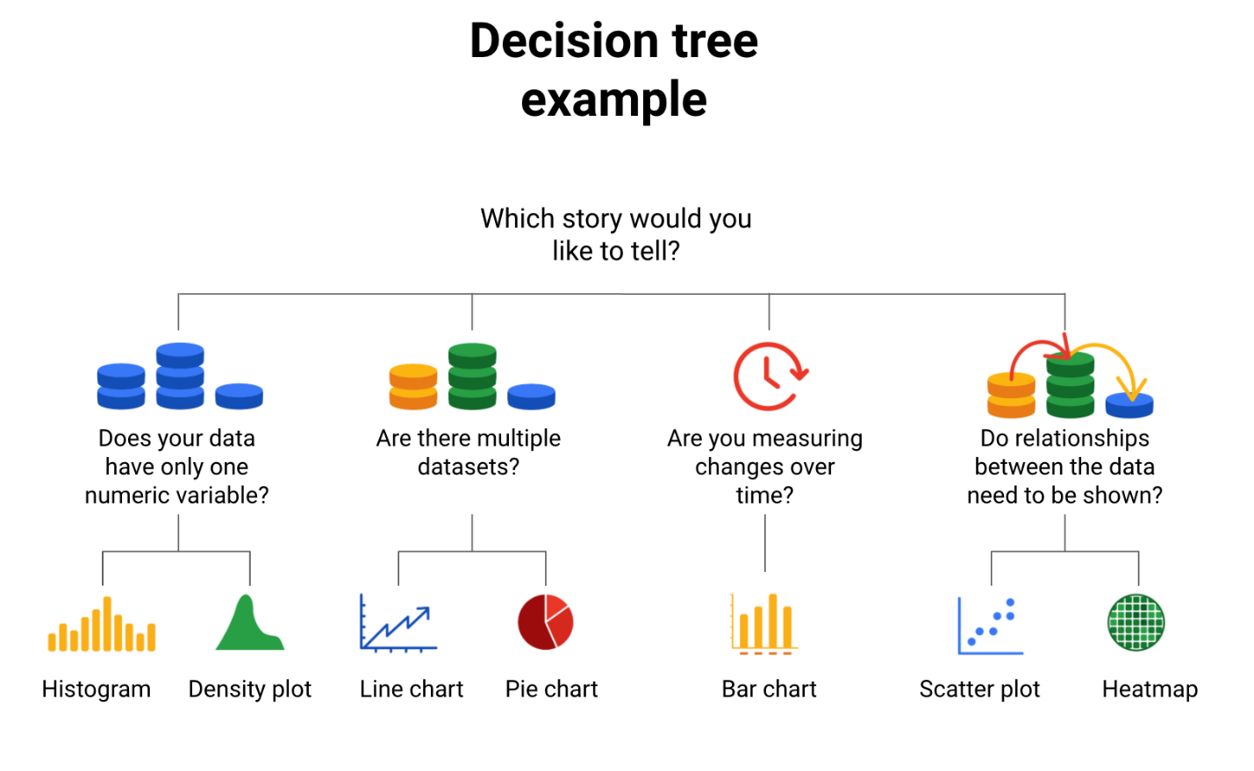-Does your data have only one numeric variable? Histogram or Density plot -Are there multiple data sets?  Line chart or pie chart -Are you measuring changes over time? Bar chart -Do relationships between the data need to be shown? Scatter plot or heatmap

**Begin with your story**

Start off by evaluating the type of data you have and go through a series of questions to determine the best visual source:

* **Does your data have only one numeric variable?** If you have data that has one, continuous, numerical variable, then a histogram or density plot are the best methods of plotting your categorical data. Depending on your type of data, a bar chart can even be appropriate in this case. For example, if you have data pertaining to the height of a group of students, you will want to use a histogram to visualize how many students there are in each height range:

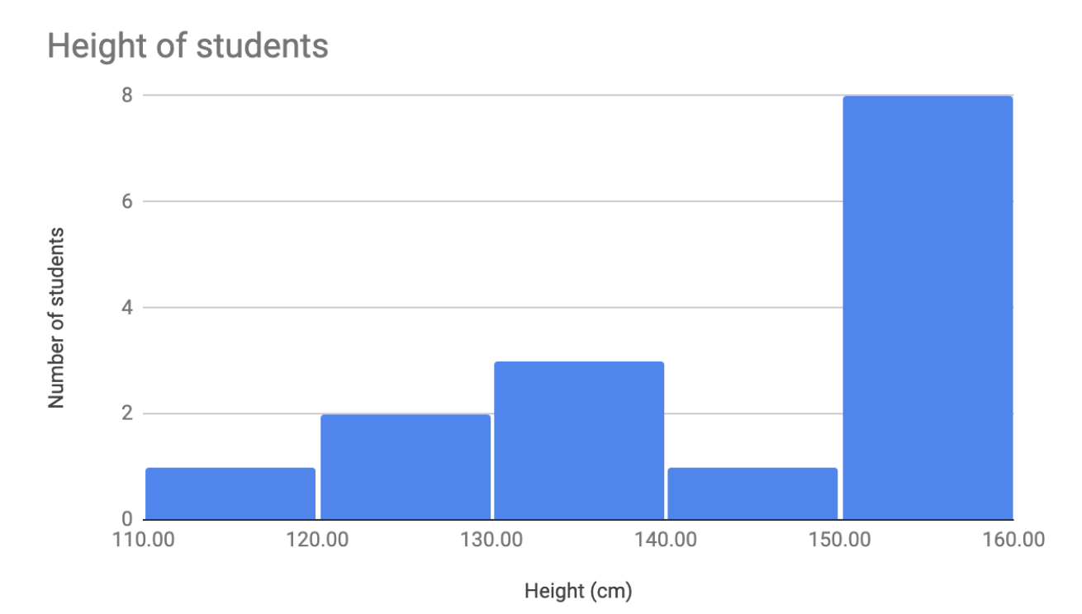

* **Are there multiple datasets?**For cases dealing with more than one set of data, consider a line or pie chart for accurate representation of your data. A line chart will connect multiple data sets over a single, continuous line, showing how numbers have changed over time. A pie chart is good for dividing a whole into multiple categories or parts. An example of this is when you are measuring quarterly sales figures of your company. Below are examples of this data plotted on both a line and pie chart.

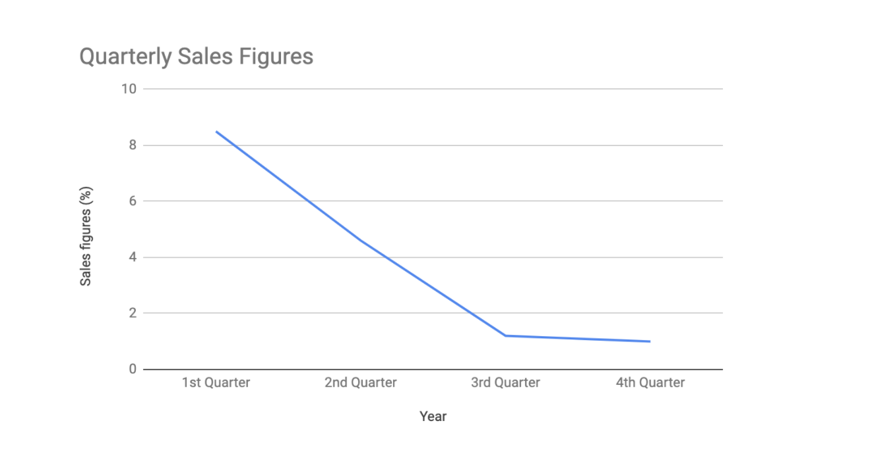

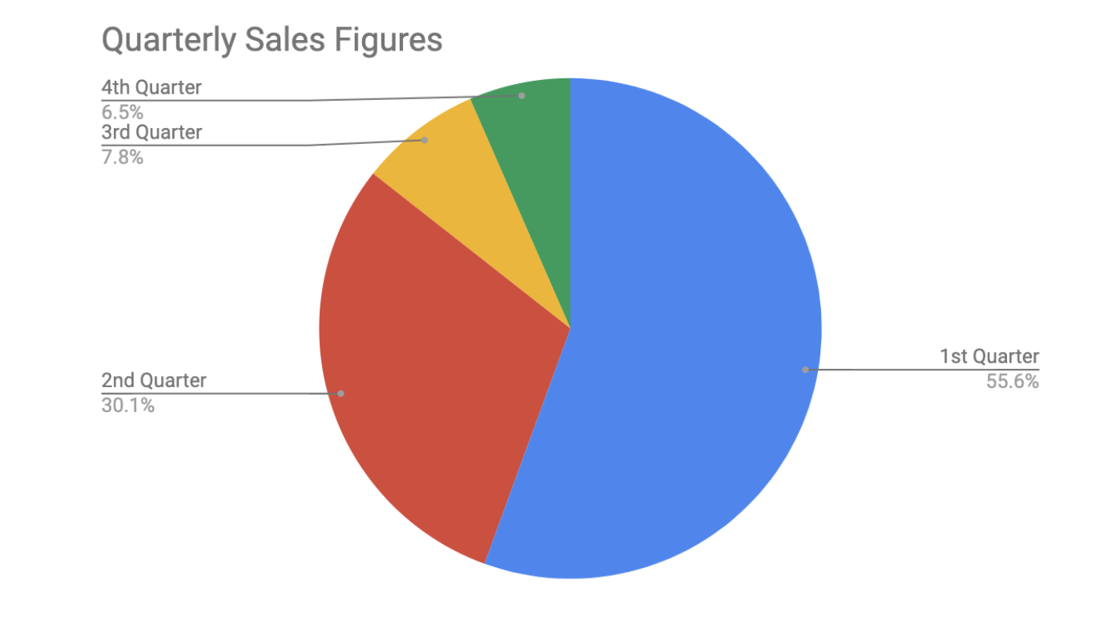

* **Are you measuring changes over time?** A line chart is usually adequate for plotting trends over time. However, when the changes are larger, a bar chart is the better option. If, for example, you are measuring the number of visitors to NYC over the past 6 months, the data would look like this:

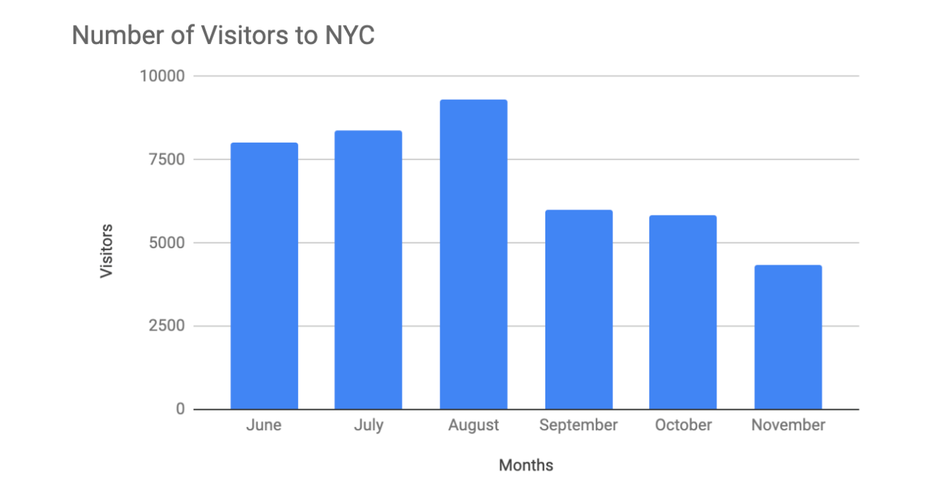

* **Do relationships between the data need to be shown?** When you have two variables for one set of data, it is important to point out how one affects the other. Variables that pair well together are best plotted on a scatterplot. However, if there are too many data points, the relationship between variables can be obscured so a heat map can be a better representation in that case. If you are measuring the population of people across all 50 states in the United States, your data points would consist of millions so you would use a heat map. If you are simply trying to show the relationship between the number of hours spent studying and its effects on grades, your data would look like this:

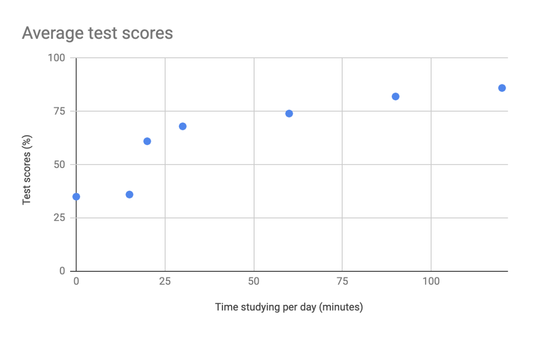

**Additional resources**

The decision tree example used in this reading is one of many. There are multiple decision trees out there with varying levels of details that you can use to help guide your visual decisions. If you want more in-depth insight into more visual options, explore the following resources:

* [From data to visualization](https://www.data-to-viz.com/): This is an excellent analysis of a larger decision tree. With this comprehensive selection, you can search based on the kind of data you have or click on each  graphic example for a definition and proper usage.
* [Selecting the best chart](https://www.youtube.com/watch?v=C07k0euBpr8): This two-part YouTube video can help take the guesswork out of data chart selection. Depending on the type of data you are aiming to illustrate, you will be guided through when to use, when to avoid, and several examples of best practices. [Part 2](https://www.youtube.com/watch?v=qGaIB-bRn-A) of this video provides even more examples of different charts, ensuring that there is a chart for every type of data out there.

**1.**

Question 1

What type of data visualization uses size contrast to compare two or more values?

1 point

Line graph

Pie chart

Histogram

Bar graph

**2.**

Question 2

Fill in the blank: Correlation charts show \_\_\_\_\_ among data.

1 point

patterns

trends

outliers

relationships

**3.**

Question 3

When does causation occur?

1 point

When an action directly leads to an outcome

When an action potentially leads to different outcomes

When multiple actions lead to identical outcomes

When an action possibly leads to an outcome

**4.**

Question 4

For a risk-management project, a data team creates visualizations that are automatically updated as new data becomes available. This enables team members to monitor market volatility as it evolves. What type of visualizations have they created?

1 point

Dynamic

Static

Responsive

Structured

Welcome back, future data analyst.

As a budding analyst, you'll be exposed to a lot of data.

People learn and absorb data in so many different ways, and

one of the most effective ways that this can happen is through visualization.

Data visualization is the graphic representation and presentation of data.

In reality, it's just putting information into an image to make it easier for

other people to understand.

If you've ever looked at any kind of map, whether it's paper or online,

then you know exactly how helpful visuals could be.

Data visualizations are definitely having a moment right now.

Online we are surrounded by images that show information in all kinds of ways,

but the history of data visualization goes back way further than the Web.

Visualizing data began long ago with maps,

which are the visual representation of geographic data.

This map of the known world is from 1502. Map makers continued to improve

their visualizations as new lands were charted.

New data was collected about those locations,

and new methods for visualizing the data were created.

Scientists and mathematicians began to truly embrace the idea of arranging data

visually in the 1700s and 1800s.

This bar graph is from 1821 and

it doesn't look too different from bar graphs that we see today.

But since the beginning of the digital age of data analytics in the 1990s,

the scope and

reach of visualizations have grown along with the data they graphically represent.

As we keep learning how to more efficiently communicate with visuals,

the quality of our insights continue to grow too.

Today we can quantify human behavior through data, and

we've learned to use computers to collect, analyze and visualize that data.

As an analyst in today's world,

you'll probably split your time with data visuals in two ways:

looking at visuals in order to understand and draw conclusions about data or

creating visuals from raw data to tell a story.

Either way, it's always good to keep in mind that data visualizations will be your

key to success.

This is especially true once you reach the point where you're ready to present

the results of your data analysis to an audience.

Getting people to understand your vision and thought process can feel challenging.

But a well-made data visualization has the power to change people's minds.

Plus, it can help someone who doesn't have the same technical background or

experience as you form their own opinions.

So here's a quick rule for creating a visualization.

Your audience should know exactly what they're looking at within the first five

seconds of seeing it.

Basically, this means the visual should be clear and easy to follow.

In the five seconds after that,

your audience should understand the conclusion your visualization is making.

Even if they aren't totally familiar with the research you've been doing.

They might not agree with your conclusion, and that's okay.

You can always use their feedback to adjust your visualization and

go back to the data to do further analysis.

So now let's talk about what we have to do to create a visualization that's

understandable, effective and, most importantly, convincing.

Let's start from the beginning.

Data visualizations are a helpful tool for

fitting a lot of information into a small space.

To do this, you first need to structure and organize your thoughts.

Think about your objectives and

the conclusions you've reached after sorting through data.

Then think about the patterns you've noticed in the data, the things that

surprised you and, of course, how all of this fits together into your analysis.

Identifying the key elements of your findings help set the stage for

how you should organize your presentation.

Check out this data visualization made by David McCandless,

a well-known data journalist.

This graphic includes four key elements:

the information or data, the story, the goal and the visual form.

It's arranged in a four-part Venn diagram,

which tells us that all four elements are needed for a successful visualization.

So far, you've learned a lot about the data used in visualizations.

That's important because it's a key building block for your visualization.

The story or concept adds meaning to the data and makes it interesting.

We'll talk more about the importance of data storytelling later, but for now,

just remember that the story and

the data combined provide an outline of what you're trying to show.

The goal or function makes the data both useful and usable, and

the visual form creates both beauty and structure.

With just two elements, you can create a rough sketch of a visual.

This could work if you're at an early stage, but won't give you a complete

visualization because you'd be missing other key elements.

Even using three elements gets you closer, but you're not quite finished.

For example, if you combine information, goal, and

visual form without any story, your visual will probably look fine,

but it won't be interesting. On their own,

each element has value, but visualizations only become truly powerful and effective

when you combine all four elements in a way that makes sense. And

when you think about all of these elements together,

you can create something meaningful for your audience.

At Google I make sure to develop visualizations

to tell stories about data that include all four of these elements, and

I can tell you that each element is a key to a visualization success.

That's why it's so important for

you as the analyst to pay close attention to each element as we move forward.

Other people might not know or

understand the exact steps you took to come to the conclusions you've made, but

that shouldn't stop them from understanding your reasoning.

Basically, an effective data visualization should lead viewers to reach the same

conclusion you did, but much more quickly.

Because of the age we live in,

we're constantly being shown different ways to view and absorb information.

This means that you've already seen lots of visuals you can reference as you design

your own visualizations.

You have the power to tell convincing stories that could change opinions and

shift mindsets.

That's pretty cool. But you also have the responsibility to pay attention to

the perspectives of others as you create these stories.

So it's important to always keep that in mind.

Coming up, we'll start drawing connections between data and

images to create a strong foundation for your visual masterpieces.

I can't wait to get started.

**Effective data visualizations**

It can be difficult to understand data insights by examining individual data points or a table of information. Often, insights become more obvious when presented in an effective visual format. You can use data visualization (often called  “data viz”) techniques to help your audience interpret data in a concise, visual manner.

When creating data visualizations, you must strike a balance between presenting enough information for your audience to understand the meaning of the visualization and not overwhelming them with too much detail. In this reading, you’ll learn tips and techniques for crafting visualizations that are both impactful and effective. You’ll explore:

* Two frameworks for organizing data
* Pre-attentive attributes

**Frameworks for organizing your thoughts about visualization**

Frameworks help organize your thoughts about data visualization and give you a useful checklist to reference as you plan and evaluate your data visualization. Here are two frameworks that employ slightly different techniques. Both are intended to improve the quality of your visuals.

[The McCandless method](https://www.informationisbeautiful.net/visualizations/what-makes-a-good-data-visualization/)

You learned about the David McCandless method earlier in the course; as a refresher, the McCandless method lists four elements of good data visualization:

1. **Information:** the data with which you’re working
2. **Story:** a clear and compelling narrative or concept
3. **Goal:** a specific objective or function for the visual
4. **Visual form:** an effective use of metaphor or visual expression

The McCandless method provides terminology that isolates the specific elements of a graphic, allowing the person making a visual the ability to evaluate how well those criteria have been met. The aim when crafting a visualization is to incorporate all four elements effectively. Visualizations that fail to incorporate all four elements can be ineffective at communicating insights in various ways. For example, visual form without a goal, story, or data could be a sketch or even art. Data in visual form without a goal or function is just a pretty picture. Data with a goal but no story or visual form can be boring. All four elements need to be present to create an effective visual.

[Kaiser Fung’s Junk Charts trifecta checkup](https://junkcharts.typepad.com/junk_charts/junk-charts-trifecta-checkup-the-definitive-guide.html)

This approach is a set of questions that can help consumers of data visualization critique what they are consuming and determine how effective it is. You can also use these questions to determine if your data visualization is effective:

1. What is the practical question?
2. What does the data say?
3. What does the visual say?

Each of these questions offers an opportunity to investigate a given problem with a slightly different context. A well-designed visual effectively answers all three of those questions at once. Moreover, this framework helps you think about your data viz from the perspective of your audience.

**Pre-attentive attributes**

In addition to the frameworks mentioned above, several standard building blocks can help you construct your data visualizations. Creating effective visuals means leveraging what is known about how the brain works, and then using specific visual elements to communicate the information effectively. Pre-attentive attributes are the elements of a data visualization that people recognize automatically and without conscious effort. The essential, basic building blocks that make visuals immediately understandable are called marks and channels.

**Marks**

**Marks** are basic visual objects such as points, lines, and shapes. Every mark can be broken down into four qualities:

1. **Position:** Where is a specific mark in space relative to a scale or to other marks?

For example, if you’re looking at two different trends, position allows you to compare the pattern of one element relative to another.



2. **Size:** How big, small, long, or tall is a mark?

The comparison of object sizes can be an easy visual interpretation for humans. This can be very useful for conveying the relationship between categories or data points. However, this also presents a potential problem: The human eye can inadvertently interpret comparisons that aren’t intended to convey meaning. For example, sometimes objects that appear to be the same size when they are not. Controlling the scale of a visual is important even when comparative sizes are not intended to offer information.



3. **Shape:** Does the shape of a specific object communicate something about it?

Rather than using simple dots or lines, a bit of creativity can enhance how quickly people are able to interpret a visual by using shapes that align with a given application. In the example below, it is immediately obvious that numbers of people are represented because the bars are person-shaped.



4. **Color:** What color is a mark?

Colors can be used both as a simple differentiator of groupings or as a way to communicate other concepts such as profitable versus unprofitable, or hot versus cold.



**Channels**

**Channels** are visual aspects or variables that represent characteristics of the data in a visualization. They are basically specialized marks that have been used to visualize data. It’s important to understand that channels vary in terms of how effective they are at communicating data based on three elements:

1. **Accuracy:** Are the channels helpful in accurately estimating the values being represented?

For example, color is very accurate when communicating categorical differences, such as apples and oranges. But it is much less effective when distinguishing quantitative data, such as 5 from 5.5.



2. **Popout:** How easy is it to distinguish certain values from others?

There are many ways of drawing attention to specific parts of a visual, and lots of them leverage pre-attentive attributes including line length, size, line width, shape, enclosure, hue, and intensity.



3. **Grouping:** How effective is a channel at communicating groups that exist in the data?

Consider the proximity, similarity, enclosure, connectedness, and continuity of the channel.



But, remember: The more you emphasize one single thing, the more that counts. Emphasis diminishes with each item you emphasize because the items begin to compete with one another.

**Key takeaways**

Throughout your career as an analyst, you will use different techniques and types of data visualizations to present data and insights in a concise, impactful manner. This will include organizing your data, selecting the right type of data visualizations, and designing them  in such a way that they are easy to understand and highly communicative while avoiding any visuals that are misleading or inaccurate.

Keep in mind that data visualization is an art form, and it takes time to develop these skills. Over your career as a data analyst, you will  learn how to design and evaluate data visualizations. Use these tips to think critically about data visualization—both as a creator and as an audience member.

**Resources**

* [The beauty of data visualization](https://www.ted.com/talks/david_mccandless_the_beauty_of_data_visualization?language=en#t-150183): In this video, David McCandless explains the need for design to not just be beautiful, but for it to be meaningful as well. Data visualization must be able to balance function and form for it to be relevant to your audience.
* [‘The McCandless Method’ of data presentation](https://artscience.blog/home/the-mccandless-method-of-data-presentation): At first glance, this blog appears to be written by a David McCandless fan, and it is. However, it contains very useful information and provides an in-depth look at the 5-step process that McCandless uses to present his data.
* [Information is beautiful](https://informationisbeautiful.net/): Founded by McCandless himself, this site serves as a hub of sample visualizations that make use of the McCandless method. Explore data from the news, science, the economy, and so much more and learn how to make visual decisions based on facts from all kinds of sources.
* [Beautiful news](https://informationisbeautiful.net/beautifulnews/): In this McCandless collection, explore uplifting trends and statistics that are beautifully visualized for your creative enjoyment. A new chart is released every day so be sure to visit often to absorb the amazing things happening all over the world.
* [The Wall Street Journal Guide to Information Graphics: The Dos and Don'ts of Presenting Data, Facts, and Figures](https://www.amazon.com/Street-Journal-Guide-Information-Graphics/dp/0393072959): This is a comprehensive guide to data visualization, including chapters on basic data visualization principles and how to create useful data visualizations even when you find yourself in a tricky situation. This is a useful book to add to your data visualization library, and you can reference it over and over again.
* Hello again. Earlier we talked about why
* data visualizations are so
* important to both analysts and stakeholders.
* Now we'll discuss the connections you can make
* between data and images in your visualizations.
* Visual communication of data is important to
* those using the data to help make decisions.
* To better understand the connection
* between data and images,
* let's talk about some examples of
* data visualizations and how
* they can communicate data effectively.
* You maybe come across lots of these in your daily life.
* We'll explore them a little bit more here.
* A good place to start is a bar graph.
* Bar graphs use size contrast to
* compare two or more values.
* The horizontal line of
* a bar graph usually placed at the bottom,
* is called the x-axis,
* and bar graphs with vertical bars,
* the x-axis is used to represent categories,
* time periods, or other variables.
* The vertical line of a bar graph usually
* placed to the left is called the y-axis.
* The y-axis usually has
* a scale of values for the variables.
* In this example, the time of day is compared to
* someone's level of motivation
* throughout the whole workday.
* Bar graphs are a great way to clarify trends.
* Here, it's clear this person's motivation is low at
* the beginning of the day and gets higher
* and higher by the end of the workday.
* This type of visualization makes it
* very easy to identify patterns.
* Another example is a line graph.
* Line graphs are a type of visualization that can help
* your audience understand shifts or changes in your data.
* They're usually used to track
* changes through a period of time,
* but they can be paired with other factors too.
* In this line graph,
* we're using two lines to compare
* the popularity of cats and dogs over a period of time.
* With two different line colors,
* we can immediately tell that
* dogs are more popular than cats.
* We'll talk more about using colors and patterns to make
* visualizations more accessible to audiences later too.
* Even as a line moves up and down,
* there's a general trend upwards and the line
* for dogs always stays higher than the line for cats.
* Now let's check out another visualization
* you'll probably recognize.
* Say hello to the pie chart.
* Pie charts show how much each part
* of something makes up the whole.
* This pie chart shows us
* all the activities that make up someone's day.
* Half of it's spent working,
* which is shown by the amount of
* space that the blue section takes up.
* From a quick scan,
* you can easily tell
* which activities make up a good chunk of
* the day in this pie chart
* and which ones take up less time.
* Earlier, we learned how maps
* help organize data geographically.
* The great thing about maps is they can hold a lot of
* location-based information and they're
* easy for your audience to interpret.
* This example shows survey data
* about people's happiness in Europe.
* The borderlines are well-defined and the colors
* added make it even easier to tell the countries apart.
* Understanding the data represented here,
* which we'll come back to again later,
* can happen pretty quickly.
* So data visualization is an excellent tool for making
* the connection between an image
* and the information it represents,
* but it can sometimes be misleading.
* One way visualizations can be
* manipulated is with scaling and proportions.
* Think of a pie chart. Pie charts show
* proportions and percentages between categories.
* Each part of the circle or
* pi should reflect its percentage to the whole,
* which is equal to 100 percent.
* So if you want to visualize your sales analysis to show
* the percentage of your company sales
* that come from online transactions,
* you could use a pie chart.
* The size of each slice would be
* the percentage of total sales that it represents.
* So if your online sales accounted for 60 percent,
* the slice would be 60 percent of the whole pie.
* Now here's a misleading pie chart.
* It's supposed to show opinions about pizza toppings,
* but each slice or
* segment represents more than one option.
* They all add up to well over 100 percent.
* There is lots of ingredients listed below
* the image that are not even included in the visual data.
* All of the segments are the same size,
* even though they're supposed to
* be showing different values.
* If a visualization looks
* confusing then it probably is confusing.
* Let's explore another example where
* the size of the graphic components comes into play.
* This time with a bar chart.
* In a truncated bar chart like this one,
* the values on the y-axis don't start at zero.
* The data points start at 9,100 and at intervals of 100.
* This makes it seem like the data, let's say,
* it's for novel clicks per day on
* different website links, is fairly wide-ranging.
* In this view, website E
* seems to clearly receive way more clicks than website D,
* which receives more clicks than website C and so on.
* While the graph is clear and
* the elements are easy to understand,
* the way the data is presented is misleading.
* Let's try to fix this by changing the graph's y-axis,
* so that it starts at zero instead.
* Now, the difference between the website
* clicks per day don't look nearly as drastic.
* By making the y-axis start at zero,
* we're changing the visual proportions to be
* more accurate and more honest.
* Some platforms always start their y-axis at zero,
* but other programs like
* spreadsheets might not fix the y-axis.
* So it's important to keep this in
* mind when creating visualizations.
* By following the conventions of data analysis,
* you'll be able to avoid misleading visualizations.
* You always want your visualization to be
* clear and easy to understand,
* but never at the expense of
* communicating ideas that are true to the data.
* So we've talked about
* some effective data-driven visualizations
* like bar graphs,
* line graphs, and pie charts,
* and when to use them.
* On top of that, we've discussed some things to avoid in
* your visualizations to keep them from being misleading.
* Coming up, we'll check out how to make
* those visualizations reach
* your target audience. See you then.

Hello, and welcome back.

You probably didn't think you'd be learning about

art in a data analytics course,

but that's exactly what we're going to do.

Both data analysts and

artists use elements of art in their work.

We'll introduce those elements to you here,

and we'll show you how to

apply them to visualizations later.

The elements we'll check out are line,

shape, color, space and movement.

Now, these aren't the only elements to consider,

but these particular ones can add value to

your data viz by making them

more visually effective and compelling.

Lines and visualizations can be curved or straight,

thick or thin, vertical, horizontal, or diagonal.

They can add visual form to

your data and help

build a structure for your visualization.

These charts show some of

the variety that lines can bring to your data viz.

The combo chart shows two different types of lines,

both providing a graphic for the data.

The line chart does the

same, but uses curved lines instead.

Shapes are also known for their variety.

Shapes and visualizations should

always be two-dimensional.

This is because three-dimensional objects in

a visualization can complicate the

visual and confuse the audience.

Shapes are also a great way to add eye-catching contrast,

especially size contrast to your data story.

This circle used for a pie chart lets

someone quickly understand the data in a familiar format.

Shapes with symmetry are usually more familiar to people,

so there's less work for the audience to

do when viewing symmetrical data viz.

But the asymmetrical shapes in

this map are still instantly recognizable as countries.

It's good to note that

the data you're sharing with your audience will

usually inform the types of shapes

you want to use in your data viz.

Next, we have colors, and colors are, well, colors.

Of course, in the eyes of artists and analysts,

colors can be much more complex.

Colors can be described by

their hue, intensity, and value.

The hue of a color is basically its name,

red, green, blue and so on.

Intensity is how bright or dull a color is,

and finally, there's value.

The value is how light or

dark the colors are in a visualization.

In more scientific terms value

indicates how much light is being reflected.

Dark values with some black added

are called shades of color,

like these shades of green.

Light values with white added are called tints,

like these tints of blue.

In this map, there are shades and tints of gray.

The value of these colors help us understand

the population data in the map and varying

the color's value can be a very effective way to

draw our audience's attention to specific areas.

Space is the area between, around and in the objects.

There should always be space in data visualizations,

just not too much or too little.

For example, the space

between the bars of a bar graph like

this one should be smaller

than the width of the bars themselves.

This will draw the viewer's attention to the bar

and the data it represents instead of the empty space.

Finally, there's movement.

Movement is used to create a sense of

flow or action in a visualization.

One of my favorite examples is the data viz,

the Wealth and Health of Nations.

This viz showcases a correlation between

the financial health and physical health of nations.

It traces these elements over time

so you can see how the two correlated effects play out.

The movement pulls in data from

the 1800s all the way up until recently.

The interactivity allows for

a greater volume of data to be

displayed and we'll reveal

multiple stories from the same data visualization.

Remember, this is something

that should be used sparingly.

There's a fine line between attracting

attention and distracting the audience.

A static image lets you control

all elements of the story you want to tell.

When you start incorporating movement and interactivity,

the story is controlled by

whoever is controlling the interactivity,

whether that's you or

possibly your audience if you've

turned control over to them.

We'll discuss this delicate balance

later on in the course.

When you bring many of these art elements together

in a visualization like this one about sea levels,

it can be beautiful and provoking.

It proves that there's a place for

creative expression in data analytics.

Coming up, we'll continue exploring ways to add

meaningful creative expression to

your data viz. Bye for now.

**Principles of design**

In this reading, you are going to learn more about using the elements of art and principles of design to create effective visualizations. So far, we have learned that communicating data visually is a form of art. Now, it's time to explore the nine design principles for creating beautiful and effective data visualizations that can be informative and appeal to all audiences.

After we go through the various design principles, spend some time examining the visual examples to ensure that you have a thorough understanding of how the principle is put into practice. Let’s get into it!

**Nine basic principles of design**

There are ninebasic **principles of design** that data analysts should think about when building their visualizations.

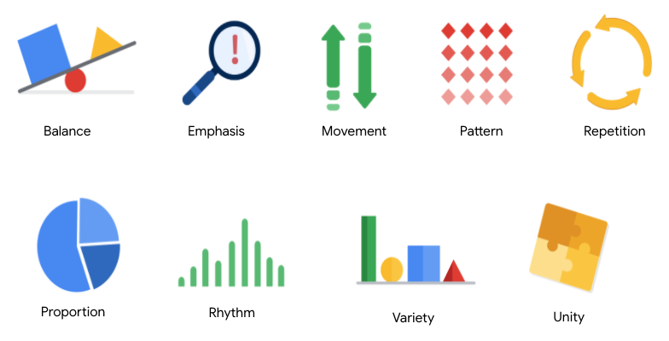

**1. Balance**: The design of a data visualization is balanced when the key visual elements, like color and shape, are distributed evenly. This doesn’t mean that you need complete symmetry, but your visualization shouldn’t have one side distracting from the other. If your data visualization is balanced, this could mean that the lines used to create the graphics are similar in length on both sides, or that the space between objects is equal. For example, [**this column chart**](https://developers.google.com/chart/interactive/docs/gallery/columnchart) (also shown below) is balanced; even though the columns are different heights and the chart isn’t symmetrical, the colors, width, and spacing of the columns keep this data visualization balanced. The colors provide sufficient contrast to each other so that you can pay attention to both the motivation level and the energy level displayed.

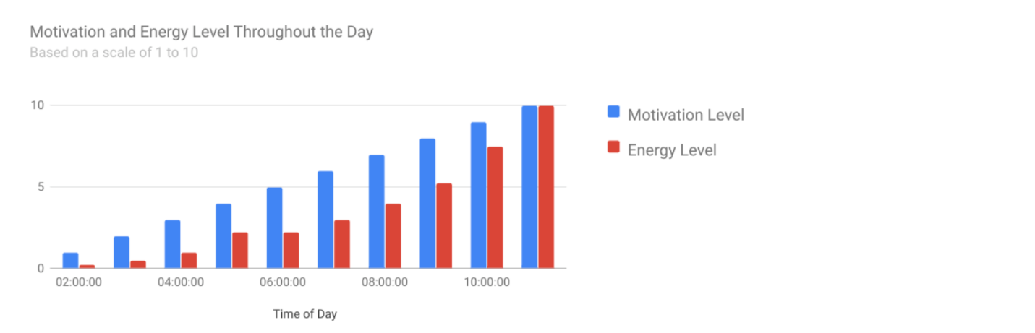

**2. Emphasis:** Your data visualization should have a focal point, so that your audience knows where to concentrate. In other words, your visualizations should emphasize the most important data so that users recognize it first. Using color and value is one effective way to make this happen. By using contrasting colors, you can make certain that graphic elements—and the data shown in those elements—stand out.

For example, you will notice a heat map data visualization below from [**The Pudding’s “Where Slang Comes From"**](https://pudding.cool/2017/02/new-slang/)article. This heat map uses colors and value intensity to emphasize the states where search interest is highest. You can visually identify the increase in the search over time from low interest to high interest. This way, you are able to quickly grasp the key idea being presented without knowing the specific data values.

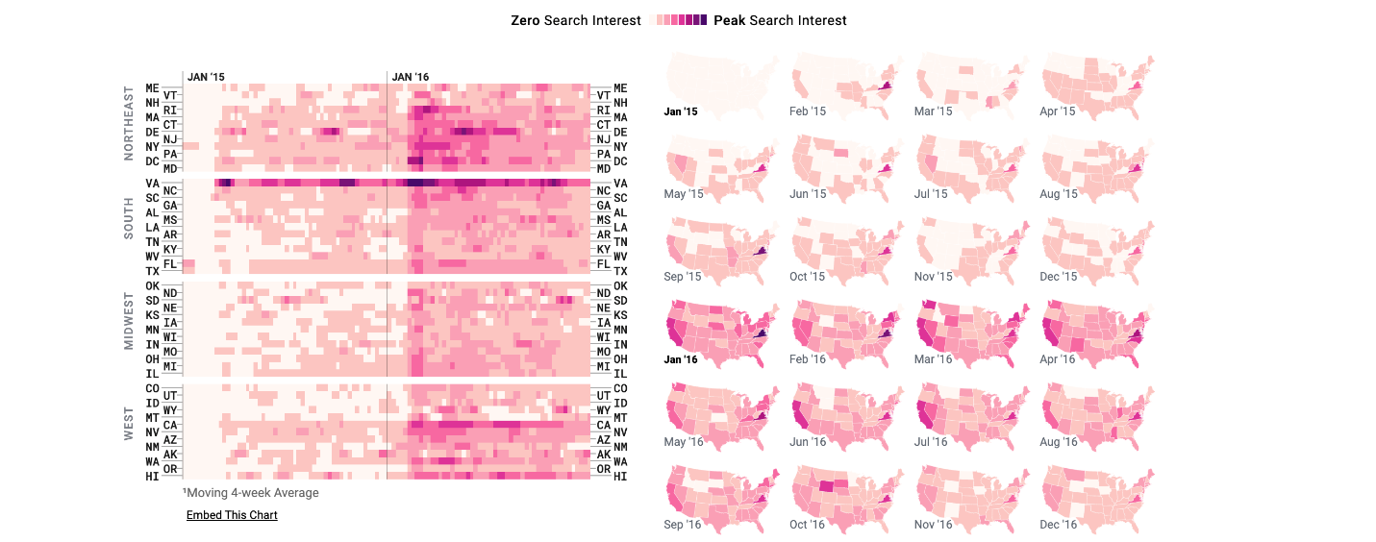

**3. Movement:** Movement can refer to the path the viewer’s eye travels as they look at a data visualization, or literal movement created by animations. Movement in data visualization should mimic the way people usually read. You can use lines and colors to pull the viewer’s attention across the page.

For example, notice how the average line in [**this combo chart**](https://developers.google.com/chart/interactive/docs/gallery/combochart) (also shown below) draws your attention from left to right. Even though this example isn’t moving, it still uses the movement principle to guide viewers’ understanding of the data.

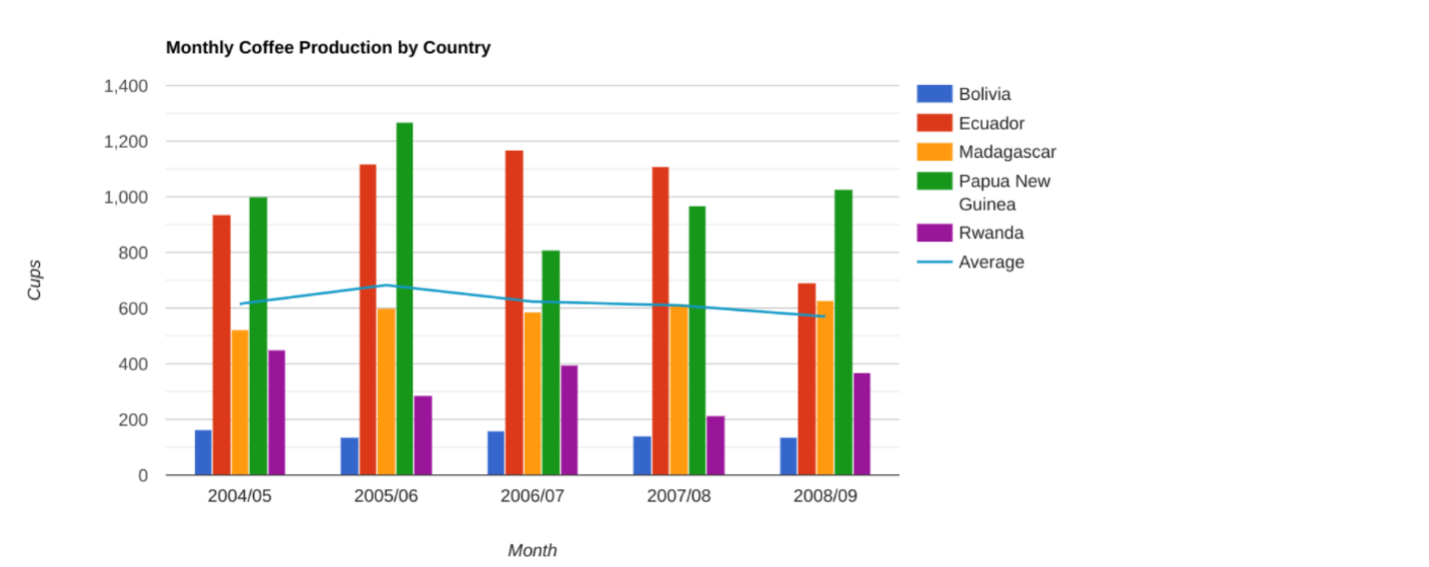

**4. Pattern:** You can use similar shapes and colors to create patterns in your data visualization. This can be useful in a lot of different ways. For example, you can use patterns to highlight similarities between different data sets, or break up a pattern with a unique shape, color, or line to create more emphasis.

In the example below, the different colored categories of [**this stacked column chart**](https://developers.google.com/chart/interactive/docs/gallery/barchart)(also shown below)are a consistent pattern that makes it easier to compare book sales by genre in each column. Notice in the chart that the Fantasy & Sci Fi category (royal blue) is increasing over time even as the general category (green) is staying about the same.

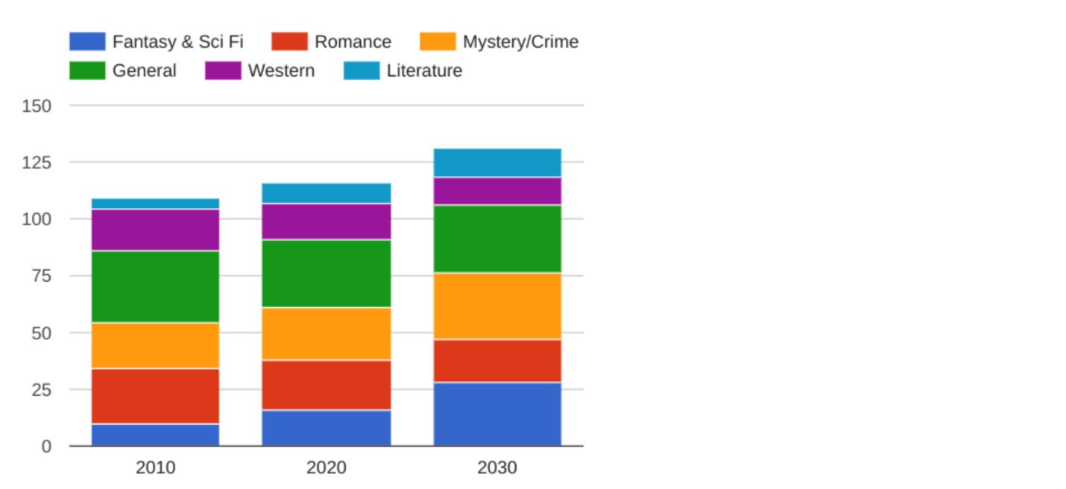

**5. Repetition:** Repeating chart types, shapes, or colors adds to the effectiveness of your visualization. Think about the book sales chart from the previous example: the repetition of the colors helps the audience understand that there are distinct sets of data. You may notice this repetition in all of the examples we have reviewed so far. Take some time to review each of the previous examples and notice the elements that are repeated to create a meaningful visual story.

**6. Proportion:** Proportion is another way that you can demonstrate the importance of certain data. Using various colors and sizes helps demonstrate that you are calling attention to a specific visual over others. If you make one chart in a dashboard larger than the others, then you are calling attention to it. It is important to make sure that each chart accurately reflects and visualizes the relationship among the values in it. In [**this dashboard**](https://developers.google.com/chart/interactive/docs/gallery/controls) (also shown below), the slice sizes and colors of the pie chart compared to the data in the table help make the number of donuts eaten by each person the focal point.

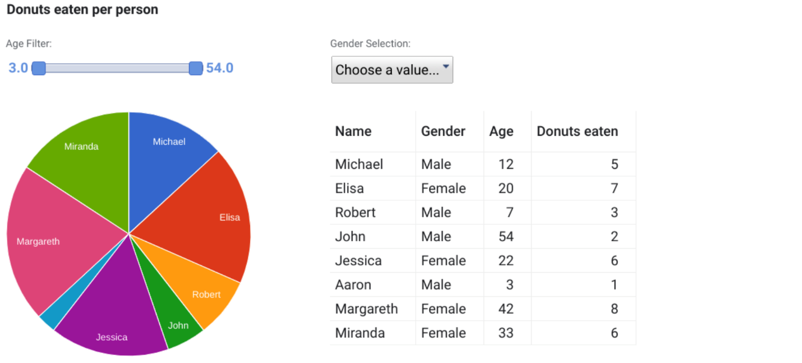

These first six principles of design are key considerations that you can make while you are creating your data visualization. These next three principles are useful checks once your data visualization is finished. If you have applied the initial six principles thoughtfully, then you will probably recognize these next three principles within your visualizations already.

**7. Rhythm:** This refers to creating a sense of movement or flow in your visualization. Rhythm is closely tied to the movement principle. If your finished design doesn’t successfully create a flow, you might want to rearrange some of the elements to improve the rhythm.

**8. Variety:** Your visualizations should have some variety in the chart types, lines, shapes, colors, and values you use. Variety keeps the audience engaged. But it is good to find balance since too much variety can confuse people. The variety you include should make your dashboards and other visualizations feel interesting and unified.

**9. Unity:** The last principle is unity. This means that your final data visualization should be cohesive. If the visual is disjointed or not well organized, it will be confusing and overwhelming.

Being a data analyst means learning to think in a lot of different ways. These nine principles of design can help guide you as you create effective and interesting visualizations.

Welcome back, let's jump in.

Play video starting at ::4 and follow transcript0:04

Hopefully by now we've developed a clear picture of data viz.

We've explored everything from design principles to the types of charts you can

use in your visualizations.

Choosing the right visualization for

your data findings can often come down to one question.

Which one will make it easiest for

the user to understand the point you're trying to make?

Play video starting at ::26 and follow transcript0:26

No matter how complex your analysis is, your audience will only

care about what's in front of them and how easy they can understand it.

As you complete your analysis, you'll have to decide which visualization serve your

needs and your audiences needs for each task.

For example, if you want to show a comparison of the different age groups

of visitors to a website, a line graph with a line for each age group,

plus one for total users would work well.

Let's say you want to highlight the differences among the age groups

to compare them or directly, for

that you might use a positive negative bar chart like this.

Play video starting at :1:7 and follow transcript1:07

We've touched on this before, but

let's make some more connections between the data you'll have after analysis and

the visualizations you'll want to use for different cases.

Play video starting at :1:19 and follow transcript1:19

We'll start with some charts.

Play video starting at :1:21 and follow transcript1:21

You've worked with some of these before and

will cover more about charts with more examples later.

You'll also discover that the best charts to suit your purposes might

depend on the needs of your industry, and company,

and the stakeholders who will be in your audience.

For comparing data over time we showed you how line graphs could be effective.

Like in this one bar graphs and stacked bar graphs, along with area charts,

can also be good ways to visualize how data changes over time.

By the way, there's a lot of charts out there,

we'll give you as much information as possible about as many as we can.

But doing your own research or

practicing using them in visualizations will also be helpful.

Okay, when you're comparing distinct objects like in our

example about mobile versus computer usage, ordered bar, and

group bar graphs, and ordered column charts are useful.

Play video starting at :2:16 and follow transcript2:16

Then there's charts that show parts of a whole.

This is known as data composition, and it's achieved by combining the individual

parts of a visualization and displaying them together as a whole.

Stack bars, donuts, stacked areas, pie charts and tree maps can do all this.

Now to show relationships in your data, you might want to use scatterplot and

bubble charts, column/line charts and heatmaps.

Let's revisit the happiness data vis to show you an example of this.

Each of these scatterplots show the relationship between a country's happiness

score and one of the factors that contributes to that score.

Play video starting at :2:57 and follow transcript2:57

So the health versus happiness scatterplot shows a strong relationship between

the life expectancy of people living in a country and how happy those people are.

Basically, as life expectancy increases, so does their happiness score.

Speaking of happiness, a successful data visualization results in a happy audience.

So it's important to understand how your audience is

viewing your data visualizations, since they should always be top of mind.

And it all starts in the brain, when processing information our brains try to

find patterns and rely on visual context.

As data analysts,

we can use our understanding of the human visual system to produce better visuals.

When we create visualizations, we can do so in a way that helps the audience

process the information and helps them remember what they're seeing.

Visual journalists Dona Wong proposes that effective visuals,

like the database we've been discussing here have three essential elements.

The first is clear meaning,

good visualizations clearly communicate their intended insight.

The second is a sophisticated use of contrast,

which helps separate the most important data from the rest using visual context

that our brains naturally look for.

The third essential element for effective visuals is refined execution.

Visuals with refined execution include deep attention to detail,

using visual elements like lines, shapes, colors, value, space and movement.

In other words, the elements of art that we talked about earlier.

The first rule in most businesses is to satisfy the customer,

it's no different with data analytics.

While your customers will probably be managers and other stakeholders,

you should always think of them first when creating data visualizations.

Think about the five second rule we called out earlier.

If you make your data viz easy to look at and understand quickly, then you have

done your job and then you'll be satisfied just like your customers.

Coming up we'll talk about design, thinking and data visualizations.

See you soon.

**Data is beautiful**

At this point, you might be asking yourself: What makes a good visualization? Is it the data you use? Or maybe it is the story that it tells? In this reading, you are going to learn more about what makes data visualizations successful by exploring David McCandless’ elements of successful data visualization and evaluating three examples based on those elements. Data visualization can change our perspective and allow us to notice data in new, beautiful ways. A picture is worth a thousand words—that’s true in data too! You will have the option to save all of the data visualization examples that are used throughout this reading; these are great examples of successful data visualization that you can use for future inspiration.

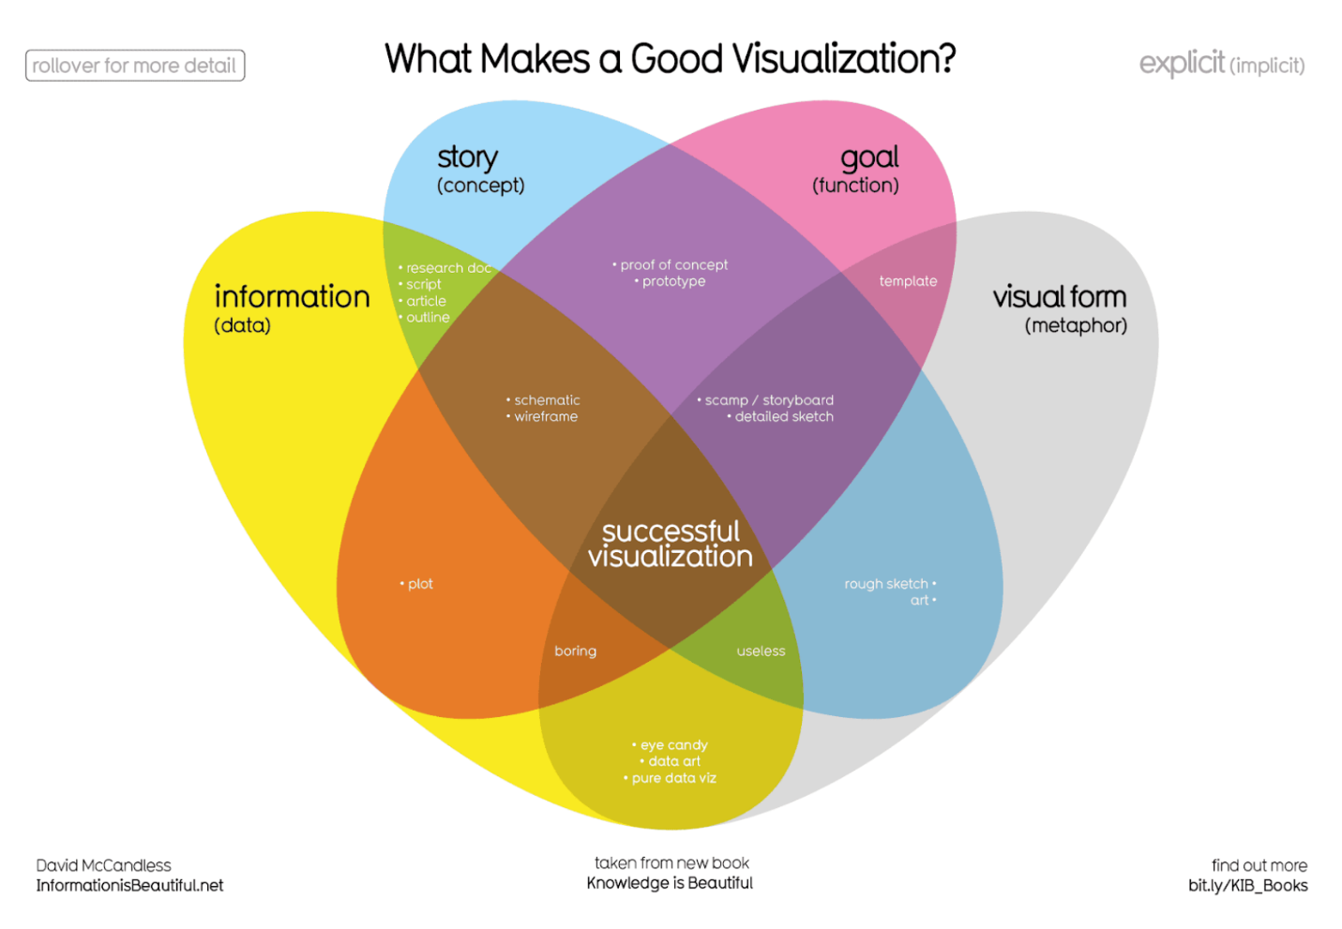Where just two or three ovals overlap, there are different types of incomplete data visualization. At the center, where all four overlap, contains the words “successful visualization”. This visualization stresses the idea that all four elements are necessary to create a successful data visualization

You can also access a .pdf version of this visualization and save it for your own reference by clicking the file below:

[WEB\_What-Makes-a-Good-Infoviz.pdf](https://d3c33hcgiwev3.cloudfront.net/P5sik46MQMmbIpOOjGDJ0g_6ccbbc544b41477883b63dd5f37dbbf5_WEB_What-Makes-a-Good-Infoviz.pdf?Expires=1706832000&Signature=TlVFPezd3KAAJLrAwuxCcqOobmvTCFdiAt7lspBuQZdVwyBeVVXQC99njvph9k0TnHrf45FU6Vj1weNPfxHSGo8orUoq6XMeL93pMwD-5E5pSRPcI4lK81q1QwT6C-gnYOY90fu6IHUuB4yVAGbuPwC1cWAfBBbkEmswsEd96SY_&Key-Pair-Id=APKAJLTNE6QMUY6HBC5A" \t "_blank)

[PDF File](https://d3c33hcgiwev3.cloudfront.net/P5sik46MQMmbIpOOjGDJ0g_6ccbbc544b41477883b63dd5f37dbbf5_WEB_What-Makes-a-Good-Infoviz.pdf?Expires=1706832000&Signature=TlVFPezd3KAAJLrAwuxCcqOobmvTCFdiAt7lspBuQZdVwyBeVVXQC99njvph9k0TnHrf45FU6Vj1weNPfxHSGo8orUoq6XMeL93pMwD-5E5pSRPcI4lK81q1QwT6C-gnYOY90fu6IHUuB4yVAGbuPwC1cWAfBBbkEmswsEd96SY_&Key-Pair-Id=APKAJLTNE6QMUY6HBC5A" \t "_blank)

**Four elements of successful visualizations**

The Venn diagram by David McCandless identifies four elements of successful visualizations:

* **Information (data):** The information or data that you are trying to convey is a key building block for your data visualization. Without information or data, you cannot communicate your findings successfully.
* **Story (concept):** Story allows you to share your data in meaningful and interesting ways. Without a story, your visualization is informative, but not really inspiring.
* **Goal (function):** The goal of your data visualization makes the data useful and usable. This is what you are trying to achieve with your visualization. Without a goal, your visualization might still be informative, but can’t generate actionable insights.
* **Visual form (metaphor):** The visual form element is what gives your data visualization structure and makes it beautiful. Without visual form, your data is not visualized yet.

All four of these elements are important on their own, but a successful data visualization balances all four. For example, if your data visualization has only two elements, like the information and story, you have a rough outline. This can be really useful in your early planning stages, but is not polished or informative enough to share. Even three elements are not quite enough—you need to consider all four to create a successful data visualization.

In the next part of this reading, you will use these elements to examine two data visualization examples and evaluate why they are successful.

**Example 1: Visualization of dog breed comparison**

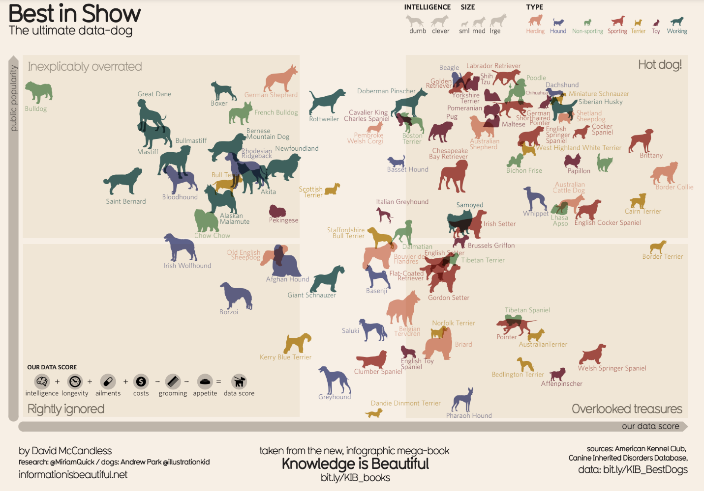It uses two axes, popularity and data score, to place different dog breeds on a four-square chart. The squares are labelled “Inexplicably Overrated,” “The Rightly Ignored,” “Hot Dogs!,” and “Overlooked Treasures.” Different dog breeds, visualized with plotted points shaped like dogs, are distributed on the chart based on their popularity and their data score.

Save this data visualization as a .pdf by clicking the file below:

[IIB-LICENSED\_Best-in-Show.pdf](https://d3c33hcgiwev3.cloudfront.net/9_ukt6X2QOu7pLel9tDrfw_359529dc0bd647de843a11274ca5ace9_IIB-LICENSED_Best-in-Show.pdf?Expires=1706832000&Signature=Tt3l5Em2vee36pyrq~PKmi3ct7nXHIksphed2j1c5tKavsuSmGB-Mqow1BPgYgnPhFG40-2EBC5GSeFEvRUPO6VDxnir37~aMCsMGPrEKeI5kMYRyhHuB9VPnk3LqITOzq7FidNn5zY8CwyWLGVQk2FMZaev9uVebhGuay1Txlk_&Key-Pair-Id=APKAJLTNE6QMUY6HBC5A" \t "_blank)

[PDF File](https://d3c33hcgiwev3.cloudfront.net/9_ukt6X2QOu7pLel9tDrfw_359529dc0bd647de843a11274ca5ace9_IIB-LICENSED_Best-in-Show.pdf?Expires=1706832000&Signature=Tt3l5Em2vee36pyrq~PKmi3ct7nXHIksphed2j1c5tKavsuSmGB-Mqow1BPgYgnPhFG40-2EBC5GSeFEvRUPO6VDxnir37~aMCsMGPrEKeI5kMYRyhHuB9VPnk3LqITOzq7FidNn5zY8CwyWLGVQk2FMZaev9uVebhGuay1Txlk_&Key-Pair-Id=APKAJLTNE6QMUY6HBC5A" \t "_blank)

**View the data**

The Best in Show visualization uses data about different dog breeds from the American Kennel Club. The data has been compiled in a spreadsheet. Click the link below and select "Use Template" to view the data.

Link to the template: [KIB - Best in Show](https://docs.google.com/spreadsheets/d/1cbqOIishrWTrfSgxjCrdua-m91B67Qls/edit?usp=share_link&ouid=100233597079733080159&rtpof=true&sd=true)

Or, if you don't have a Google account, download the file below.

[KIB - Best in Show (public)](https://d3c33hcgiwev3.cloudfront.net/-tlQpnbgR2-ZUKZ24GdvPg_5754482a15824030bab88668386dde06_KIB---Best-in-Show-public-.xlsx?Expires=1706832000&Signature=JI4qnUwfL1LienrsjX17jFT6OoEMS5oTD-xg5naeVDJ1VbSeJl8OItn-Odc56kCjeyL0Jnh0DPG-6IgT0ZCGSht1aY1vtaduSYWIQIoMTBEKFcSeQvy~H86Sl-om6wp~kGHVx8e7GMx3lbA5PXxiM5x9DCQRZexw5R0ndcco52A_&Key-Pair-Id=APKAJLTNE6QMUY6HBC5A" \t "_blank)

[XLSX File](https://d3c33hcgiwev3.cloudfront.net/-tlQpnbgR2-ZUKZ24GdvPg_5754482a15824030bab88668386dde06_KIB---Best-in-Show-public-.xlsx?Expires=1706832000&Signature=JI4qnUwfL1LienrsjX17jFT6OoEMS5oTD-xg5naeVDJ1VbSeJl8OItn-Odc56kCjeyL0Jnh0DPG-6IgT0ZCGSht1aY1vtaduSYWIQIoMTBEKFcSeQvy~H86Sl-om6wp~kGHVx8e7GMx3lbA5PXxiM5x9DCQRZexw5R0ndcco52A_&Key-Pair-Id=APKAJLTNE6QMUY6HBC5A" \t "_blank)

**Examine the four elements**

This visualization compares the popularity of different dog breeds to a more objective data score. Consider how it uses the elements of successful data visualization:

* **Information (data):** If you view the data, you can explore the metrics being illustrated in the visualization.
* **Story (concept):** The visualization shows which dogs are overrated, which are rightly ignored, and those that are really hot dogs! And, the visualization reveals some overlooked treasures you may not have known about previously.
* **Goal (function):** The visualization is interested in exploring the relationship between popularity and the objective data scores for different dog breeds. By comparing these data points, you can learn more about how different dog breeds are perceived.
* **Visual form (metaphor):** In addition to the actual four-square structure of this visualization, other visual cues are used to communicate information about the dataset. The most obvious is that the data points are represented as dog symbols. Further, the size of a dog symbol and the direction the dog symbol faces communicate other details about the data.

**Example 2: Visualization of rising sea levels**

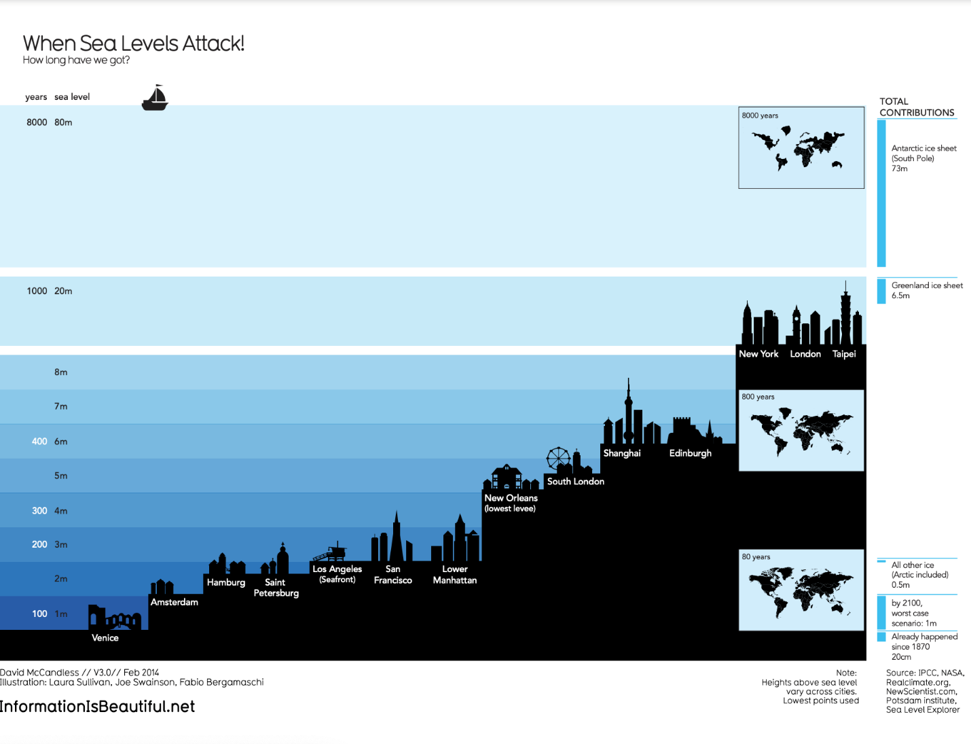demonstrates how much sea levels are projected to rise over the course of 8,000 years. On the y-axis, it lists both the number of years and the sea level in meters. From right to left, starting with the lowest sea level, the chart includes silhouettes of different cities around the world to demonstrate how long it would take for most of the world to be underwater. It also includes inset maps of the continents and how they would appear at different times as sea levels continue to rise.

Save this data visualization as a .pdf by clicking the file below:

[IIB-LICENSED\_Sea-Levels.pdf](https://d3c33hcgiwev3.cloudfront.net/5eB5YE1QSPSgeWBNUKj0MQ_64cb4212fa57404a9a1d0274cc8ae8ba_IIB-LICENSED_Sea-Levels.pdf?Expires=1706832000&Signature=R22bd8j~gTJ0JeIjtuS~DuBgtm4nPuZWyum~1pHMENJt0HtYD3MYNUcj7wrfCi0b~J7x~iuWTIeleJWyTFKN-R33OgTapB1VeQx39d~MWG1afg~6vA4q0olkkmHpwSCgezW6cf5G1NHVVB4jF9U4EA67be6JkpZ8mF47L1OmIlY_&Key-Pair-Id=APKAJLTNE6QMUY6HBC5A" \t "_blank)

[PDF File](https://d3c33hcgiwev3.cloudfront.net/5eB5YE1QSPSgeWBNUKj0MQ_64cb4212fa57404a9a1d0274cc8ae8ba_IIB-LICENSED_Sea-Levels.pdf?Expires=1706832000&Signature=R22bd8j~gTJ0JeIjtuS~DuBgtm4nPuZWyum~1pHMENJt0HtYD3MYNUcj7wrfCi0b~J7x~iuWTIeleJWyTFKN-R33OgTapB1VeQx39d~MWG1afg~6vA4q0olkkmHpwSCgezW6cf5G1NHVVB4jF9U4EA67be6JkpZ8mF47L1OmIlY_&Key-Pair-Id=APKAJLTNE6QMUY6HBC5A" \t "_blank)

**Examine the four elements**

This When Sea Levels Attack visualization illustrates how much sea levels are projected to rise over the course of 8,000 years. The silhouettes of different cities with different sea levels, rising from right to left, helps to drive home how much of the world will be affected as sea levels continue to rise. Here is how this data visualization stacks up using the four elements of successful visualization:

* **Information (data):** This visualization uses climate data on rising sea levels from a variety of sources, including NASA and the Intergovernmental Panel on Climate Change. In addition to that data, it also uses recorded sea levels from around the world to help illustrate how much rising sea levels will affect the world.
* **Story (concept):** The visualization tells a very clear story: Over the course of 8,000 years, much of the world as we know it will be underwater.
* **Goal (function):** The goal of this project is to demonstrate how soon rising sea levels are going to affect us on a global scale. Using both data and the visual form, this visualization makes rising sea levels feel more real to the audience.
* **Visual form (metaphor):** The city silhouettes in this visualization are a beautiful way to drive home the point of the visualization. It gives the audience a metaphor for how rising sea levels will affect the world around them in a way that showing just the raw numbers can’t do. And for a more global perspective, the visualization also uses inset maps.

**Key takeaways**

Notice how each of these visualizations balance all four elements of successful visualization. They clearly incorporate data, use storytelling to make that data meaningful, focus on a specific goal, and structure the data with visual forms to make it beautiful and communicative. The more you practice thinking about these elements, the more you will be able to include them in your own data visualizations.

Hey, welcome back.

We've covered a lot of ground in our exploration of data visualizations.

We've talked a lot about how your audience should be the focus when you

are making decisions about charts, colors, space, labels and

everything else that goes into a data viz.

Now let's talk about design thinking.

Design thinking is a process used to solve complex problems in a user-centric way.

Play video starting at ::25 and follow transcript0:25

When you bring design thinking into your work,

you're trying to identify alternative strategies for

your visualizations that might not be clear right away.

You have to challenge your own thinking and

explore different ways of approaching the problems and finding solutions.

Airbnb is one example of a company that use a design thinking approach to help

their business grow.

When the company a vacation rental online marketplace, wasn't generating as

much revenue as they wanted, they decided to start experimenting.

Even though the data they collected and analyzed was valuable,

they needed to look at their product through the eyes of the customer.

They realized the photos of the places that customers were seeing just weren't

very good, so they decided to help their customers replace the not so

great photos with more professional looking ones.

So they hired a photographer and

went door to door to take professional photos of their New York City listings.

In a week, the listings with these photos saw 2 to 3 times more bookings, and their

revenue nearly doubled, thanks to their new design thinking, user based mindset.

If design thinking can work for companies like Airbnb,

it can help data analysts too, and data visualization is the perfect stage of your

analysis to apply a user based mindset.

Play video starting at :1:45 and follow transcript1:45

If you use design thinking when planning and creating your data viz, you'll be

making decisions based on the needs of the people who will be viewing them.

This way your audience will be engaged and

enlightened by how you visualize your findings.

While the design thinking process comes in lots of different forms,

they all have stages or phases.

We'll talk about five phases that you can use when creating data visualizations,

empathize, define, ideate, prototype, and test.

In the spirit of design thinking,

these phases don't have to follow a set order.

Instead, think of them as an overview of actions that can

help you produce a user centered design in your visualizations.

In the empathize phase you think about the emotions and

needs of the target audience of your data viz, whether it's stakeholders,

team members or the general public.

Here you should avoid areas where people might face obstacles interacting with your

visualizations.

For example, let's say you've been working on an analysis for a pharmaceutical

company about how patients have been responding to a new treatment.

You're getting ready to visualize the data, so you should think about

the audience, which will include stakeholders like pharmacists, doctors and

other medical professionals.

Maybe you're thinking of using a color scheme that you like, but

you realize that these colors might be a challenge to some people.

The colors might be too bright or dramatic, which might not be right for

the seriousness of the data.

Or the colors might not have enough contrast for

people who have color vision deficiencies.

Play video starting at :3:23 and follow transcript3:23

By adjusting the colors,

you'll be empathizing with the needs of your audience.

If there's someone on your team who is vision impaired,

you want to find a way to explain the data verbally as well.

The define phase helps you to find your audiences needs, their problems, and

your insights.

This goes hand in hand with the empathize phase as you'll use what you learned in

that phase to help you spell out exactly what your audience needs

from your visualization.

You could use this phase to think about which data to show in your visualization.

Maybe this data viz will also be presented to patients who are part of your

company's study.

Play video starting at :4:1 and follow transcript4:01

While you'll need to meet your objectives,

there might be data that could make these people uncomfortable.

Play video starting at :4:8 and follow transcript4:08

You can think of ways to position that data to make it more digestible.

Or if you're presenting to different audiences,

you can adjust your visualizations to meet each group's needs by seeking input from

members of the group or colleagues who've worked with that group before.

Play video starting at :4:25 and follow transcript4:25

In the ideate phase, you start to generate your data viz ideas.

You'll use all of your findings from the empathize and

define phases to brainstorm potential data viz solutions.

Play video starting at :4:37 and follow transcript4:37

This might involve creating drafts of your visualization with different color

combinations or maybe experimenting with different shapes.

Creating as many examples as possible will help you refine your ideas.

The key here is to always remember your audience when coming up with ideas and

strategies.

You want to think about how you can position your visualizations to meet

the needs and expectations of your audience.

The final two phases are prototype and test.

Here you'll start putting your charts, dashboards or

other visualizations together.

Play video starting at :5:10 and follow transcript5:10

If you've kept your audience in mind through all the phases to this point,

then your data viz will be informative and approachable.

Play video starting at :5:18 and follow transcript5:18

You might want to create lots of visualizations to choose which one best

meets your objective.

Play video starting at :5:24 and follow transcript5:24

You could test your visualizations by showing them to team members before

presenting them to stakeholders.

If you've created more than one for the same data, or for

different audiences like the medical professionals and

the patients from our earlier example, you can share all of your options.

As always, listen to any feedback you get.

Critiques both your own and others are key to the design thinking process.

They help you keep your focus on the audience by integrating new ideas in your

final product.

The phrase thinking outside the box is used a lot, but

it definitely applies here.

The box in this case is your own usual way of approaching data, and

its visualization.

If you embrace design thinking,

you'll be able to create super effective data viz for any audience.

Up next, we'll cover more things you need to consider within your data viz.

See you there.

**[Optional] Design thinking for visualization improvement**

Design thinking for data visualization involves five phases:

1. **Empathize:** Thinking about the emotions and needs of the target audience for the data visualization
2. **Define:** Figuring out exactly what your audience needs from the data
3. **Ideate:** Generating ideas for data visualization
4. **Prototype:** Putting visualizations together for testing and feedback
5. **Test:** Showing prototype visualizations to people before stakeholders see them

As interactive dashboards become more popular for data visualization, new importance has been placed on efficiency and user-friendliness. In this reading, you will learn how design thinking can improve an interactive dashboard. As a junior analyst, you wouldn’t be expected to create an interactive dashboard on your own, but you can use design thinking to suggest ways that developers can improve data visualizations and dashboards.

**An example: online banking dashboard**

Suppose you are an analyst at a bank that has just released a new dashboard in their online banking application. This section describes how you might explore this dashboard like a new user would, consider a user’s needs, and come up with ideas to improve data visualization in the dashboard. The dashboard in the banking application has the following data visualization elements:

* Monthly spending is shown as a donut chart that reflects different categories like utilities, housing, transportation, education, and groceries.
* When customers set a budget for a category, the donut chart shows filled and unfilled portions in the same view.
* Customers can also set an overall spending limit, and the dashboard will automatically assign the budgeted amounts (unfilled areas of the donut chart) to each category based on past spending trends.

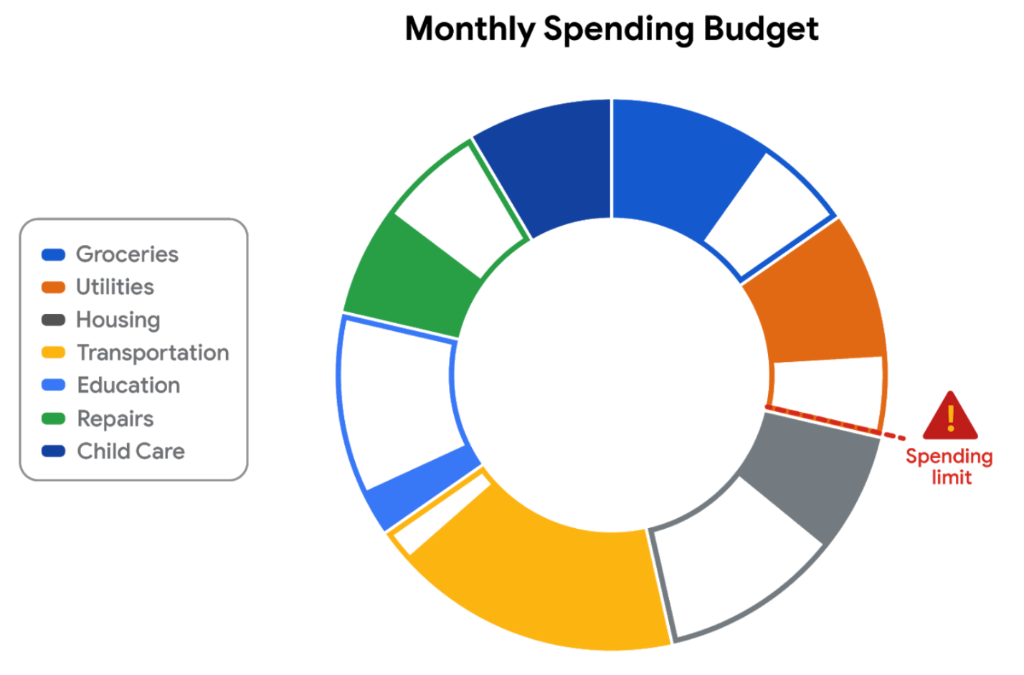

**Empathize**

First, empathize by putting yourself in the shoes of a customer who has a checking account with the bank.

* Do the colors and labels make sense in the visualization?
* How easy is it to set or change a budget?
* When you click on a spending category in the donut chart, are the transactions in the category displayed?

What is the main purpose of the data visualization? If you answered that it was to help customers stay within budget or to save money, you are right! Saving money was a top customer need for the dashboard.

**Define**

Now, imagine that you are helping dashboard designers define other things that customers might want to achieve besides saving money.

What other data visualizations might be needed?

* Track income (in addition to spending).
* Track other spending that doesn’t neatly fit into the set categories (this is sometimes called **discretionary spending**).
* Pay off debt.

Can you think of anything else?

**Ideate**

Next, ideate additional features for the dashboard and share them with the software development team.

* What new data visualizations would help customers?
* Would you recommend bar charts or line charts in addition to the standard donut chart?
* Would you recommend allowing users to create their own (custom) categories?

Can you think of anything else?

**Prototype**

Finally, developers can prototype the next version of the dashboard with new and improved data visualizations.

**Test**

Developers can close the cycle by having you (and others) test the prototype before it is sent to stakeholders for review and approval.

**Key takeaways**

This design thinking example showed how important it is to:

* Understand the needs of users.
* Generate new ideas for data visualizations.
* Make incremental improvements to data visualizations over time.

You can refer to the following articles for more information about design thinking:

* [Three Critical Aspects of Design Thinking for Big Data Solutions](https://dataconomy.com/2019/05/three-critical-aspects-of-design-thinking-for-big-data-solutions/)
* [Data and Design Thinking: Why Use Data in the Design Process?](https://www.enginess.io/insights/data-and-design-thinking)

**1.**

Question 1

Which element of design can add visual form to data and help build the structure of a visualization?

1 point

Movement

Line

Shape

Space

**2.**

Question 2

What term describes how bright or dull a color is within a data visualization?

1 point

Vibrance

Value

Intensity

Hue

**3.**

Question 3

Fill in the blank: Design thinking is a process used to solve complex problems in a \_\_\_\_\_ way.

1 point

linear

prescriptive

technical

user-centric

**4.**

Question 4

While designing a data visualization, you consider whether the colors you chose will be easily viewed and by your stakeholders. What stage of design thinking does this scenario describe?

1 point

Define

Empathize

Test

Ideate

**Pro tips for highlighting key information**

Headlines, subtitles, labels, and annotations help you turn your data visualizations into more meaningful displays. After all, you want to invite your audience into your presentation and keep them engaged. When you present a visualization, they should be able to process and understand the information you are trying to share in the first five seconds. This reading will teach you what you can do to engage your audience immediately.

If you already know what headlines, subtitles, labels and annotations do, go to the guidelines and style checks at the end of this reading. If you don’t, these next sections are for you.

**Headlines that pop**

A **headline** is a line of words printed in large letters at the top of a visualization to communicate what data is being presented. It is the attention grabber that makes your audience want to read more. Here are some examples:

* [Which Generation Controls the Senate?](https://i.redd.it/rw0vrjakuoc61.png): This headline immediately generates curiosity. Refer to the [subreddit post](https://www.reddit.com/r/dataisbeautiful/comments/l1yly6/oc_which_generation_controls_the_senate/) in the dataisbeautiful community, r/dataisbeautiful, on January 21, 2021.
* [Top 10 coffee producers](https://ichef.bbci.co.uk/news/976/cpsprodpb/65D8/production/_100827062_chart-globalcoffeeproduction-iskhe-nc.png): This headline immediately informs how many coffee producers are ranked. Read the full article: [bbc.com/news/business-43742686](https://www.bbc.com/news/business-43742686).

Check out the chart below. Can you identify what type of data is being represented? Without a headline, it can be hard to figure out what data is being presented. A graph like the one below could be anything from average rents in the tri-city area, to sales of competing products, or daily absences at the local elementary, middle, and high schools.

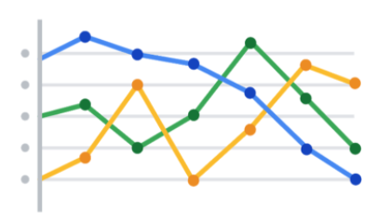

Turns out, this illustration is showing average rents in the tri-city area. So, let’s add a headline to make that clear to the audience. Adding the headline, “**Average Rents in the Tri-City Area**” above the line chart instantly informs the audience what it is comparing.

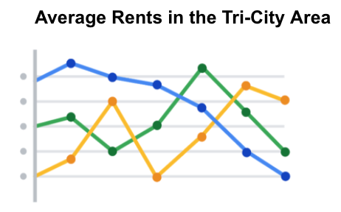

**Subtitles that clarify**

A **subtitle** supports the headline by adding more context and description. Adding a subtitle will help the audience better understand the details associated with your chart. Typically, the text for subtitles has a smaller font size than the headline.

In the average rents chart, it is unclear from the headline “**Average Rents in the Tri-City Area**”which cities are being described. There are tri-cities near San Diego, California (Oceanside, Vista, and Carlsbad), tri-cities in the San Francisco Bay Area (Fremont, Newark, and Union City), tri-cities in North Carolina (Raleigh, Durham, and Chapel Hill), and tri-cities in the United Arab Emirates (Dubai, Ajman, and Sharjah).

We are actually reporting the data for the tri-city area near San Diego. So adding “**Oceanside, Vista, and Carlsbad**” becomes the subtitle in this case. This subtitle enables the audience to quickly identify which cities the data reflects.

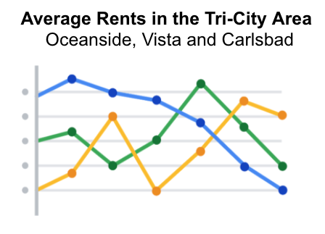

**Labels that identify**

A **label** in a visualization identifies data in relation to other data. Most commonly, labels in a chart identify what the x-axis and y-axis show. Always make sure you label your axes. We can add “**Months (January - June 2020)**” for the x-axis and “**Average Monthly Rents ($)**” for the y-axis in the average rents chart.

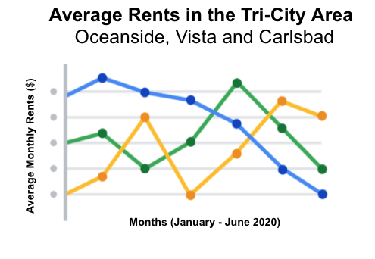

Data can also be labeled directly in a chart instead of through a chart legend. This makes it easier for the audience to understand data points without having to look up symbols or interpret the color coding in a legend.

We can add direct labels in the average rents chart. The audience can then identify the data for Oceanside in yellow, the data for Carlsbad in green, and the data for Vista in blue.

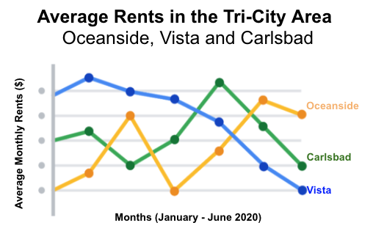

**Annotations that focus**

An **annotation** briefly explains data or helps focus the audience on a particular aspect of the data in a visualization.

Suppose in the average rents chart that we want the audience to pay attention to the rents at their highs. Annotating the data points representing the highest average rents will help people focus on those values for each city.

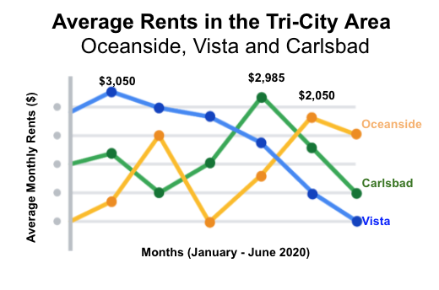

**Guidelines and pro tips**

Refer to the following table for recommended guidelines and style checks for headlines, subtitles, labels, and annotations in your data visualizations. Think of these guidelines as guardrails. Sometimes data visualizations can become too crowded or busy. When this happens, the audience can get confused or distracted by elements that aren’t really necessary. The guidelines will help keep your data visualizations simple, and the style checks will help make your data visualizations more elegant.

| **Visualization components** | **Guidelines** | **Style checks** |
| --- | --- | --- |
| Headlines | - **Content**: Briefly describe the data - **Length**: Usually the width of the data frame - **Position**: Above the data | - Use brief language - Don’t use all caps - Don’t use italic - Don’t use acronyms - Don't use abbreviations - Don’t use humor or sarcasm |
| Subtitles | - **Content**: Clarify context for the data - **Length**: Same as or shorter than headline - **Position**: Directly below the headline | - Use smaller font size than headline - Don’t use undefined words - Don’t use all caps, bold, or italic - Don’t use acronyms - Don't use abbreviations |
| Labels | - **Content**: Replace the need for legends - **Length**: Usually fewer than 30 characters - **Position**: Next to data or below or beside axes | - Use a few words only - Use thoughtful color-coding - Use callouts to point to the data - Don’t use all caps, bold, or italic |
| Annotations | - **Content**: Draw attention to certain data - **Length**: Varies, limited by open space - **Position**: Immediately next to data annotated | - Don’t use all caps, bold, or italic - Don't use rotated text - Don’t distract viewers from the data |

**Key takeaways**

You want to be informative without getting too detailed. To meaningfully communicate the results of your data analysis, use the right visualization components with the right style. In other words, let simplicity and elegance work together to help your audience process the data you are sharing in five seconds or less.

Hey, great to have you back, let's dive back in.

Over 1 billion people in the world have a disability.

That's more than the populations of the United States, Canada,

France, Italy, Japan, Mexico, and Brazil combined.

Before you design a data viz, it's important to keep that fact in mind.

Not everyone has the same abilities, and

people take in information in lots of different ways.

You might have a viewer who's deaf or hard of hearing and relies on captions, or

someone who's color blind might look to specific labeling for more description.

We've covered a lot of ways to make a data visualization beautiful and informative.

And now it's time to take that knowledge and make it accessible to everyone,

including those with disabilities.

Accessibility can be defined a number of different ways.

Right from the start,

there's a few ways you can incorporate accessibility in your data visualization.

You'll just have to think a little differently,

it helps to label data directly instead of relying exclusively on legends,

which require color interpretation and more effort by the viewer to understand.

This can also just make it a faster read for those with or without disabilities.

Check out this data viz, the colors make it challenging to read and

the legend is confusing.

Now, if we just remove the legend and add in data labels, bam,

you've got a clearer presentation.

Another way to make your visualizations more accessible is to provide text

alternatives, so that it can be changed into other forms people need,

such as large print, braille, or speech.

Alternative text provides a textual alternative to non-text content.

It allows the content and function of the image to be accessible to those with

visual or certain cognitive disabilities.

Here's an example that shows additional text describing the chart.

And speaking of text, you can make data from charts and

diagrams available in a text-based format through an export to Sheets or Excel.

You can also make it easier for

people to see and hear content by separating foreground from background.

Using bright colors,

that contrast against the background can help those with poor visibility,

whether permanently or temporarily clearly see the information conveyed.

Another option is to avoid relying solely on color to convey information,

and instead distinguished with different textures and shapes.

Another general rule is to avoid over complicating data visualizations.

Overly complicated data visualizations turn off most audiences

because they can't figure out where and what to focus on.

That's why breaking down data into simple visualizations is key.

A common mistake is including too much information in a single piece, or

including long chunks, of text or too much information and graphs and charts.

This can defeat the whole purpose of your visualization,

making it impossible to understand at first glance.

Ultimately, designing with an accessibility mindset means thinking about

your audience ahead of time.

Focusing on simple, easy to understand visuals, and most importantly, creating

alternative ways for your audience to access and interact with your data.

And when you pay attention to these details, we can find solutions that make

data visualizations more effective for everyone.

So now you completed your first course of exploration of data visualization.

You've discovered the importance of creating data viz that cater to your

audience while keeping focus on the objective.

You learn different ways to brainstorm and plan your visualizations, and

how to choose the best charts to meet that objective.

And you also learned how to incorporate elements of science, art and

even philosophy into your visualizations.

Coming up we'll check out how to take all of these learnings and

apply them in Tableau.

You'll get to see how this data visualization tool makes your data viz

work more efficient and effective.

See you soon.

[MUSIC]

I'm Andrew and I'm a data and Insights Manager on the ads research Insights Team.

What does that actually mean?

I help my company Google, make better decisions through data and

I also work with our data to tell stories for marketers.

Basically data storytelling at scale.

Accessibility should be built into everything we do.

Accessibility is really about making sure that you are creating data visualization,

graphs, charts, tables, that anyone can interact with whether they

have a long term or even as a temporary form of impairment.

It could be auditory, it could be visual, could be sensory in some way.

Typically the ones we talked about in data visualization have to deal with color and

contrast.

Or maybe they can't see.

So there's a number of things you can do any visualizations as you're getting,

ready to show people and bring it out into the world.

To make it easier for them to understand your graph, and understand the points

you're trying to make, and just to make yourself more inclusive, you're going

to create this stuff and you're not going to be the one presenting it anymore.

It's going to show up in a place where you won't be the one being able to navigate

the data for people and frame it for people.

And that's a good thing.

But as it moves further away from you,

you also won't be there standing by it being able to explain it to people and

be like, hey, here's the point, or, hey, maybe you can't read or see this or

maybe these colors are confusing, let me make sure that you got the point clearly.

It's just a way of making sure that everyone in the room is

able to experience the thing you've worked so hard on and able to take away the point

in a clear way that they too, can basically take action on the data that

you spent all this time working with and making you know presentable for folks.

So all these things, they're great for accessibility and

they're more inclusive but they're also this making you a better data analyst and

a better storyteller, because they force you to

become more empathetic of your audience and who's receiving your data.

You're making this to move the hearts and minds of other people to convince someone

else that this data is meaningful to them and they should take an action on it.

Or they should know this and they should use this for the organization or for

their lives or for whatever the thing may be.

And so, by focusing on accessibility, by focusing on the audience, by making it

more inclusive, you're making your data clear and more impactful for everyone.

**Design a chart in 60 minutes**

By now, you understand the principles of design and how to think like a designer. Among the many options of data visualization is creating a **chart**, which is a graphical representation of data.

Choosing to represent your data via a chart is usually the most simple and efficient method. Let’s go through the entire process of creating any type of chart in 60 minutes. The goal here is to develop a prototype or mock up of your chart that you can quickly present to an audience. This will also enable you to have a sense of whether or not the chart is communicating the information that you want.

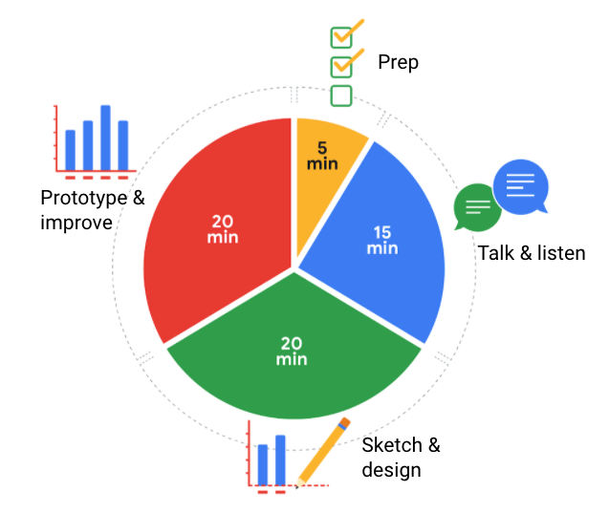5 minutes- prep 15 minutes- talk & listen 20 minutes- prototype & improve 20 minutes- sketch & design

Follow this high level 60-minute chart to guide your thinking whenever you begin working on a data visualization.

**Prep (5 min):** Create the mental and physical space necessary for an environment of comprehensive thinking. This means allowing yourself room to brainstorm *how* you want your data to appear while considering the amount and type of data that you have.

**Talk and listen (15 min):** Identify the object of your work by getting to the “ask behind the ask” and establishing expectations. Ask questions and really concentrate on feedback from stakeholders regarding your projects to help you hone how to lay out your data.

**Sketch and design (20 min):** Draft your approach to the problem. Define the timing and output of your work to get a clear and concise idea of what you are crafting.

**Prototype and improve (20 min):** Generate a visual solution and gauge its effectiveness at accurately communicating your data. Take your time and repeat the process until a final visual is produced. It is alright if you go through several visuals until you find the perfect fit.

**Key takeaways**

This is a great overview you can use when you need to create a visualization in a short amount of time. As you become more experienced in data visualization, you will find yourself creating your own process. You will get a more detailed description of different visualization options in the next reading, including line charts, bar charts, scatterplots, and more. No matter what you choose, always remember to take the time to prep, identify your objective, take in feedback, design, and create.

**1.**

Question 1

What are the three basic visualization considerations? Select all that apply.

1 point

Labels

Headlines

Text

Subtitles

**2.**

Question 2

Directly labeling a data visualization helps viewers identify data more efficiently. Legends are often less effective because they are positioned away from the data.

1 point

True

False

**3.**

Question 3

Why do data analysts use alternative text to make their data visualizations more accessible?

1 point

To make the presentation of data clearer

To add context to the data visualization

To make data visualizations easier to read

To provide a textual alternative to non-text content

**4.**

Question 4

You are creating a data visualization and want to ensure it is accessible. What strategies do you use to make your visualization available to a wider audience? Select all that apply.

1 point

Simplify your visualization

Do not include labels

Focus on necessary information over long chunks of text

Avoid overly complicated charts

# Glossary terms from module 1

## ****Terms and definitions for Course 6, Module 1****

**Alternative text:** Text that provides an alternative to non-text content, such as images and videos

**Annotation:** Text that briefly explains data or helps focus the audience on a particular aspect of the data in a visualization

**AVERAGEIF:** A spreadsheet function that returns the average of all cell values from a given range that meet a specified condition

**Balance:** The design principle of creating aesthetic appeal and clarity in a data visualization by evenly distributing visual elements

**Bar graph:** A data visualization that uses size to contrast and compare two or more values

**Calculus:** A branch of mathematics that involves the study of rates of change and the changes between values that are related by a function

**Causation:** When an action directly leads to an outcome, such as a cause-effect relationship

**Channel:** A visual aspect or variable that represents characteristics of the data in a visualization

**Chart:** A graphical representation of data from a worksheet

**Cluster:** A collection of data points on a data visualization with similar values

**CONVERT:** A SQL function that changes the unit of measurement of a value in data

**Correlation:** The measure of the degree to which two variables change in relationship to each other

**CREATE TABLE:** A SQL clause that adds a temporary table to a database that can be used by multiple people

**Data composition:** The process of combining the individual parts in a visualization and displaying them together as a whole

**Decision tree**: A tool that helps analysts make decisions about critical features of a visualization

**Design thinking:** A process used to solve complex problems in a user-centric way

**Distribution graph:** A data visualization that displays the frequency of various outcomes in a sample

**DROP TABLE:** A SQL clause that removes a temporary table from a database

**Dynamic visualizations:** Data visualizations that are interactive or change over time

**Emphasis:** The design principle of arranging visual elements to focus the audience’s attention on important information in a data visualization

**HAVING:** A SQL clause that adds a filter to a query instead of the underlying table that can only be used with aggregate functions

**Headline:** Text at the top of a visualization that communicates the data being presented

**Heat map:** A data visualization that uses color contrast to compare categories in a dataset

**Histogram:** A data visualization that shows how often data values fall into certain ranges

**Inner query:** A SQL subquery that is inside of another SQL statement

**Label:** Text in a visualization that identifies a value or describes a scale

**Legend:** A tool that identifies the meaning of various elements in a data visualization

**Line graph:** A data visualization that uses one or more lines to display shifts or changes in data over time

**Map:** A data visualization that organizes data geographically

**Mark:** A visual object in a data visualization such as a point, line, or shape

**MAXIFS:** A spreadsheet function that returns the maximum value from a given range that meets a specified condition

**Mental model:** A data analyst’s thought process and approach to a problem

**Movement:** The design principle of arranging visual elements to guide the audience’s eyes from one part of a data visualization to another

**MINIFS:** A spreadsheet function that returns the minimum value from a given range that meets a specified condition

**Narrative:** (Refer to story)

**Ordinal data:** Qualitative data with a set order or scale

**Pattern:** The design principle of using similar visual elements to demonstrate trends and relationships in a data visualization

**Pie chart:** A data visualization that uses segments of a circle to represent the proportions of each data category compared to the whole

**Pre-attentive attributes:** The elements of a data visualization that an audience recognizes automatically without conscious effort

**Proportion:** The design principle of using the relative size and arrangement of visual elements to demonstrate information in a data visualization

**R:** A programming language used for statistical analysis, visualization, and other data analysis

**Ranking:** A system to position values of a dataset within a scale of achievement or status

**Relativity:** The process of considering observations in relation or proportion to something else

**Repetition:** The design principle of repeating visual elements to demonstrate meaning in a data visualization

**Rhythm:** The design principle of creating movement and flow in a data visualization to engage an audience

**Scatterplot:** A data visualization that represents relationships between different variables with individual data points without a connecting line

**SELECT INTO:** A SQL clause that copies data from one table into a temporary table without adding the new table to the database

**Sort range:** A spreadsheet menu function that sorts a specified range and preserves the cells outside the range

**Sort sheet:** A spreadsheet menu function that sorts all data by the ranking of a specific sorted column and keeps data together across rows

**Static visualization:** A data visualization that does not change over time unless it is edited

**Story:** The narrative of a data presentation that makes it meaningful and interesting

**Subtitle:** Text that supports a headline by adding context and description

**Tableau:** A business intelligence and analytics platform that helps people visualize, understand, and make decisions with data

**Unity:** The design principle of using visual elements that complement each other to create aesthetic appeal and clarity in a data visualization

**Variety:** The design principle of using different kinds of visual elements in a data visualization to engage an audience

**Visual form:** The appearance of a data visualization that gives it structure and aesthetic appeal

**X-axis:** The horizontal line of a graph usually placed at the bottom, which is often used to represent time scales and discrete categories

**Y-axis:** The vertical line of a graph usually placed to the left, which is often used to represent frequencies and other numerical variables

**1.**

Question 1

Fill in the blank: A data professional includes \_\_\_\_\_ visualizations in a presentation because stakeholders do not want the visualizations to change unless they choose to edit them.

1 point

interactive

static

linked

dynamic

**2.**

Question 2

You are a junior data analyst at a web design firm presenting new website features to a client. The client team represents a broad audience of people. What steps should you take to help your visualizations be accessible to everyone? Select all that apply.

1 point

Label data directly whenever possible

Provide text alternatives

Minimize contrast between colors

Reduce the amount of information in the presentation

**3.**

Question 3

A data analyst in application engineering visualizes the response times of a web server. The graphic represents how often the data values fall into certain ranges. What type of visualization have they created?

1 point

Bar graph

Histogram

Venn diagram

Pie chart

**4.**

Question 4

A data professional working for a tea shop finds that customers are more likely to purchase hot beverages on cold days. They discover this because two variables in their data rise and fall at the same time. What is this an example of?

1 point

Tabulation

Causation

Correlation

Visualization

**5.**

Question 5

Which of the following statements accurately describe key elements of data visualizations? Select all that apply.

1 point

Lines in visualizations must be straight.

Shapes in visualizations should always be two-dimensional.

The hue of a color is basically its name, such as green or blue.

Lines can be used to help build the structure for a visualization.

**6.**

Question 6

While creating a chart, a data analyst chooses a darker shade for outliers and a lighter tint for data points that are above or below a certain threshold. Which element of effective visualization does this describe?

1 point

Subtitles

Clear meaning

Sophisticated use of contrast

Refined execution

**7.**

Question 7

Fill in the blank: Donut charts use \_\_\_\_\_ to combine the individual parts in a visualization and display them together as a whole.

1 point

sizing

data composition

color shading

patterns

**8.**

Question 8

Which of the following statements correctly describe bar graphs? Select all that apply.

1 point

Bar graphs use size contrast to compare two or more values.

Bar graphs use smoothing to represent a trend.

The y-axis of a bar graph usually has a scale of values for the variables.

In a bar graph, the horizontal line is usually placed at the bottom, and the vertical line is placed to the left.

Hello again. We've already discussed how helpful data

visualizations can be when we want to fit

a lot of knowledge into a small space.

Now it's time to explore a powerful tool that can help

you create these visualizations

and bring your data to life.

It's called Tableau, a visual analytics platform that

makes it a lot easier to explore and manage data.

You might remember hearing a bit about

Tableau in some of our earlier discussions,

but you're about to discover even more.

Plus, when you get comfortable with Tableau,

you'll find it even easier to use similar tools,

giving you another skill

that will help you stand out in the job hunt.

Coming up, we'll cover some of

the features that make Tableau

effective for visualizations and

why it's used across industries.

After that, the fun really starts.

We'll jump right in and explore the Tableau interface,

identifying and applying

the various tools it has to offer.

I'll show you how to add

data sources, control visual elements,

and work with a variety of features

that will make your visualization really powerful.

Like any software platform,

there's some best practices to keep in mind.

So I'll show you some examples of the

good and the bad when it comes to visualizations.

We'll also get creative using

color vision deficiency palettes to

make our visualizations more accessible,

and we'll show you how multiple data sources can

be combined to tell a more comprehensive story.

By the time we wrap up here,

you'll be able to publish your own visualizations

on Tableau.

I am so excited to lead you on this Tableau tour.

It's another useful tool that

you'll be able to turn to as

a future data analyst so that

you can visualize and published data you care about.

After all, data has a story,

and this is your chance to share it with others.

All right, let's discover what it's all about.

Welcome back.

Mastering online tools like Tableau will make it easier for your audience to

understand difficult concepts or identify new patterns in your data.

Need to help a news outlet showcase changing real estate prices in regional

markets?

Check.

Want to help a nonprofit use their data in better ways to streamline operations?

Check.

Play video starting at ::23 and follow transcript0:23

Need to explore what video games sales look like over the past few decades?

Double check many different kinds of companies are using Tableau right now to

do all of these things and more.

This means there's a good chance you'll end up using it at some point.

in your career.

But I'm getting ahead of myself.

First, let's talk about what Tableau actually is.

You might remember learning that Tableau is a business intelligence and

analytics platform that you can use online to help people see,

understand, and make decisions with data.

But it's not all business all the time.

Take this data viz, for example,

created by Tableau enthusiast Steve Thomas to record Bigfoot sightings across the US.

It's available on Tableau

Public, which will be using together in our activities in this course

Tableau can help you make and easily share interactive dashboards,

maps, and graphs with your data.

Without any coding, you can connect to data and lots of formats like Excel,

CSV, and Google Sheets.

You might also find yourself working with a company that uses another option,

like Looker or Google Data Studio. for example. Like Tableau, Looker and

Google Data Studio help you take raw data and bring it to life visually,

but each does this in different ways.

For example, while Tableau's offered in a variety of formats like browser and

desktop, Looker and Google Data Studio are completely browser-based.

But here's the great news.

Once you learn the fundamentals of Tableau,

you'll find they easily transfer to other visualization tools,

Ready to get started using it? Then, without further ado, meet Tableau up next.

**Begin to use Tableau Public**

As you’ve been learning, Tableau is a powerful data visualization tool used by data professionals around the world. Tableau offers a free browser version of its software, Tableau Public, which enables learners like you to try out its capabilities. Tableau Public is the software you will use throughout this course on data visualization. In this reading, you will sign up (if you haven’t already done so) and log in to Tableau Public. Then, you’ll be guided through the Tableau Public platform and account features.

**Sign in to Tableau Public**

**Sign in with an existing account**

If you already have a Tableau.com account, use your existing login credentials to sign in to Tableau Public. Click [here](https://community.tableau.com/s/tableau-public-faq#subhead6) to learn more. If this is your first time signing in to Tableau Public with your Tableau.com account, set an account password by resetting your password. To do so, select [reset password](https://id.tableau.com/resetPassword).

**Sign in for the first time**

If you do not yet have a pre-existing Tableau.com or Tableau Public account, use these instructions to create one. If you have a Tableau Public account, skip ahead to the “Navigate Tableau Public” section

First, go to the [Tableau Public home page](https://public.tableau.com/). If this link does not open to the Tableau Public homepage, enter public.tableau.com in your browser’s address bar.

**Note:** Tableau Public works best on Chrome (Windows, Mac, Android), Edge (Windows), Firefox (Windows and Mac), Safari (Mac and IOS).

Next, click **Sign Up for Tableau Public**.

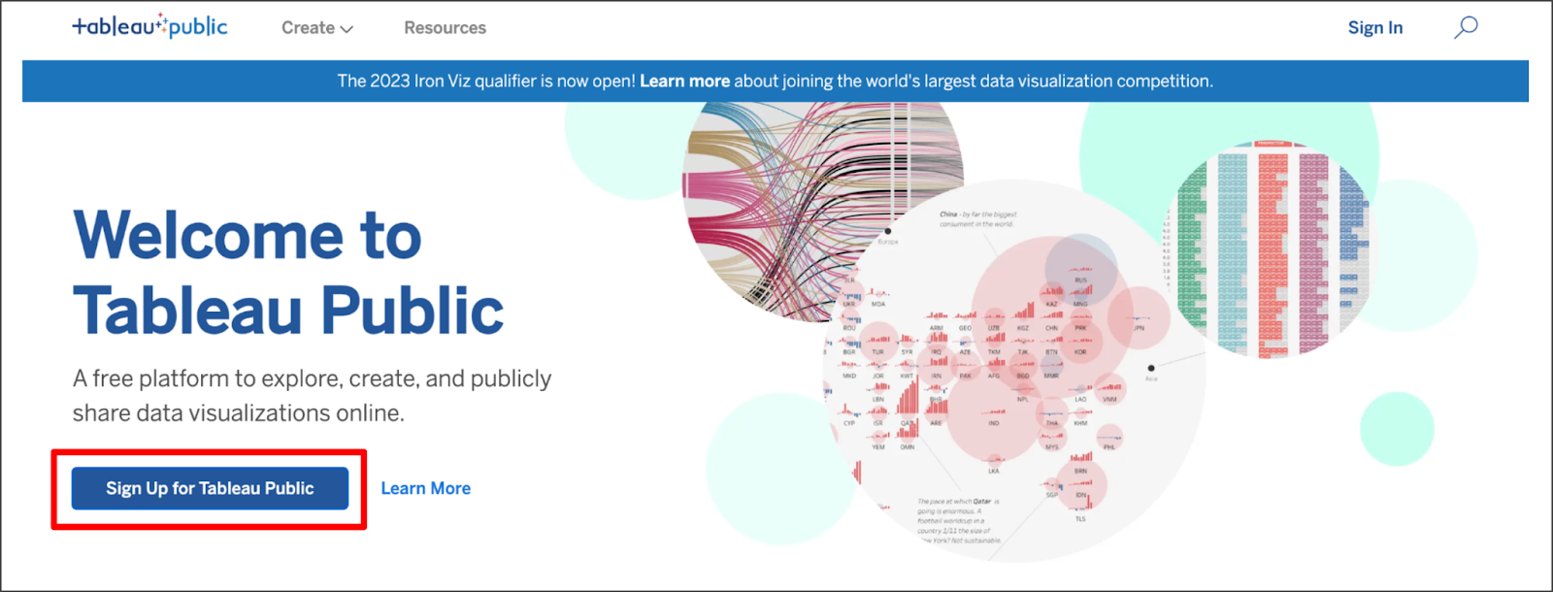This is a free platform to explore, create, and publicly share data visualizations online. There is a hyperlink option to learn more.

Fill in all the required fields and click **Create My Account**.

**Navigate Tableau Public**

The Tableau Public home page contains resources and guides to help data professionals learn more about and get inspired by data visualizations. You can explore any and all of the links on this landing page to help enhance your knowledge of Tableau. If you’re new to Tableau Public, the most helpful place to start is the Learn page, which has how-to videos, (free to use) sample data, and user forums.

**Access My Profile**

During this course, the instructor will give you the opportunity to log in to Tableau Public and follow along in the creation of a data visualization. Select the user symbol icon on the Tableau Public homepage then **My Profile** from the dropdown menu to get started.

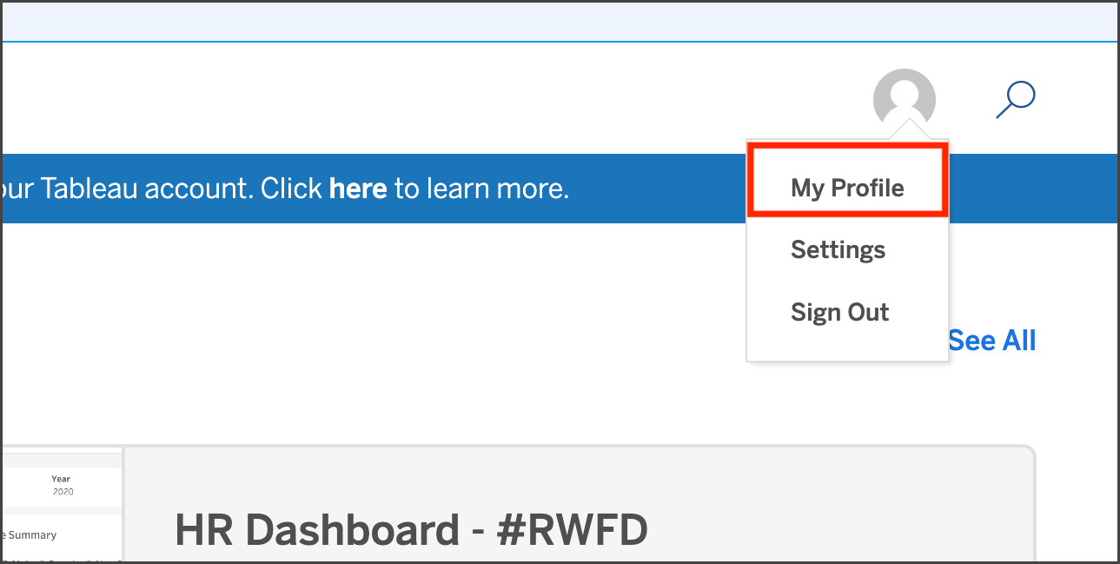

**Create a Viz**

Within your Tableau Public profile, you’ll find tabs for **Vizzes**, **Favorites**, **Following**, and **Followers**. If you haven’t created a public viz yet, there are two buttons in the **Vizzes** tab: **Create a Viz** and **Explore Sample Data**. Selecting the Explore Sample Data button is a great way to try out the tool on your own and test how the software works in a sandbox-like environment. There is also a **Create a Viz** button at the upper right of the page. At the instructor’s prompt, select either of the two **Create a Viz** buttons.

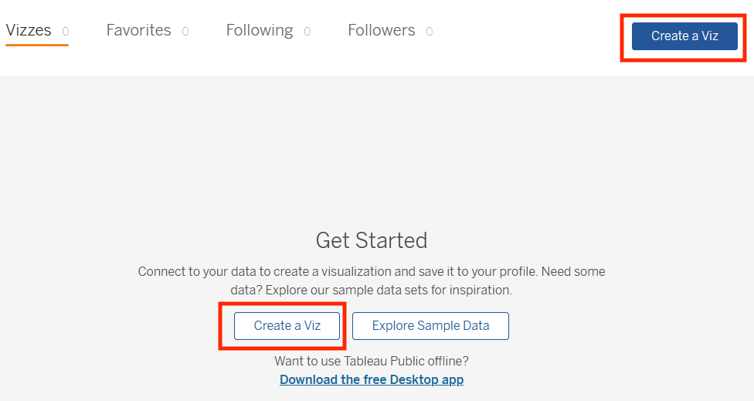The text on this page reads: Connect to your data to create a visualization and save it to your profile. Need some data? Explore our sample data sets for inspiration. Want to use Tableau Public offline? There is a hyperlink to Download the free Desktop app.

After you select **Create a Viz**, you will be directed to a screen that asks you to connect to data. Tableau Public needs data to work with, such as a spreadsheet, .json, or .csv file, for example. When prompted by the instructor, upload the data provided using the **Connect to Data** screen. You can also use any of the sample data that you find in the [Learn](https://public.tableau.com/app/learn/sample-data) area.

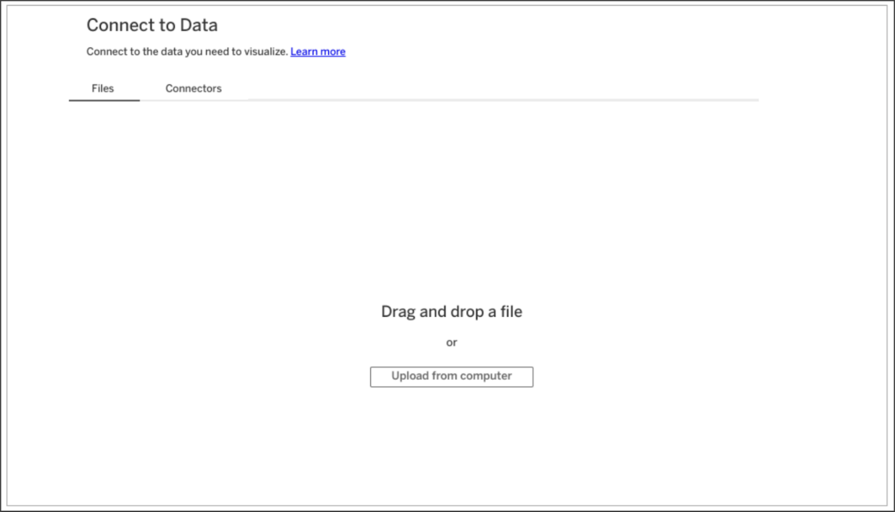The Connect to Data screen. Connect to the data you need to visualize. There is a hyperlink to Learn more. The Files tab is open, where you can drag and drop a file or upload from computer.

After you upload data, you are ready to start designing data visualizations. Happy designing, future Viz Whiz!

**Key takeaways**

Now that you’ve completed this reading, you should be able to access Tableau Public with your own account, navigate the Tableau Public resources, and connect to data. These are your first steps to learning how to design data visualizations with Tableau!

**Resources for more information**

To help you troubleshoot or to learn more, explore the following links:

* Tableau Public not working? Check out these [Technical specifications and storage requirements](https://www.tableau.com/products/techspecs#public).
* [The Tableau Public Discover page](https://public.tableau.com/app/discover) includes ‘Viz of the Day’ and other beautiful vizzes designed on the platform.
* [Google Career Certificates](https://public.tableau.com/profile/grow.with.google#!/) page on Tableau Public: This gallery contains all the visualizations created in the video lessons so you can explore these examples more in-depth.
* [Tableau Public resources page](https://public.tableau.com/app/learn/community-resources): This links to the resources page, including some how-to videos and sample data.
* [Tableau Accessibility FAQ](https://community.tableau.com/s/question/0D54T00000C6nsjSAB/faq-accessibility?_ga=2.189822891.1471813031.1653667812-1362170659.1601475625): Access resources about accessibility in Tableau visualizations using the FAQ, which includes links to blog posts, community forums, and tips for new users.
* [Tableau community forum](https://community.tableau.com/s/): Search for answers and connect with other users in the community on the forum page.
* [Build Your Data Literacy course](https://trailhead.salesforce.com/en/content/learn/trails/build-your-data-literacy): Build your data literacy skills in order to interpret, explore, and communicate effectively with data.

Hello, and welcome to the intersection of analytics and

art, the place where data analysts like me go to unleash the true

potential of data with meaningful visuals, and

the place where future data analysts like you can also go to learn how to do this.

Welcome to Tableau,

one of the many visualization platforms that helps you do more with your data.

When you turn data into a visualization, you get to watch it transform

before your eyes into a meaningful story that people can connect to and care about.

Visualizations in Tableau are dynamic, not static.

As a quick refresher, dynamic visualizations are interactive or

change with time.

The interactive nature of these graphics means your audience has some control over

what they see, and you have incredible flexibility with how you create them.

So let's create our own visualization using a preloaded table on Tableau Public.

It's important to note that there's

different ways to create visualizations in Tableau.

Tableau has a few different offerings, but for

this course we're using Tableau Public in browser, which is free.

Play video starting at :1:17 and follow transcript1:17

One cool thing about Tableau Public is the public gallery with data viz examples

from across the web.

For now, you'll be working with one of these examples from the gallery.

You'll be copying over data workbooks to your own profile to start creating and

publishing visualizations.

Play video starting at :1:37 and follow transcript1:37

To get started, sign into your Tableau Public account.

You can check out an earlier reading for more details.

Then, to access the Workbook, open the Google Career Certificates page on

Tableau Public by clicking the link included in this video and

the reading from earlier.

This opens a new tab that is still linked to your account.

Play video starting at :2: and follow transcript2:00

Here's what the page should look like.

Play video starting at :2:3 and follow transcript2:03

There are a few workbooks loaded up with different data sets that you can save to

your own profile.

These are a great starting point for creating your own visualizations.

There will also be a resource following this video that goes through how to

download Tableau and load your own data.

But for now, let's use this gallery as a starting point.

Now click to view the workbook titled, Just the Data- World Happiness.

Play video starting at :2:32 and follow transcript2:32

This brings up the data table we use to help create the World Happiness data viz

that's in the gallery.

Next, go to the menu in the upper right corner and click Make a copy.

At this point, Tableau will save a copy of this workbook to your own profile,

so you can create your own visualizations.

Play video starting at :2:53 and follow transcript2:53

Now that you're working in your own copy, create a new worksheet so

you can build a data viz from scratch.

You'll click on Worksheet in the top menu, and then New Worksheet.

To start building your data viz, add Country as a detail in the marks shelf.

You can do this by dragging the Country table over to the Detail icon.

Play video starting at :3:17 and follow transcript3:17

This sets up your viz as a world map to represent the data in the table.

Play video starting at :3:23 and follow transcript3:23

Next, add the Happiness Score to the color on the mark shelf.

This applies a color scheme to the viz, in this case, shades of blue.

This range of colors doesn't offer a lot of contrast,

especially for people with color vision deficiencies.

So to adjust the colors, click the Color menu and click Edit Colors.

Then change the color scheme to Green-Blue Diverging and check the box for

stepped colors, which shows a clearer difference between the highest and

lowest happiness score.

Darker blue means a higher happiness score,

whereas darker green relates to a lower happiness score.

You can see this broken down in the scale, so

with just a couple of steps we have an interesting visualization that

shows happiness data in a way that's easy to digest.

The countries and colors on the map are readable and offer some great insights.

But let's keep going so

we can explore more Tableau features to refine your data viz.

Because there are three years of data in the table we're using,

you can filter the data to only include 2016.

Using multiple years can also be useful depending on your objective.

Regardless, you have lots of options for filtering.

So we'll add Year to the filter shelf.

Play video starting at :4:46 and follow transcript4:46

Then we'll choose to filter by year.

Play video starting at :4:52 and follow transcript4:52

And we'll select 2016.

Play video starting at :4:56 and follow transcript4:56

Let's focus our visualization on one region, the European region.

To do this, move your cursor to find the view toolbar.

Play video starting at :5:6 and follow transcript5:06

Use the tools in this toolbar to pan to and zoom in on the European region.

This takes some time and practice.

Once you have a pretty good view of Europe and its surrounding areas,

use the shape tools in the same toolbar to select as much of Europe as you can.

Since we're practicing,

make your best guess if you're not sure which countries to include.

If you were working on a visualization that you were going to share with others,

you'd want to double check that it was accurate.

Hover your cursor over one of the countries and it shows you data about that

specific country, as well as all the countries you've selected in the region.

Play video starting at :5:47 and follow transcript5:47

Then, use the Lasso selection tool to select just a few countries like this.

Play video starting at :5:53 and follow transcript5:53

Keep Only, this applies another filter,

this time to the country you're including in your viz.

Play video starting at :6:2 and follow transcript6:02

You'll notice that the color scheme of these countries is updated.

This reflects that the range of colors is now only being applied to these countries.

Countries in this region might have been in the same part of

the range when compared to the rest of the world, but now they're in different parts

because the data being measured is specific to this region.

Play video starting at :6:23 and follow transcript6:23

To make your viz even better, add the Happiness Score as a label in the map.

You can now see a happiness score for each country on the map.

This adds an extra layer of detail to the viz,

to help make a connection to the actual data.

There's an option to change the data type of the happiness scores from decimals

to whole numbers.

But when you do this,

you lose the contrast that the values with the decimals offers.

So change it back to show the happiness score as a decimal.

Play video starting at :6:57 and follow transcript6:57

Now, to make it even more interactive, let's add a filter with a slider.

This will allow your audience to filter by happiness score, so

they can focus on fewer countries.

But first, let's bring in more of the map we started with.

To do this, hover on the map, and

select the zoom home icon in the toolbar to reveal more countries on the map.

Play video starting at :7:19 and follow transcript7:19

Next we're going to add Happiness Score to the filter shelf.

We'll select All Values and click Next.

Play video starting at :7:28 and follow transcript7:28

Then for the range of values, we'll click OK, to accept the default settings.

In the filter shelf, click the drop down to open the menu for

the Happiness Score and select Show Filter.

Play video starting at :7:42 and follow transcript7:42

If we select the drop down for the menu again,

we can confirm that Show Filter has a checkmark next to it.

You can toggle the checkmark to display or not display the filter.

Play video starting at :7:55 and follow transcript7:55

When show filter is marked, a slider is displayed to the right of the map.

Now try filtering to show a happiness score of 6.0 or below.

And there you have it,

our first visualization based on data we brought in from an external source.

Pretty powerful, right?

We'll save our viz so we can admire it anytime we want to, and

maybe even practice using the Tableau tools with it.

It's always important to save your work,

but make sure not to include any personal information in your file name.

All of the data visualizations created in Tableau Public are visible to, well,

the public.

You can also keep your visualizations hidden, you'll see

the eye with a slash through it on your viz, and the viz will remain hidden.

It's up to you, but lots of data viz created by users like you, are viewable.

In fact, you can easily check them out by searching on Tableau Public.

Then you can search for any kind of data viz,

including World Happiness visualizations.

You'll come across all types of data viz, many with advanced settings.

Some of the examples you'll find in the gallery are stronger than others.

Coming up, we'll talk about effective data visualizations and

some ways you can make your data viz work even stronger.

See you soon.

**Visualizations in spreadsheets and Tableau**

This reading summarizes the seven primary chart types: column, line, pie, horizontal bar, area, scatter, and combo. Then, it describes how visualizations in spreadsheets compare to those in Tableau.

**Primary chart types in spreadsheets**

In spreadsheets, **charts** are graphical representations of data from one or more sheets. Although there are many variations to choose from, we will focus on the most broadly applicable charts to give you a sense of what is possible in a spreadsheet. As you review these examples, keep in mind that these are meant to give you an overview of visualizations rather than a detailed tutorial. Another reading in this program will describe the applicable steps and process to create a chart more specifically. When you are in an application, you can always select **Help** from the menu bar for more information.

* To create a chart In Google Sheets, select the data cells, click **Insert** from the main menu, and then select **Chart**. You can set up and customize the chart in the dialog box on the right.
* To create a chart in Microsoft Excel, select the data cells, click **Insert** from the main menu, and then select the chart type. Tip: You can optionally click **Recommended Charts** to view Excel’s recommendations for the data you selected and then select the chart you like from those shown.

These are the primary chart types available:

* **Column (vertical bar)**: a column chart allows you to display and compare multiple categories of data by their values.

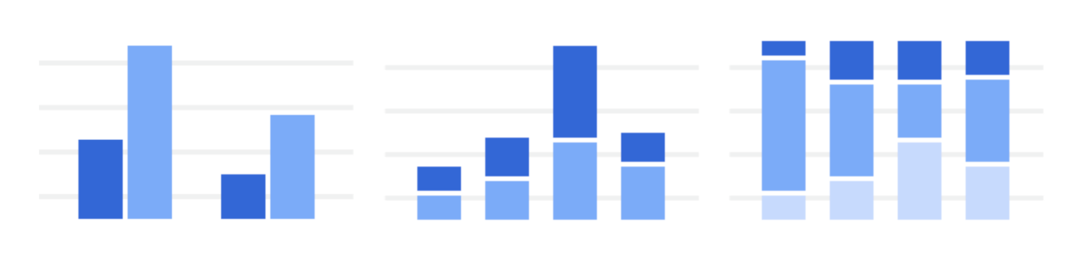

* **Line**: a line chart showcases trends in your data over a period of time. The last line chart example is a combo chart which can include a line chart. Refer to the description for the combo chart type.

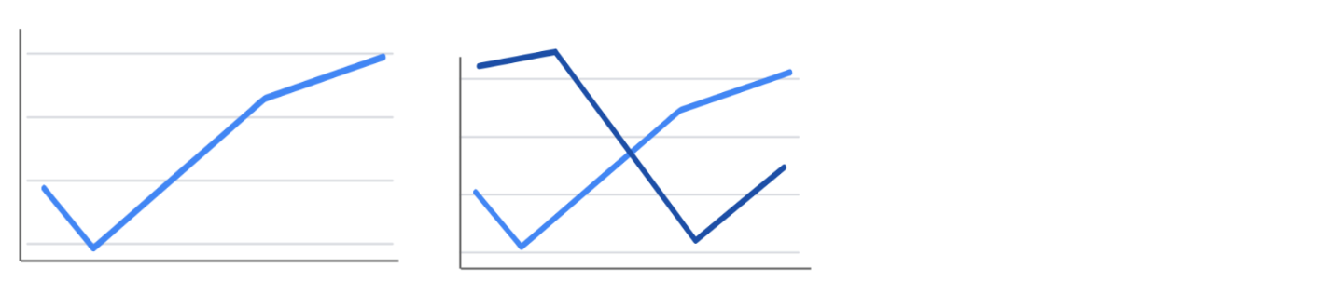

* **Pie**: a pie chart is an easy way to visualize what proportion of the whole each data point represents.

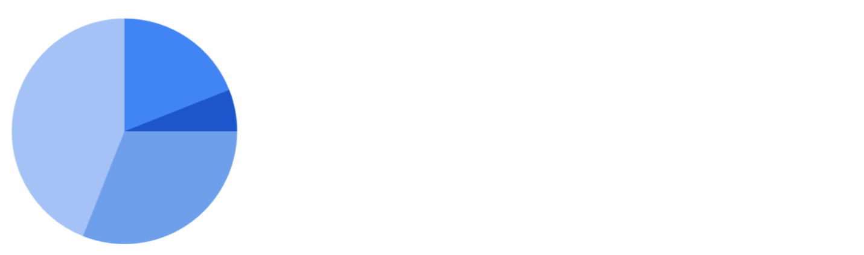

* **Horizontal bar**: a bar chart functions similarly to a column chart, but is flipped horizontally.

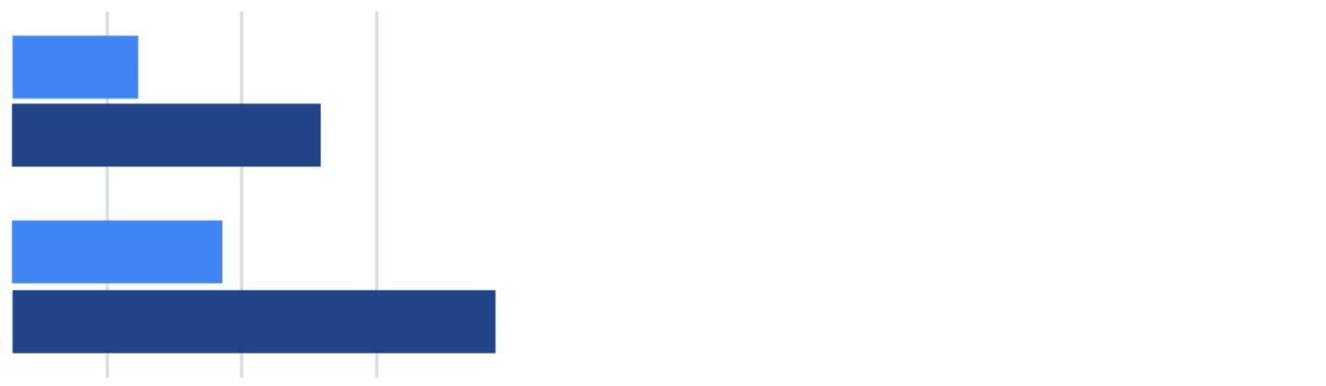

* **Area**: area charts allow you to track changes in value across multiple categories of data.

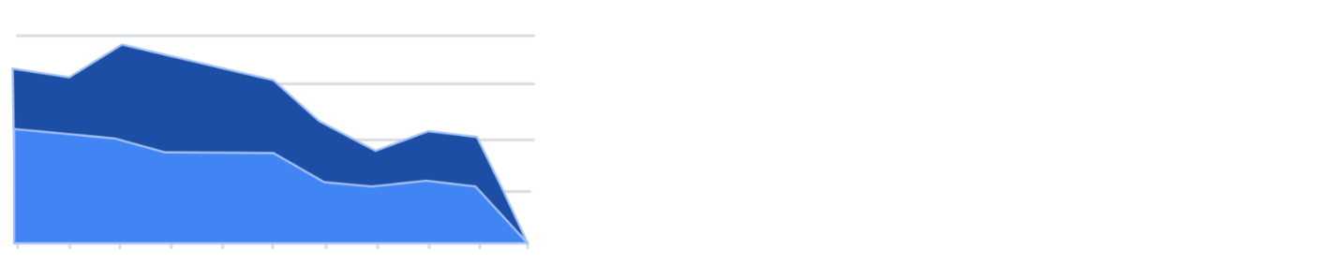

* **Scatter**: scatterplots are typically used to display trends in numeric data.

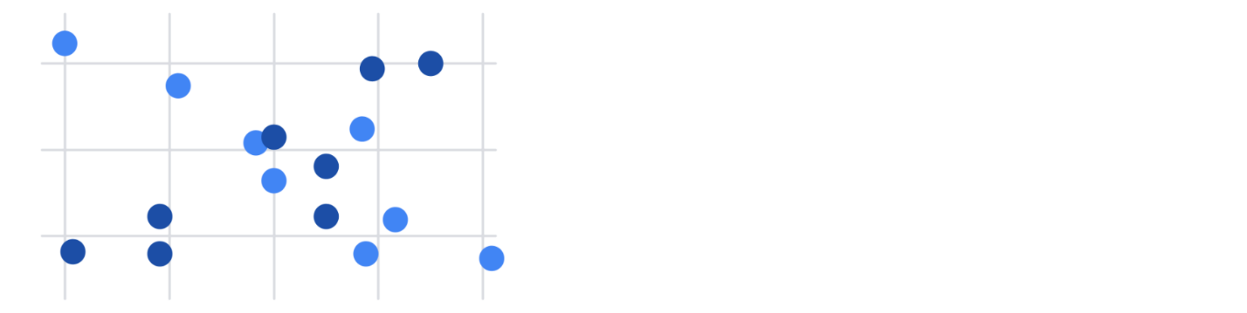

* **Combo**: combo charts use multiple visual markers like columns and lines to showcase different aspects of the data in one visualization. The example below is a combo chart that has a column and line chart together.

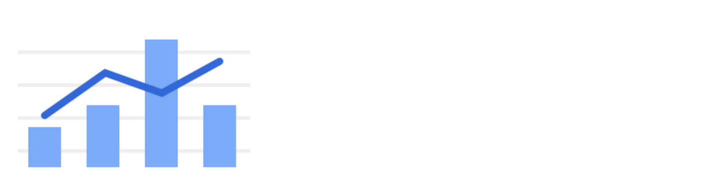

You can find more information about other charts here:

* [Types of charts and graphs in Google Sheets:](https://support.google.com/docs/answer/190718?hl=en) a Google Help Center page with a list of chart examples you can download.
* [Excel Charts](https://www.tutorialspoint.com/excel_charts/excel_charts_types.htm): a tutorial outlining all of the different chart types in Excel, including some subcategories.

**How visualizations differ in Tableau**

As you have also learned, Tableau is an analytics platform that helps data analysts display and understand data. Most if not all of the charts that you can create in spreadsheets are available in Tableau. But, Tableau offers some distinct charts that aren’t available in spreadsheets. These are handy guides to help you select chart types in Tableau:

* [Which chart or graph is right for you?](http://www.tableau.com/sites/default/files/media/which_chart_v6_final_0.pdf) This presentation covers 13 of the most popular charts in Tableau.
* [The Ultimate Cheat Sheet on Tableau Charts](https://towardsdatascience.com/the-ultimate-cheat-sheet-on-tableau-charts-642bca94dde5). This blog describes 24 chart variations in Tableau and guidelines for use.

**Types of visualizations in Tableau**

In addition to more traditional charts, Tableau also offers some more specific visualizations that you can use in your dashboard design:

* **Highlight tables** appear like tables with conditional formatting. Review the [steps to build a highlight table](https://help.tableau.com/current/pro/desktop/en-us/buildexamples_highlight.htm).
* **Heat maps** show intensity or concentrations in the data. Review the [steps to build a heat map](https://help.tableau.com/current/pro/desktop/en-us/buildexamples_highlight.htm).
* **Density maps** illustrate concentrations (such as a population density map). Refer to [instructions to create a heat map for density](https://help.tableau.com/current/pro/desktop/en-us/maps_howto_heatmap.htm).
* **Gantt charts** demonstrate the duration of events or activities on a timeline. Review the [steps to build a Gantt chart](https://help.tableau.com/current/pro/desktop/en-us/buildexamples_gantt.htm).
* **Symbol maps** display a mark over a given longitude and latitude. Learn more from this [example of a symbol map](https://interworks.com/blog/ccapitula/2014/08/18/tableau-essentials-chart-types-symbol-map/).
* **Filled maps** are maps with areas colored based on a measurement or dimension. Explore an [example of a filled map](https://interworks.com/blog/ccapitula/2014/09/23/tableau-essentials-chart-types-filled-map/).
* **Circle views** show comparative strength in data. Learn more from this [example of a circle view](https://interworks.com/blog/ccapitula/2014/10/17/tableau-essentials-chart-types-circle-view/).
* **Box plots**, also known as **box and whisker charts,** illustrate the distribution of values along a chart axis. Refer to the [steps to build a box plot](https://help.tableau.com/current/pro/desktop/en-us/buildexamples_boxplot.htm).
* **Bullet graphs** compare a primary measure with another and can be used instead of dial gauge charts. Review the [steps to build a bullet graph](https://help.tableau.com/current/pro/desktop/en-us/qs_bullet_graphs.htm).
* **Packed bubble charts** display data in clustered circles. Review the [steps to build a packed bubble chart](https://help.tableau.com/current/pro/desktop/en-us/buildexamples_bubbles.htm).

**Key takeaway**

This reading described the chart types you can create in spreadsheets and introduced visualizations that are more unique to Tableau.

Hi and welcome back.

In this video, we're going to use tableau to create a database,

a great way to share insights with others.

To begin, you'll need to download the data set we'll use for this activity.

Click the link to create a copy of the data set and download it.

If you don't have a Google account,

download the data set directly from the attachment.

As we go through the steps, you can put this video on one side of the screen and

follow along in another window.

You might notice your screen is slightly different from what you see here.

Tableau might have updated its interface, but

the steps should be pretty much the same.

First, log in to Tableau Public.

If you haven't created an account,

go back to the reading about logging into Tableau Public.

Okay, now go to the circle and select My Profile.

From there, choose Create a Viz.

This will open the Tableau Public interface.

Play video starting at ::59 and follow transcript0:59

From the Connect to Data window, go to the Files tab and

upload the CO2 data set we downloaded earlier.

Or you can navigate to the Data tab to the Tableau Public interface.

Under the drop down, click new Data source, then open the CO2 data set.

After the data uploads, the screen will show the data source interface.

Underneath connections, double-click on the sheet CO2 data cleaned to load that

data into the main part of the screen.

You can also drag and drop the sheet into the area where it says Drag tables here.

Click Update now to preview the data you opened in the bottom portion of

the screen.

Each row corresponds to a single data point, and

each column represents a different feature.

Tableau interprets the type of data in each column.

Each icon represents a different type of data.

For example, a number sign represents numerical data,

while an abc represents string data.

A globe represents geographic data, and so on.

Tableau has interpreted the first two columns as geographic data,

the third column as string data, and the last three columns as numeric data.

All right, let's make a data viz that demonstrates the amount of CO2 emissions

that come from each country.

To do this, choose the Sheet 1 tab,

on the far left of the screen is a banner with column names above a gray line.

In tableau, these are called the dimensions of the data.

Below this line, are the different measures that you can track for

these dimensions.

Play video starting at :2:43 and follow transcript2:43

To create a chart that displays the CO2 emissions per country,

we're going to start by double-clicking the country name dimension.

The main display will show a map of the countries on the planet,

with dots indicating which countries are represented in the data.

Play video starting at :3:1 and follow transcript3:01

The dots are all the same size because with no measure selected,

tableau defaults to scale each country equally.

Play video starting at :3:10 and follow transcript3:10

If you want to scale by CO2 emissions, we'll need to include a specific measure.

Double-click or drag and drop onto the sheet the measure CO2 kilotons.

This will change the size of the dots to be proportional to the amount of CO2

emitted.

Play video starting at :3:28 and follow transcript3:28

Tableau has a wide selection of options for depicting the measures for

a given dimension.

Most of these options are contained in the middle column between the main display and

the columns with dimensions and measures.

Now, let's customize the look of our chart to better communicate trends in the data.

If we drag and drop a measure on one of the marks, such as color, size, and

label, we can change that aspect of the measure's visualization on the chart.

For instance, say we want to change the color of the CO2 measure,

we would drag the measure CO2 kilotons to the box with the color label.

Then we can select this box to pull up a list of color options.

Feel free to pause this video and play around with the different options,

get creative.

If you ever want to reverse a change that you make to a tableau sheet,

just use the back arrow.

There it is, we just created our first chart using Tableau.

But what if we wanted to change the dimensions or measures?

Instead of visualizing the CO2 per country,

maybe we want to chart the CO2 per capita per region.

To do this, we could double-click on the dimension Region and

then do the same for the measure CO2 Per Capita.

This builds a new chart.

We can edit the title by hovering the cursor over the title box and

clicking on the arrow to bring up a drop down menu.

Then we'll choose Edit Title.

Let's give it the name Global CO2 Emissions.

Or if we wanted to delete a chart,

we could select the Clear Sheet button in the toolbar.

This will wipe out the chart and bring us back to an empty sheet.

Don't worry if you do this by accident or change your mind.

The back button introduced earlier will bring the chart back.

To delete a sheet entirely, right-click on the sheets tab and select Delete.

We won't be able to delete a sheet if it's the only sheet in our file.

But be careful, unlike clearing a sheet,

deleting a sheet altogether cannot be undone.

Play video starting at :5:35 and follow transcript5:35

Make sure to save your progress by hovering over the file tab and

selecting Publish As.

Congratulations, now you're ready to start visualizing your data.

This is far from the end of the story, though.

Soon you will explore and more advanced tools in tableau.

**Optional: Using Tableau Desktop**

You have started exploring Tableau as a data visualization tool in business intelligence dashboards to convey insights with stakeholders. Throughout this program, you will continue to use and access Tableau—eventually using it to create your own dashboards. This reading will enable you to familiarize yourself with Tableau's interface and functionality.

**Create a profile on Tableau Public**

With Tableau Public, you can create and share visualizations. If you don’t already have an account, make one on the [Tableau Public](https://public.tableau.com/s/) site. Note that trying to make an account from the main page will sign you up for a Tableau Free Trial rather than a Tableau Public account.

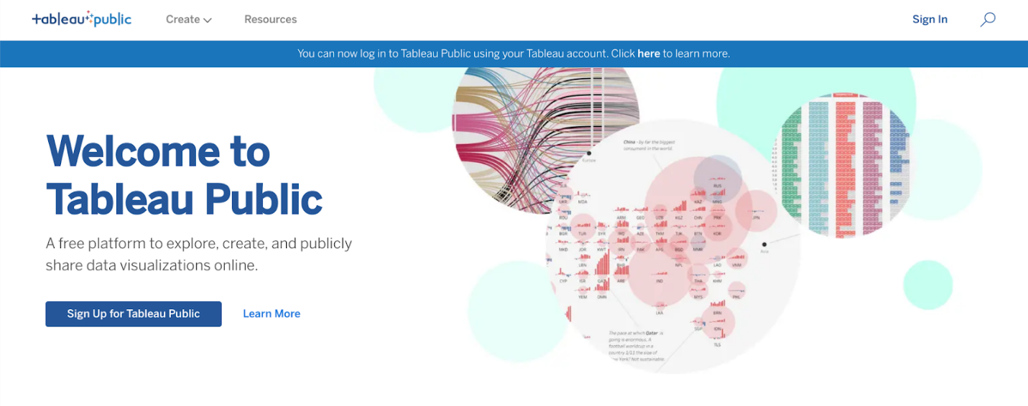

The difference between these two options is that a Free Trial lasts for 14 days, whereas Tableau Public gives you long-term access through the web version of the program. It has some limitations compared to the other versions of Tableau, but it is free to use and will enable you to complete the upcoming activities. You can also use your Tableau credentials to access Tableau Public if you already have an account! You are welcome to try the free trial or purchase Tableau, but it is not required for this program.

Complete the information in the signup form. When you click the **Create My Profile** button, you’ll be transferred to your profile page. This is where your Tableau Public visualizations can be made public to share with your peers. In the tabs on this page, you can access lists of visualizations you’ve made, visualizations you’ve favorited, authors you are following, and authors who are following you. By clicking **Edit Profile,** you can add additional information like your bio, title, organization, and links to social media accounts. This is also where you can enable Tableau Public’s **Hire Me** button. The **Hire Me** button will indicate to potential hiring managers that your Tableau skills are available for hire.

**Optional: Download the desktop version**

With the desktop application, you can use features from Tableau Public without connecting to the internet. It is free to use, just like Tableau Public’s online version. Keep in mind that this application cannot be used on the Chromebook operating system and is not required for this course. If you are using Windows or Mac OS, this desktop application will enable you to complete upcoming activities that use Tableau Public. To download [Tableau Public Desktop Edition](https://www.tableau.com/products/public/download) (this is optional), log into your account and review the [system requirements](https://www.tableau.com/products/techspecs#public) for your operating system.

**Loading and linking data**

Tableau enables you to load in your own data and link it to other datasets directly in the platform. When you log in, choose to **Create a Viz.** This will open a new worksheet where you can upload data or connect to online sources, such as your Google Drive.

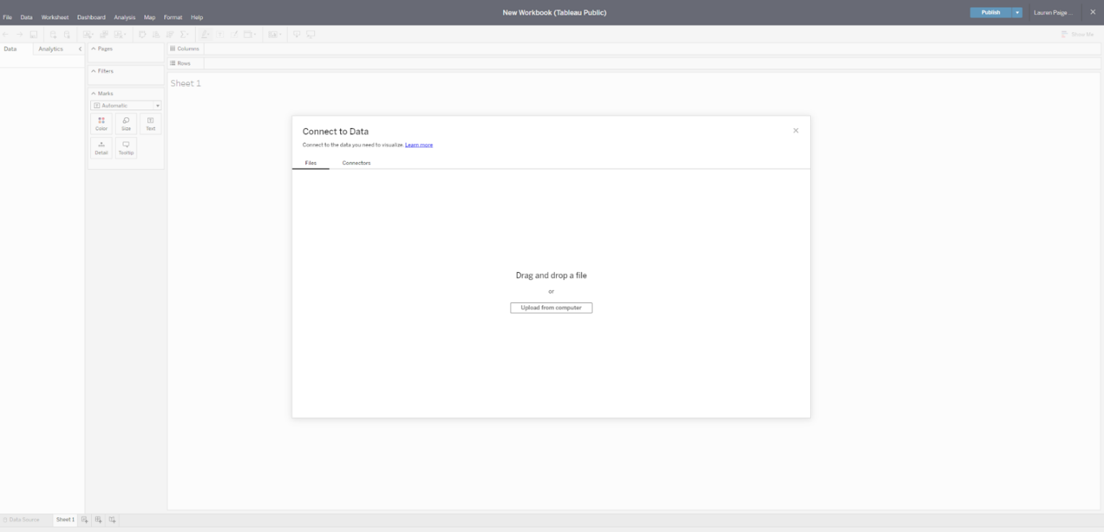

Once you upload data to your worksheet, it will populate the Connections pane.

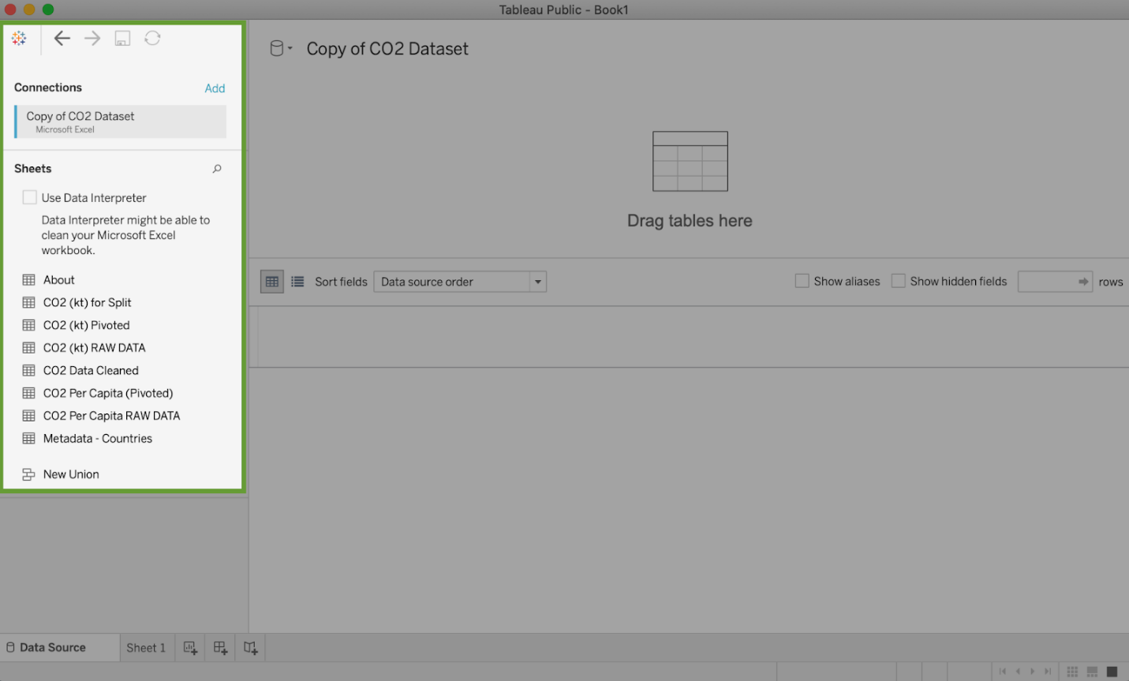

You can add more connections to other data sources in order to build visualizations that compare different datasets. Simply drag and drop tables from the Sheets section in order to join tables and generate those connections:

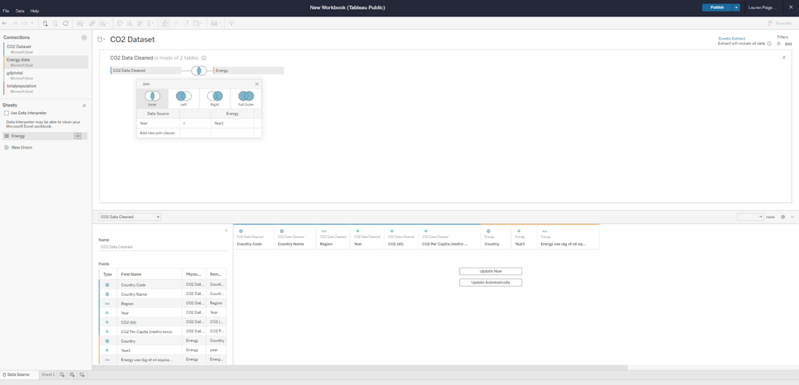

**Dimensions and measures**

Tableau uses dimensions and measures to generate customized charts. For example, check out this chart focusing on CO2 emissions per country. The Country Name dimension can be used to show a map of the countries on the planet with dots indicating which countries are represented in the data.

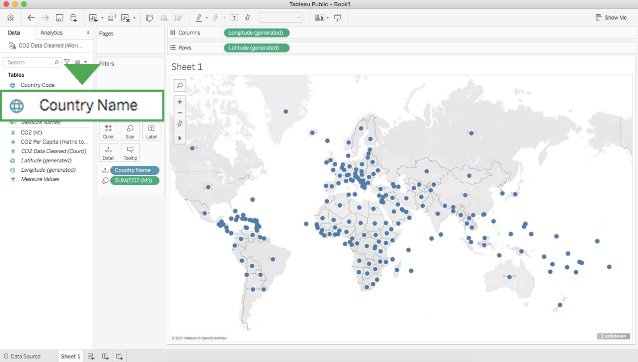

The dots are all the same size because—with no measure selected—Tableau defaults to scale each country equally. If you want to scale by CO2 emissions, you need to include a specific measure. Here is the same chart with a measure for CO2 kiloton (kt). This changes the size of the dots to be proportional to the amount of CO2 emitted:

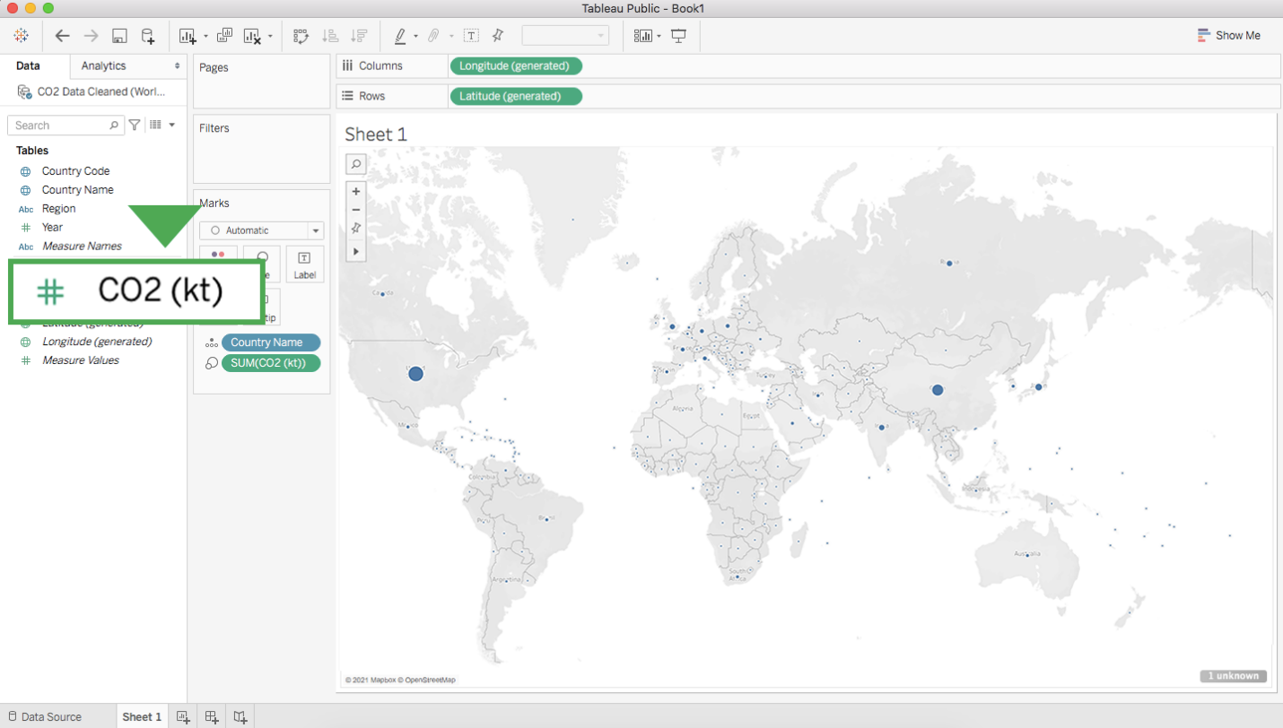

Tableau has a wide variety of options for depicting the measure for a given dimension. Most of these options are contained near the main display and the column with dimensions and measures.

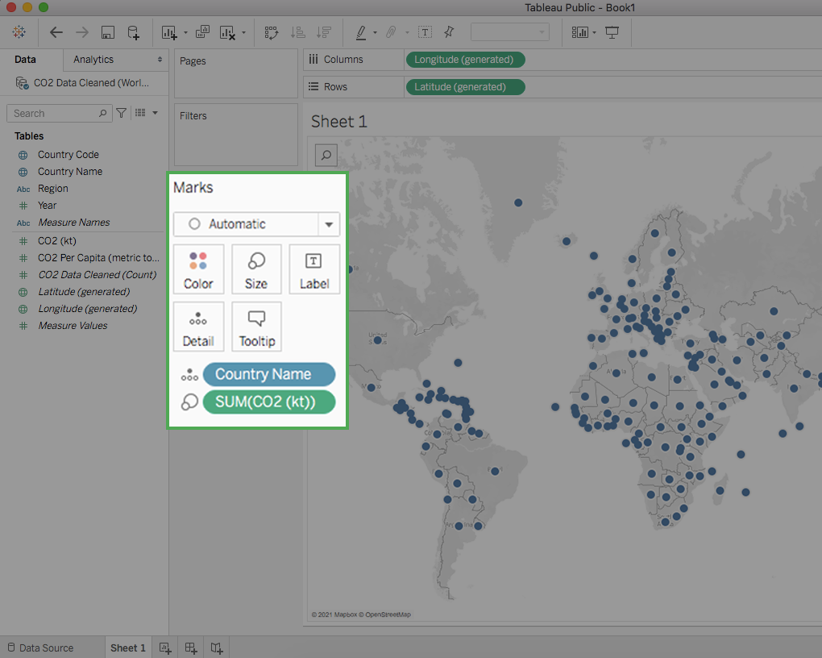

**Key takeaways**

Tableau allows you to customize measures with options such as Color, Size, and Label, which change those aspects of the measure’s visualization on the chart. As you customize measures in Tableau, you will want to consider accessibility for your audience. As a refresher, you can check out [this video on accessible visualizations from the Google Data Analytics Certificate program.](https://www.coursera.org/learn/visualize-data/lecture/yVjKD/accessible-visualizations)

Hi there. In this video we'll take a closer look at

effective and ineffective data visualizations

using Tableau. That's right.

Even though this platform can help you

create some really beautiful visuals,

all of those features and functions can lead

to something that's just not very useful too.

You might remember the five second rule

we spoke about earlier.

A sign of a good data visualization

is that once you show it to an audience,

they should understand what you're trying to

convey within five seconds.

This means it's clear,

effective, and most importantly, convincing.

If you keep that rule of thumb in mind

before you begin any Tableau Viz,

you'll be on the right path to creating good visuals.

Let's take a look at an example of

a good use of a diverging color palette.

A diverging color palette displays

two ranges of values using color intensity to

show the magnitude of the number and

the actual color to show which range the numbers from.

It's a good way to show the difference between numbers.

Here, green is associated with

higher numbers and red with lower numbers.

You may come across tables like this as it

relates to business metrics and KPIs.

The colors you choose should fit within

the scope of the audience's expectations.

While this might not always be true globally,

a lot of people associate green

with positive and red with negative.

This makes things nice and clear.

Here's an ineffective data Viz example.

There's a lot about this Viz isn't working well,

but these colors are hard to read.

This graph uses green and orange

and the data points are really close together.

These colors don't clearly show

the difference between low and high data points.

Data visualization allows us to

share meaningful stories about data,

but we can't do it if it's too hard for

the audience to understand the data Viz were sharing.

Using color pairings that don't fit

your audience's expectations could add

another layer of unnecessary complexity.

Brace yourself because there's another way to

make an ineffective data visualization even worse.

If you add a few too many labels,

you end up with a data visualization

that's really hard to take in.

Doing this makes the visualization too busy.

It takes up too much space and it

prevents the labels from being clearly shown.

All of this is made worse by

using different fonts across the labels.

What we have here is good data

turn bad because of the visuals.

Having an interactive visualization can be useful

for both your audience and for you as the analyst.

But just like anything else,

the more power you have,

the more responsibility you have.

Lose sight on the qualities of a good viz and

you can lose control over

the story you want the data to tell.

Now that you learned how to use

visual enhancements to your advantage.

Next up, we'll check out ways you can get

even more creative with them. Stay tuned.

**Essential design principles**

You recently learned about pre-attentive attributes of data visualization—the building blocks of data visualizations: marks and channels. In this reading, you’ll take this understanding a step further with essential design principles.

As an analyst, your audiences will have a variety of roles, backgrounds, and perspectives. You might present information to other data analysts, to clients, or to executives in your company’s C-suite. You’re responsible for developing data visualizations that convey the information your audience needs in a manner that makes sense to everyone.

**Design principles**

These design principles are important to your work as a data analyst because they help ensure that you’re creating visualizations that communicate your data effectively to your audience. By keeping these rules in mind, you can plan and evaluate your data visualizations to decide if they’re working. And, if they aren’t, you can adjust them!

| **Principle** | **Description** |
| --- | --- |
| Choose the right visual | One of the first things you have to decide is which visual will be the most effective for your audience. Sometimes, a simple table is the best visualization. Other times, you need a more complex visualization to illustrate your point. |
| Optimize the data-ink ratio | The data-ink entails focusing on the part of the visual that is essential to understanding the point of the chart. Try to minimize non-data ink like boxes around legends or shadows to optimize the data-ink ratio. |
| Use orientation effectively | Make sure the written components of the visual, like the labels on a bar chart, are easy to read. You can change the orientation of your visual to make it easier to read and understand. |
| Color | There are a lot of important considerations when thinking about using color in your visuals. These include using color consciously and meaningfully, staying consistent throughout your visuals, being considerate of what colors mean to different people, and using inclusive color scales that make sense for everyone viewing them. |
| Numbers of elements | Think about how many elements you include in any visual. If your visualization uses lines, try to plot five or fewer. If that isn’t possible, use color or hue to emphasize important lines. Also, when using visuals like pie charts, try to keep the number of segments to less than seven since too many elements can be distracting. |

**Avoiding misleading or deceptive charts**

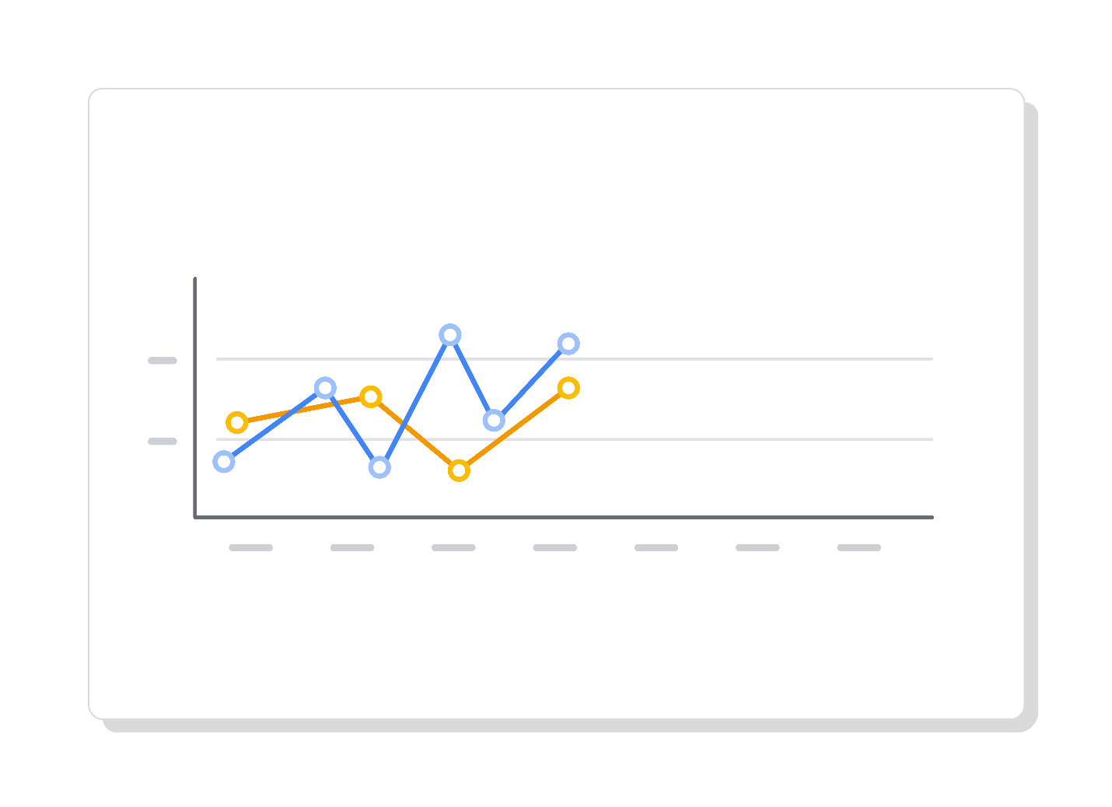

As you are considering what kind of visualization to create and how to design it, you will also want to be sure that you are not creating misleading or deceptive charts. Data analysis provides insights and knowledge that people use to make decisions. So, it’s important that the visualizations you create are communicating data insights accurately and truthfully.

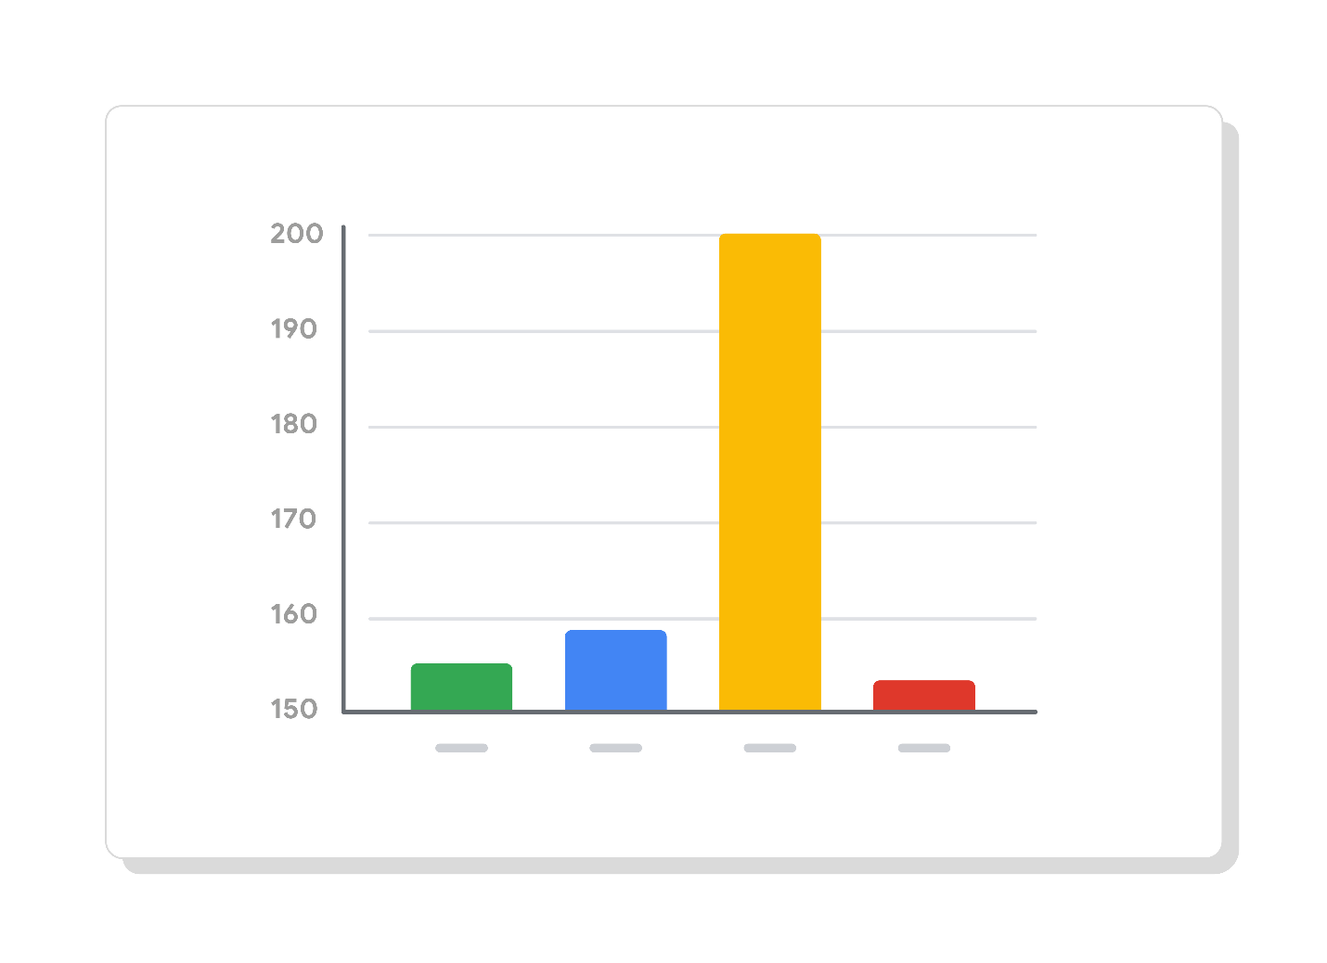

Here are some common errors to avoid so that your visualizations aren’t accidentally misleading:

| **What to avoid** | **Why** |
| --- | --- |
| Cutting off the y-axis | Changing the scale on the y-axis can make the differences between different groups in your data seem more dramatic, even if the difference is actually quite small. |
| Misleading use of a dual y-axis | Using a dual y-axis without clearly labeling it in your data visualization can create extremely misleading charts. |
| Artificially limiting the scope of the data | If you only consider the part of the data that confirms your analysis, your visualizations will be misleading because they don’t take all of the data into account. |
| Problematic choices in how data is binned or grouped | It is important to make sure that the way you are grouping data isn’t misleading or misrepresenting your data and disguising important trends and insights. |
| Using part-to-whole visuals when the totals do not sum up appropriately | If you are using a part-to-whole visual like a pie chart to explain your data, the individual parts should add up to equal 100%. If they don’t, your data visualization will be misleading. |
| Hiding trends in cumulative charts | Creating a cumulative chart can disguise more insightful trends by making the scale of the visualization too large to track any changes over time. |
| Artificially smoothing trends | Adding smooth trend lines between points in a scatter plot can make it easier to read that plot, but replacing the points with just the line can actually make it appear that the point is more connected over time than it actually was. |

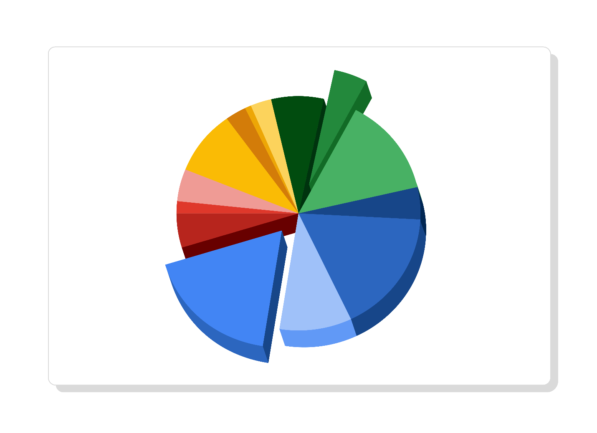

**Key takeaways**

Design principles are important for creating effective data visualizations. When creating visualizations, consider the audience, choose the right visual for the job, and be sure to avoid misleading or deceptive visuals. By following these principles, you’ll be able to design visualizations that are effective, informative, and easy to understand, which will help you communicate findings to a wider audience and make a greater impact on your organization!

**Misleading visualizations**

You can create data visualizations in Tableau using a wide variety of charts, colors, and styles. And you have tremendous freedom in the tool to decide how these visualizations will look and how they will present your data.

Below is an example of a visualization created in Tableau:

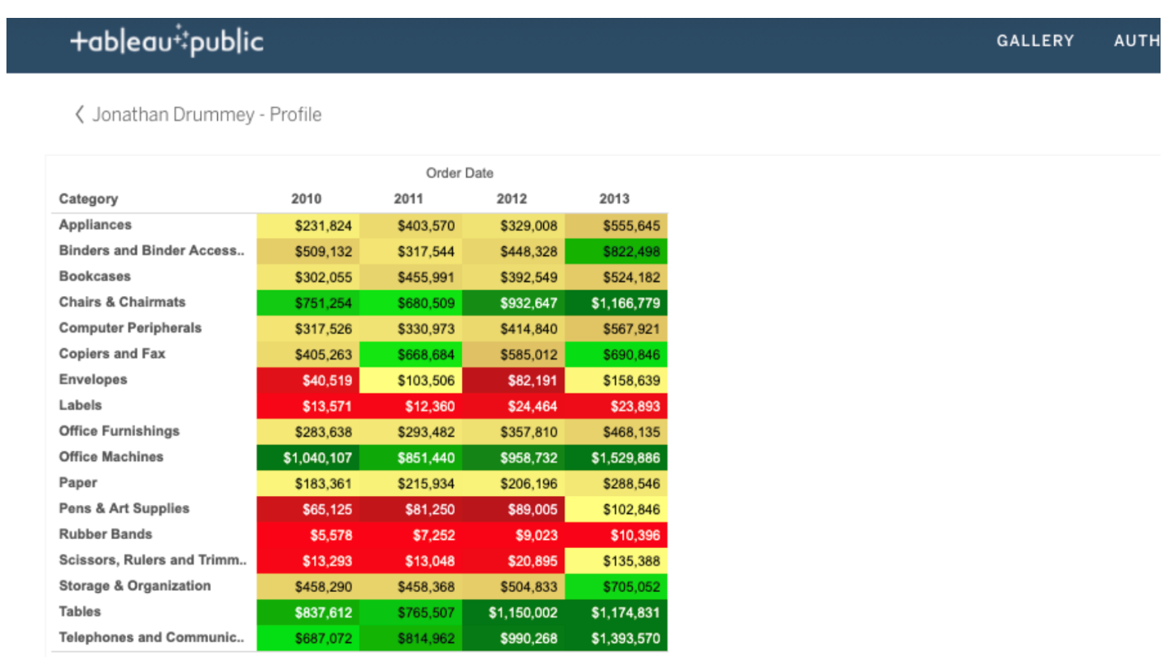

Study the visualization and think about these questions:

* Red normally indicates danger or a warning. Why do you think cells are highlighted in red?
* Green normally indicates a positive or “go” status. Is it clear why certain cells are highlighted in green?
* The purpose of the color coding isn’t clear without a legend, but can you guess what might have been the intent?

Post your theory of what the colors mean. In the same post, share in 3-5 sentences (150-200 words) how this table could be misleading and how you would improve it to avoid confusion. Then, visit the [discussion forum](https://www.coursera.org/learn/visualize-data/discussions) to browse what other learners shared and engage in at least two discussions about the visualization.

Participation is optional

Hey, good to see you again.

One of my favorite aspects of data visualizations is how creative

it lets me be.

You might remember me saying earlier that data viz the intersection of art and

analytics, and it really is.

I'm here to help you find your inner kid with a crayon from turning messy charts

into effective ones to making your visuals more accessible to people who have

color vision deficiencies.

It's time to explore how your creativity can help you get the most out of

your data.

Jump right in by signing into your Tableau account,

we'll return to our world Happiness Data in the Google Career Certificates Page.

Click the link included in this video to Open the gallery,

now click to view the workbook titled Just the Data: World Happiness.

We use the same workbook in the earlier video about getting started with Tableau.

Let's click up here to get started.

Let's say we want to use this data in this table to figure out what

the biggest contributors to a country's happiness score are.

We'll start by digging into the relationship between happiness scores and

the other country measures to see what we can find.

To start, create a new worksheet to build your own data viz from scratch,

you'll click on worksheet and then new worksheet.

Since our data has three years of values, let's filter to 2016.

Play video starting at :1:26 and follow transcript1:26

To do this, add year to the filter shelf and choose 2016.

Play video starting at :1:35 and follow transcript1:35

Add happiness score to the rows shelf.

Play video starting at :1:45 and follow transcript1:45

Then add economy GDP per capita to the column shelf.

Play video starting at :1:54 and follow transcript1:54

Next drag and drop country to the detail section,

this creates a separate circle or data point for each country.

Play video starting at :2:5 and follow transcript2:05

You might notice that where the economy scores higher,

the happiness scores also higher.

Play video starting at :2:14 and follow transcript2:14

To make this trend easier to see, let's add a trend line.

Play video starting at :2:21 and follow transcript2:21

Now duplicate this sheet so that all of your formatting stays the same.

In the duplicate sheet replace economy GDP per capita with another

measure such as family.

Drag the family table into the column shelf to replace economy.

Play video starting at :2:41 and follow transcript2:41

We'll rename our original tab economy.

Play video starting at :2:48 and follow transcript2:48

And this new tab family, so

that we can easily recognize what they show and find them when we need.

Try doing this for more of the measures.

Now let's show what multiple visualizations on a single dashboard

look like, so you can more easily see the relationship between them.

Drag your visualizations, which are now listed on the left tables column

one at a time to populate the dashboard.

They could be arranged in different ways,

take note of which trend lines have the steepest incline.

Those are the ones with the strongest relationship, the happiness score.

Each chart should have easily understood purpose that's immediately clear to your

audience, and that's just what this does.

You can also add a companion table, which shows the same data in a different way in

case people in your audience prefer tables.

In my experience, some stakeholders prefer to see their data in spreadsheets.

We've been spending a lot of time using one data source, but

you'll likely end up juggling more than one data set at a time as an analyst.

Play video starting at :3:52 and follow transcript3:52

Coming up, you'll have the option to learn more about combining multiple data sources

in Tableau bye for now.

Question 1

What color combination does a diverging color palette use to display characteristics of values?

1 point

Shade for the accuracy and grayscale for the reliability

Value for the range and tint for the margin of error

Intensity for the range and hue for the magnitude

Intensity for the magnitude and hue for the range

**2.**

Question 2

A data analyst creates a Tableau visualization to compare international trade routes. Which color choices could be misleading?

1 point

Blue and gray

Orange and brown

Beige and purple

Green and red

**3.**

Question 3

In this visualization, what steps could you take to adjust the labels in order to make the visualization more effective? Select all that apply.

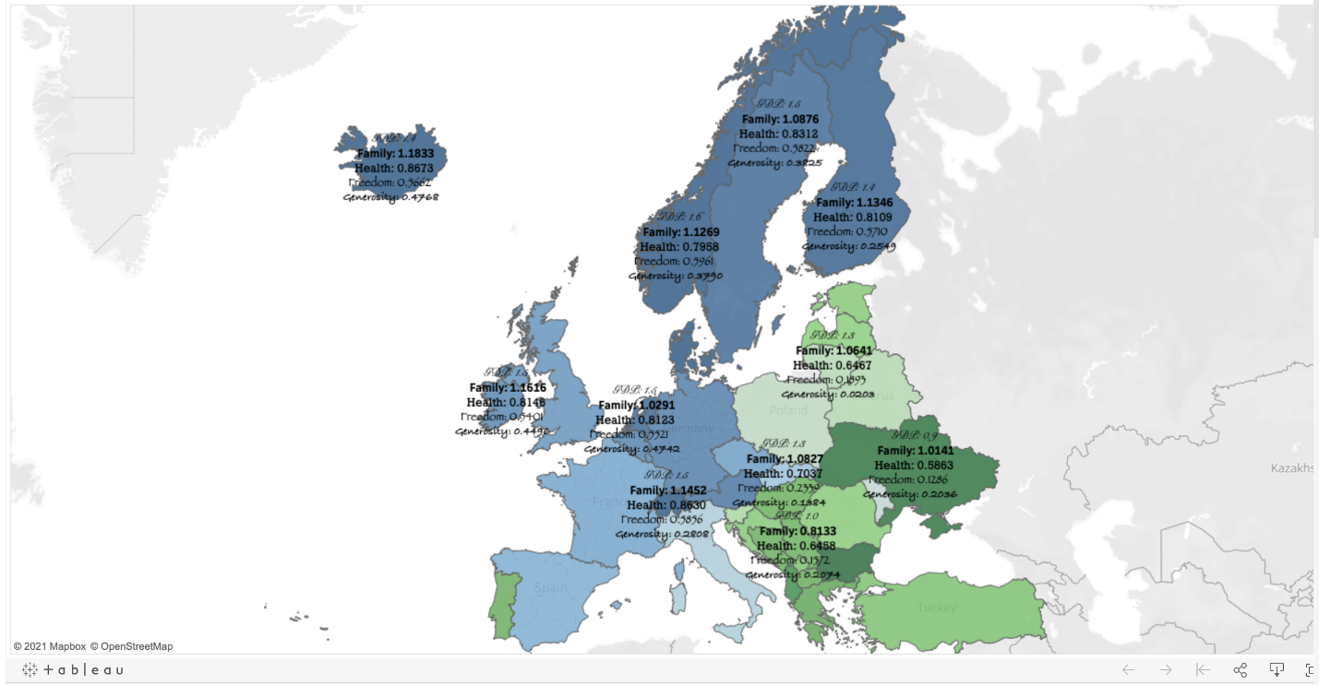

1 point

Change the font color for the labels from black to white

Move the labels to white space on the map

Reduce the number of labels

Use a single font for the labels

**4.**

Question 4

If stakeholders prefer to view data in a spreadsheet-type format, what can be added to a Tableau visualization?

1 point

Headers and footers

Legend

Companion table

Key

Hi and welcome back. In this video,

we're going to use Tableau to link multiple datasets.

This lets analysts compare

all datasets in the same visualization,

visualize comparisons and combinations of data,

and share more complex projects.

You can put this video on one side of

the screen and follow along in another window.

You might notice your screen is

slightly different from the video. That's okay.

Tableau updates its interface from time to time,

but the general steps will stay the same.

Feel free to pause this video as you work in

your own Tableau workspace

before continuing to the next step.

To begin, we're going to need to download

the four datasets we'll use for this activity,

click the link to create a copy

of the datasets and download them.

If you don't have a Google account,

download the datasets directly from the attachments.

Now imagine this scenario.

You're working as a data analyst

for a policy research institute.

For your current project,

you need to create a visualization that shows

the CO\_2 emissions per capita

for each country from 2000-2011.

You'll also provide information

about each country's population,

GDP, and energy use. Let's get started.

First, log into Tableau Public.

If you haven't created an account,

refer to the earlier reading,

logging into Tableau Public.

Go to the circle,

then choose "My profile."

From there, select "Create a Viz."

This will open the Tableau Public interface.

The connect to data window will pop up.

From here, you can go to

the Files tab and upload the CO\_2 dataset.

Now, go to the data source tab.

Then the connections column.

From here, choose the plus icon to add another dataset.

First, add energy, then

add GDP total and total population.

Now we'll have four datasets loaded into Tableau.

You can proceed to linking them with

JOINs Tableau has already

added energy into the multiple connections area.

We can remove it by dragging

it back to the connections column.

Now let's create JOINs as a reminder,

inner and outer joins are types of relationships that can

be used to combine data

based on common columns of information.

To set up our first JOIN,

we'll select CO\_2 under connections.

Beneath that in the sheet section,

click and drag CO\_2 data

cleaned to the multiple connection section.

Then double click the box created by the dataset.

This opens a physical table and lets us

create JOINs To set the first JOIN,

select the energy dataset under connections and drag

the energy sheet beneath it to

the right side of the CO\_2 data cleaned box.

A pop-up window for a JOIN will appear.

It will automatically populate with year from

CO\_2 data cleaned and Year 1 from energy.

If not, put year on the left side

of the chart and Year 1 on the right side.

Then choose "Add" from JOIN clause under year.

Select "Country Name" from the down on

the left side and "Country" on the right side.

After that, use the X to close the drop-down menu,

we need to fix something in our dataset.

Year and Year 1 have a number sign above them.

We can click those number signs and select date instead,

to change the data type for each column.

Play video starting at :4:4 and follow transcript4:04

Now, join the other datasets,

choose "GDP Total" under Connections.

Then under sheets, drag

the GDP total sheet into

the white space underneath the energy box.

The pop-up window should already be

populated with Year 1 under

data source and year GDP total under GDP total.

Before adding any additional joins,

the data type for year GDP total needs to be changed.

We'll make its data type date

just like we did with the other year columns.

Now continue setting the join.

Choose the Venn diagram between Energy and GDP total,

then add new JOIN clause under Year 1.

A drop-down menu will appear.

Under CO\_2 data cleaned, select "Country name".

Then the empty field under

GDP total across from country name.

Set the right side of the JOIN to country one.

Then close the join pop-up.

We'll repeat this process for total population,

the last dataset we downloaded.

When we drag the sheet to create the JOIN,

the window should already be populated with year under

data source and year

total population under total population.

Change year total population to

the date data type to match the other year columns.

Then select the "Venn diagram" to edit

the JOIN and click "Add new JOIN clause" under year.

Under CO\_2 Data Cleaned,

choose "Country name" then on the right side of the row,

country total population. Close the pop-up.

If you haven't yet, be sure to update

your data by clicking on the "Update Now" button.

Nice. You've joined four different sources of data.

Check out your new dataset.

While your dataset CO\_2 went from 1960-2011,

your other datasets went from 2000-2015.

The intersection, the years they have in

common only includes 2000-2011.

This is the time span that we need.

However, there are some changes we still need to make.

Some of the data types need to be converted.

Similar to when you change

your year columns to date types,

you'll need to change the energy use

and current GDP columns.

Above the energy use column is an ABC icon.

This means is a string type.

Select it to open a drop-down

and change it to number decimal.

Current GDP is also

a string type but needs to be a whole number instead.

Choose the ABC icon to change it to number whole.

Now we get to make our visualization.

To begin, choose the Sheet 1 tab,

you'll notice a column on the left side of the screen.

Under CO\_2 Data Cleaned,

drag country name to the detail square.

Drag CO\_2 per capita to the color square.

Then choose the square and edit colors.

Select the palette dropdown and change it from

automatic to red-green diverging.

Check the boxes for stepped color and reversed

because green is generally viewed as

a good thing when it comes to CO\_2 emissions,

you want the colors to move

toward red as emissions worsen.

Click the "Show Advanced" dropdown.

Then the start and end boxes.

Put zero into the start column and 62 at the end column.

Then close the window.

Drag year from under

CO\_2 data cleaned into the filters area.

Choose years, next,

all, and then okay.

In the filters box,

right-click on "Year," "Year," select "Show Filter."

The filter will appear on the right side of the screen.

On the far right side of the screen,

choose the arrow to the right of year

, select "Single value."

Now the areas will be

colored only for the values of each year.

Select any year between

2000-2011 to view that year's CO\_2 emissions.

Make sure to save your progress by clicking published as

icon or hovering over the file tab and selecting "Save."

If you are asked to create an extract,

return to the data source tab and click

"Create Extract," then click "Save" again.

Congratulations. You've linked your data

and made a comprehensive dataset in Tableau.

The more visualizations you make,

the more you'll be able to share

complex analyses and insights.

**Tableau resources for combining multiple data sources**

Now that you have some experience working with data in Tableau, you are ready to start doing more, including combining multiple data sources. This reading will provide you with some how-to guides for that, and other helpful resources you can use as you practice using Tableau on your own.

| **Resource** | **Description** |
| --- | --- |
| [**Set up data sources**](https://help.tableau.com/current/pro/desktop/en-us/datasource_prepare.htm) | This page links to other resources explaining how to **set up your data sources** and prepare them for analysis once you have connected them to your Tableau account. It specifically includes articles explaining how to join or blend data, and what a union is and how they work. This is a great starting point as you get ready to begin using and combining data sources. |
| [**Join your data**](https://help.tableau.com/current/pro/desktop/en-us/joining_tables.htm) | **Joining** refers to the process of combining data sources based on common fields. This article gives a more detailed explanation of the different joins, how to use them in Tableau, and an example join with a step-by-step guide. |
| [**Don’t be scared of relationships**](https://help.tableau.com/v2020.2/pro/desktop/en-us/datasource_dont_be_scared.htm) | **Relationships** allow you to combine multiple data sources in Tableau. This is a more flexible alternative to joins, and doesn’t force you to create one single table with your multiple data sources. This article will give you more insight into how relationships work. |
| [**How relationships differ from joins**](https://help.tableau.com/current/online/en-us/datasource_relationships_learnmorepage.htm) | This article goes into more detail about the differences between using **relationships and joins**, and guides you through the process of using relationships to combine data. |
| [**Blend your data**](https://help.tableau.com/current/pro/desktop/en-us/multiple_connections.htm) | **Data blending** is another method you can use to combine multiple data sources. Instead of truly combining the data, blends allow you to query and aggregate data from multiple sources. This resource goes into more detail about blending and includes a tutorial. |
| [**Combining multiple date fields**](https://kb.tableau.com/articles/howto/combining-start-and-end-dates-into-a-single-axis) | This resource provides examples that explain how to **combine date fields** when using four different methods of data combination in Tableau. |

These are just a few resources you can use. You can also find more information online or in the[Tableau community forums](https://community.tableau.com/s/).

**Glossary terms from module 2**

**Terms and definitions for Course 6, Module 2**

**Area chart**:A data visualization that uses individual data points for a changing variable connected by a continuous line with a filled in area underneath

**Box plot:** A data visualization that displays the distribution of values along an x-axis

**Bubble chart**: A data visualization that displays individual data points as bubbles,  comparing numeric values by their relative size

**Bullet graph:** A data visualization that displays data as a horizontal bar chart moving toward a desired value

**Circle view:** A data visualization that shows comparative strength in data

**Column chart**: A data visualization that uses individual data points for a changing variable, represented as vertical columns

**Combo chart:** A data visualization that combines more than one visualization type

**Density map**: A data visualization that represents concentrations, with color representing the number or frequency of data points in a given area on a map

**Distribution graph:** A data visualization that displays the frequency of various outcomes in a sample

**Diverging color palette:** A color theme that displays two ranges of data values using two different hues, with color intensity representing the magnitude of the values

**Donut chart**: A data visualization where segments of a ring represent data values adding up to a whole

**Filled map:** A data visualization that colors areas in a map based on measurements or dimensions

**Gantt chart:** A data visualization that displays the duration of events or activities on a timeline

**Gauge chart**: A data visualization that shows a single result within a progressive range of values

**Highlight table:** A data visualization that uses conditional formatting and color on a table

**Packed bubble chart:** A data visualization that displays data in clustered circles

**Symbol map:** A data visualization that displays a mark over a given longitude and latitude

**Terms and definitions from previous modules**

**A**

**A/B testing:** The process of testing two variations of the same web page to determine which page is more successful at attracting user traffic and generating revenue

**Absolute reference:** A reference within a function that is locked so that rows and columns won’t change if the function is copied

**Access control:** Features such as password protection, user permissions, and encryption that are used to protect a spreadsheet

**Accuracy:** The degree to which data conforms to the actual entity being measured or described

**Action-oriented question:** A question whose answers lead to change

**Administrative metadata:** Metadata that indicates the technical source of a digital asset

**Agenda**: A list of scheduled appointments

**Aggregation:** The process of collecting or gathering many separate pieces into a whole

**Algorithm:** A process or set of rules followed for a specific task

**Aliasing:** Temporarily naming a table or column in a query to make it easier to read and write

**Alternative text:** Text that provides an alternative to non-text content, such as images and videos

**Analytical skills:** Qualities and characteristics associated with using facts to solve problems

**Analytical thinking:** The process of identifying and defining a problem, then solving it by using data in an organized, step-by-step manner

**Annotation:** Text that briefly explains data or helps focus the audience on a particular aspect of the data in a visualization

**Array:** A collection of values in spreadsheet cells

**Attribute**: A characteristic or quality of data used to label a column in a table

**Audio file:** Digitized audio storage usually in an MP3, AAC, or other compressed format

**AVERAGE**: A spreadsheet function that returns an average of the values from a selected range

**AVERAGEIF:** A spreadsheet function that returns the average of all cell values from a given range that meet a specified condition

**B**

**Bad data source:** A data source that is not reliable, original, comprehensive, current, and cited (ROCCC)

**Balance:** The design principle of creating aesthetic appeal and clarity in a data visualization by evenly distributing visual elements

**Bar graph:** A data visualization that uses size to contrast and compare two or more values

**Bias:** A conscious or subconscious preference in favor of or against a person, group of people, or thing

**Big data:** Large, complex datasets typically involving long periods of time, which enable data analysts to address far-reaching business problems

**Boolean data:** A data type with only two possible values, usually true or false

**Borders**: Lines that can be added around two or more cells on a spreadsheet

**Business task:** The question or problem data analysis resolves for a business

**C**

**Calculated field:** A new field within a pivot table that carries out certain calculations based on the values of other fields

**Calculus:** A branch of mathematics that involves the study of rates of change and the changes between values that are related by a function

**CASE:** A SQL statement that returns records that meet conditions by including an if/then statement in a query

**CAST:** A SQL function that converts data from one datatype to another

**Causation:** When an action directly leads to an outcome, such as a cause-effect relationship

**Cell reference:** A cell or a range of cells in a worksheet typically used in formulas and functions

**Changelog:** A file containing a chronologically ordered list of modifications made to a project

**Channel:** A visual aspect or variable that represents characteristics of the data in a visualization

**Chart:** A graphical representation of data from a worksheet

**Clean data:** Data that is complete, correct, and relevant to the problem being solved

**Cloud:** A place to keep data online, rather than a computer hard drive

**Cluster:** A collection of data points on a data visualization with similar values

**COALESCE:** A SQL function that returns non-null values in a list

**Compatibility:** How well two or more datasets are able to work together

**Completeness:** The degree to which data contains all desired components or measures

**CONCAT:** A SQL function that adds strings together to create new text strings that can be used as unique keys

**CONCATENATE:** A spreadsheet function that joins together two or more text strings

**Conditional formatting:** A spreadsheet tool that changes how cells appear when values meet specific conditions

**Confidence interval:**  A range of values that conveys how likely a statistical estimate reflects the population

**Confidence level:** The probability that a sample size accurately reflects the greater population

**Confirmation bias:** The tendency to search for or interpret information in a way that confirms pre-existing beliefs

**Consent:** The aspect of data ethics that presumes an individual’s right to know how and why their personal data will be used before agreeing to provide it

**Consistency:** The degree to which data is repeatable from different points of entry or collection

**Context:** The condition in which something exists or happens

**Continuous data:** Data that is measured and can have almost any numeric value

**CONVERT:** A SQL function that changes the unit of measurement of a value in data

**Cookie:** A small file stored on a computer that contains information about its users

**Correlation:** The measure of the degree to which two variables change in relationship to each other

**COUNT**: A spreadsheet function that counts the number of cells in a range

**COUNTA:** A spreadsheet function that counts the total number of values within a range that meet specified criteria

**COUNTIF:** A spreadsheet function that returns the number of cells in a range that match a specified value

**COUNT DISTINCT:** A SQL function that only returns the distinct values in a specified range

**CREATE TABLE:** A SQL clause that adds a temporary table to a database that can be used by multiple people

**Cross-field validation:** A process that ensures certain conditions for multiple data fields are satisfied

**CSV (comma-separated values) file:** A delimited text file that uses a comma to separate values

**Currency:** The aspect of data ethics that presumes individuals should be aware of financial transactions resulting from the use of their personal data and the scale of those transactions

**D**

**Dashboard:** A tool that monitors live, incoming data

**Data:** A collection of facts

**Data aggregation:** The process of gathering data from multiple sources and combining it into a single, summarized collection

**Data analysis:** The collection, transformation, and organization of data in order to draw conclusions, make predictions, and drive informed decision-making

**Data analysis process:** The six phases of ask, prepare, process, analyze, share, and act whose purpose is to gain insights that drive informed decision-making

**Data analyst:** Someone who collects, transforms, and organizes data in order to draw conclusions, make predictions, and drive informed decision-making

**Data analytics:** The science of data

**Data anonymization:** The process of protecting people's private or sensitive data by eliminating identifying information

**Data bias:** When a preference in favor of or against a person, group of people, or thing systematically skews data analysis results in a certain direction

**Data composition:** The process of combining the individual parts in a visualization and displaying them together as a whole

**Data constraints:** The criteria that determine whether a piece of a data is clean and valid

**Data design:** How information is organized

**Data-driven decision-making:** Using facts to guide business strategy

**Data ecosystem:** The various elements that interact with one another in order to produce, manage, store, organize, analyze, and share data

**Data element:** Apiece of information in a dataset

**Data engineer:** A professional who transforms data into a useful format for analysis and gives it a reliable infrastructure

**Data ethics:** Well-founded standards of right and wrong that dictate how data is collected, shared, and used

**Data governance:** A process for ensuring the formal management of a company’s data assets

**Data-inspired decision-making:** Exploring different data sources to find out what they have in common

**Data integrity:** The accuracy, completeness, consistency, and trustworthiness of data throughout its life cycle

**Data interoperability:** The ability to integrate data from multiple sources and a key factor leading to the successful use of open data among companies and governments

**Data life cycle:** The sequence of stages that data experiences, which include plan, capture, manage, analyze, archive, and destroy

**Data manipulation:** The process of changing data to make it more organized and easier to read

**Data mapping:** The process of matching fields from one data source to another

**Data merging:** The process of combining two or more datasets into a single dataset

**Data model:** A tool for organizing data elements and how they relate to one another

**Data privacy:** Preserving a data subject’s information any time a data transaction occurs

**Data range:** Numerical values that fall between predefined maximum and minimum values

**Data replication:** The process of storing data in multiple locations

**Data science:** A field of study that uses raw data to createnew ways of modeling and understanding the unknown

**Data security:** Protecting data from unauthorized access or corruption by adopting safety measures

**Data strategy:** The management of the people, processes, and tools used in data analysis

**Data transfer:** The process of copying data from a storage device to computer memory or from one computer to another

**Data type:** An attribute that describes a piece of data based on its values, its programming language, or the operations it can perform

**Data validation:** A tool for checking the accuracy and quality of data

**Data validation process:** The process of checking and rechecking the quality of data so that it is complete, accurate, secure and consistent

**Data visualization:** The graphical representation of data

**Data warehousing specialist:** A professional who develops processes and procedures to effectively store and organize data

**Database:** A collection of data stored in a computer system

**Dataset:** A collection of data that can be manipulated or analyzed as one unit

**DATEDIF:** A spreadsheet function that calculates the number of days, months, or years between two dates

**Decision tree**: A tool that helps analysts make decisions about critical features of a visualization

**Delimiter:** A character that indicates the beginning or end of a data item

**Descriptive metadata:** Metadata that describes a piece of data and can be used to identify it at a later point in time

**Design thinking:** A process used to solve complex problems in a user-centric way

**Digital photo:** An electronic or computer-based image usually in BMP or JPG format

**Dirty data:** Data that is incomplete, incorrect, or irrelevant to the problem to be solved

**Discrete data:** Data that is counted and has a limited number of values

**DISTINCT:** A keyword that is added to a SQL SELECT statement to retrieve only non-duplicate entries

**Distribution graph:** A data visualization that displays the frequency of various outcomes in a sample

**DROP TABLE:** A SQL clause that removes a temporary table from a database

**Duplicate data:** Any record that inadvertently shares data with another record

**Dynamic visualizations:** Data visualizations that are interactive or change over time

**E**

**Emphasis:** The design principle of arranging visual elements to focus the audience’s attention on important information in a data visualization

**Equation:** A calculation that involves addition, subtraction, multiplication, or division (also called a math expression)

**Estimated response rate**: The average number of people who typically complete a survey

**Ethics:** Well-founded standards of right and wrong that prescribe what humans ought to do, usually in terms of rights, obligations, benefits to society, fairness, or specific virtues

**Experimenter bias:** The tendency for different people to observe things differently (Refer to Observer bias)

**External data:** Data that lives, and is generated, outside of an organization

**F**

**Fairness:** A quality of data analysis that does not create or reinforce bias

**Field:** A single piece of information from a row or column of a spreadsheet;in a data table, typically a column in the table

**Field length:** A tool for determining how many characters can be keyed into a spreadsheet field

**Fill handle:** A box in the lower-right-hand corner of a selected spreadsheet cell that can be dragged through neighboring cells in order to continue an instruction

**Filtering:** The process of showing only the data that meets a specified criteria while hiding the rest

**Find and replace:** A tool that finds a specified search term and replaces it with something else

**First-party data:** Data collected by an individual or group using their own resources

**Float:** A number that contains a decimal

**Foreign key:** A field within a database table that is a primary key in another table (Refer to primary key)

**Formula:** A set of instructions used to perform a calculation using the data in a spreadsheet

**FROM:** The section of a query that indicates from which table(s) to extract the data

**Function:** A preset command that automatically performs a specified process or task using the data in a spreadsheet

**G**

**Gap analysis:** A method for examining and evaluating the current state of a process in order to identify opportunities for improvement in the future

**General Data Protection Regulation of the European Union (GDPR):** Policy-making body in the European Union created to help protect people and their data

**Geolocation:** The geographical location of a person or device by means of digital information

**Good data source:** A data source that is reliable, original, comprehensive, current, and cited (ROCCC)

**GROUP BY:** A SQL clause that groups rows that have the same values from a table into summary rows

**H**

**HAVING:** A SQL clause that adds a filter to a query instead of the underlying table that can only be used with aggregate functions

**Header:** The first row in a spreadsheet that labels the type of data in each column

**Headline:** Text at the top of a visualization that communicates the data being presented

**Heat map:** A data visualization that uses color contrast to compare categories in a dataset

**Histogram:** A data visualization that shows how often data values fall into certain ranges

**Hypothesis testing:** A process to determine if a survey or experiment has meaningful results

**I**

**Incomplete data:** Data that is missing important fields

**Inconsistent data:** Data that uses different formats to represent the same thing

**Incorrect/inaccurate data:** Data that is complete but inaccurate

**INNER JOIN :** A SQL function that returns records with matching values in both tables

**Inner query:** A SQL subquery that is inside of another SQL statement

**Internal data:** Data that lives within a company’s own systems

**Interpretation bias:** The tendency to interpret ambiguous situations in a positive or negative way

**J**

**JOIN:** A SQL function that is used to combine rows from two or more tables based on a related column

**K**

**L**

**Label:** Text in a visualization that identifies a value or describes a scale

**Leading question:** A question that steers people toward a certain response

**LEFT:** A function that returns a set number of characters from the left side of a text string

**LEFT JOIN:** A SQL function that will return all the records from the left table and only the matching records from the right table

**Legend:** A tool that identifies the meaning of various elements in a data visualization

**LEN:** A function that returns the length of a text string by counting the number of characters it contains

**Length:** The number of characters in a text string

**LIMIT:** A SQL clause that specifies the maximum number of records returned in a query

**Line graph:** A data visualization that uses one or more lines to display shifts or changes in data over time

**Long data:** A dataset in which each row is one time point per subject, so each subject has data in multiple rows

**M**

**Mandatory:** A data value that cannot be left blank or empty

**Map:** A data visualization that organizes data geographically

**Margin of error**: The maximum amount that sample results are expected to differ from those of the actual population

**Mark:** A visual object in a data visualization such as a point, line, or shape

**MATCH:** A spreadsheet function used to locate the position of a specific lookup value

**Math expression:** A calculation that involves addition, subtraction, multiplication, or division (also called an equation)

**Math function**: A function that is used as part of a mathematical formula

**MAX:** A function that returns the largest numeric value from a range of cells

**MAXIFS:** A spreadsheet function that returns the maximum value from a given range that meets a specified condition

**Measurable question:** A question whose answers can be quantified and assessed

**Mental model:** A data analyst’s thought process and approach to a problem

**Mentor:** Someone who shares knowledge, skills, and experience to help another grow both professionally and personally

**Merger:** An agreement that unites two organizations into a single new one

**Metadata:** Data about data

**Metadata repository:** A database created to store metadata

**Metric:** A single, quantifiable type of data that is used for measurement

**Metric goal:** A measurable goal set by a company and evaluated using metrics

**MID:** A function that returns a segment from the middle of a text string

**MIN**: A spreadsheet function that returns the smallest numeric value from a range of cells

**MINIFS:** A spreadsheet function that returns the minimum value from a given range that meets a specified condition

**Modulo:** An operator (%) that returns the remainder when one number is divided by another

**Movement:** The design principle of arranging visual elements to guide the audience’s eyes from one part of a data visualization to another

**N**

**Naming conventions:** Consistent guidelines that describe the content, creation date, and version of a file in its name

**Narrative:** (Refer to story)

**Networking:** Building relationships by meeting people both in person and online

**Nominal data:** A type of qualitative data that is categorized without a set order

**Normalized database:** A database in which only related data is stored in each table

**Notebook:** An interactive, editable programming environment for creating data reports and showcasing data skills

**Null:** An indication that a value does not exist in a dataset

**O**

**Observation:** The attributes that describe a piece of data contained in a row of a table

**Observer bias:** The tendency for different people to observe things differently (also called experimenter bias)

**Open data:** Data that is available to the public

**Openness:** The aspect of data ethics that promotes the free access, usage, and sharing of data

**Operator:** A symbol that names the operation or calculation to be performed

**ORDER BY:** A SQL clause that sorts results returned in a query

**Order of operations:** Using parentheses to group together spreadsheet values in order to clarify the order in which operations should be performed

**Ordinal data:** Qualitative data with a set order or scale

**Outdated data:** Any data that has been superseded by newer and more accurate information

**OUTER JOIN:** A SQL function that combines RIGHT and LEFT JOIN to return all matching records in both tables

**Outer query:** A SQL statement containing a subquery

**Ownership**: The aspect of data ethics that presumes individuals own the raw data they provide and have primary control over its usage, processing, and sharing

**P**

**Pattern:** The design principle of using similar visual elements to demonstrate trends and relationships in a data visualization

**Pie chart:** A data visualization that uses segments of a circle to represent the proportions of each data category compared to the whole

**Pivot chart:** A chart created from the fields in a pivot table

**Pivot table:** A data summarization tool used to sort, reorganize, group, count, total, or average data

**Pixel:** In digital imaging, a small area of illumination on a display screen that, when combined with other adjacent areas, forms a digital image

**Population:** In data analytics, all possible data values in a dataset

**Pre-attentive attributes:** The elements of a data visualization that an audience recognizes automatically without conscious effort

**Primary key:** An identifier in a database that references a column in which each value is unique (Refer to foreign key)

**Problem domain:** The area of analysis that encompasses every activity affecting or affected by a problem

**Problem types:** The various problems that data analysts encounter, including categorizing things, discovering connections, finding patterns, identifying themes, making predictions, and spotting something unusual

**Profit margin:** A percentage that indicates how many cents of profit has been generated for each dollar of sale

**Proportion:** The design principle of using the relative size and arrangement of visual elements to demonstrate information in a data visualization

**Q**

**Qualitative data:** A subjective and explanatory measure of a quality or characteristic

**Quantitative data:** A specific and objective measure, such as a number, quantity, or range

**Query:** A request for data or information from a database

**Query language:** A computer programming language used to communicate with a database

**R**

**R:** A programming language used for statistical analysis, visualization, and other data analysis

**Random sampling:** A way of selecting a sample from a population so that every possible type of the sample has an equal chance of being chosen

**Range:** A collection of two or more cells in a spreadsheet

**Ranking:** A system to position values of a dataset within a scale of achievement or status

**Record:** A collection of related data in a data table, usually synonymous with row

**Redundancy:** When the same piece of data is stored in two or more places

**Reframing:** The process of restating a problem or challenge, then redirecting it toward a potential resolution

**Regular expression (RegEx):** A rule that says the values in a table must match a prescribed pattern

**Relational database:** A database that contains a series of tables that can be connected to form relationships

**Relativity:** The process of considering observations in relation or proportion to something else

**Relevant question:** A question that has significance to the problem to be solved

**Remove duplicates:** A spreadsheet tool that automatically searches for and eliminates duplicate entries from a spreadsheet

**Repetition:** The design principle of repeating visual elements to demonstrate meaning in a data visualization

**Report:** A static collection of data periodically given to stakeholders

**Return on investment (ROI):** A formula that uses the metrics of investment and profit to evaluate the success of an investment

**Revenue:** The total amount of income generated by the sale of goods or services

**Rhythm:** The design principle of creating movement and flow in a data visualization to engage an audience

**RIGHT:** A function that returns a set number of characters from the right side of a text string

**RIGHT JOIN:** A SQL function that will return all records from the right table and only the matching records from the left.

**Root cause:** The reason why a problem occurs

**ROUND:** A SQL function that returns a number rounded to a certain number of decimal places

**S**

**Sample:** In data analytics, a segment of a population that is representative of the entire population

**Sampling bias:** Overrepresenting or underrepresenting certain members of a population as a result of working with a sample that is not representative of the population as a whole

**Scatterplot:** A data visualization that represents relationships between different variables with individual data points without a connecting line

**Schema:** A way of describing how something, such as data, is organized

**Scope of work (SOW):** An agreed-upon outline of the tasks to be performed during a project

**Second-party data:** Data collected by a group directly from its audience and then sold

**SELECT:** The section of a query that indicates from which column(s) to extract the data

**SELECT INTO:** A SQL clause that copies data from one table into a temporary table without adding the new table to the database

**Small data:** Small, specific data points typically involving a short period of time, which are useful for making day-to-day decisions

**SMART methodology:** A tool for determining a question’s effectiveness based on whether it is specific, measurable, action-oriented, relevant, and time-bound

**Social media:** Websites and applications through which users create and share content or participate in social networking

**Soft skills:** Nontechnical traits and behaviors that relate to how people work

**Sort range:** A spreadsheet menu function that sorts a specified range and preserves the cells outside the range

**Sort sheet:** A spreadsheet menu function that sorts all data by the ranking of a specific sorted column and keeps data together across rows

**Sorting:** The process of arranging data into a meaningful order to make it easier to understand, analyze, and visualize

**Specific question:** A question that is simple, significant, and focused on a single topic or a few closely related ideas

**SPLIT:** A spreadsheet  function that divides text around a specified character and puts each fragment into a new, separate cell

**Sponsor:** A professional advocate who is committed to moving forward the career of another

**Spreadsheet:** A digital worksheet

**SQL:** (Refer to Structured Query Language)

**Stakeholders:** People who invest time and resources into a project and are interested in its outcome

**Static visualization:** A data visualization that does not change over time unless it is edited

**Statistical power:** The probability that a test of significance will recognize an effect that is present

**Statistical significance:** The probability that sample results are not due to random chance

**Statistics:** The study of how to collect, analyze, summarize, and present data

**Story:** The narrative of a data presentation that makes it meaningful and interesting

**String data type:** A sequence of characters and punctuation that contains textual information (also called text data type)

**Structural metadata:** Metadata that indicates how a piece of data is organized and whether it is part of one or more than one data collection

**Structured data:** Data organized in a certain format such as rows and columns

**Structured Query Language:** A computer programming language used to communicate with a database

**Structured thinking:** The process of recognizing the current problem or situation, organizing available information, revealing gaps and opportunities, and identifying options

**Subquery:** A SQL query that is nested inside a larger query

**SUBSTR:** A SQL function that extracts a substring from a string variable

**Substring:** A subset of a text string

**Subtitle:** Text that supports a headline by adding context and description

**SUM:** A function that adds the values of a selected range of cells

**SUMIF:** A spreadsheet function that adds numeric data based on one condition

**Summary table:** A table used to summarize statistical information about data

**SUMPRODUCT:** A function that multiplies arrays and returns the sum of those products

**Syntax:** The predetermined structure of a language that includes all required words, symbols, and punctuation, as well as their proper placement

**T**

**Tableau:** A business intelligence and analytics platform that helps people visualize, understand, and make decisions with data

**Technical mindset:** The ability to break things down into smaller steps or pieces and work with them in an orderly and logical way

**Temporary table:** A database table that is created and exists temporarily on a database server

**Text data type:** A sequence of characters and punctuation that contains textual information (also called string data type)

**Text string:** A group of characters within a cell, most often composed of letters

**Third-party data:** Data provided from outside sources who didn’t collect it directly

**Time-bound question:** A question that specifies a timeframe to be studied

**Transaction transparency:** The aspect of data ethics that presumes all data-processing activities and algorithms should be explainable and understood by the individual who provides the data

**Transferable skills:** Skills and qualities that can transfer from one job or industry to another

**TRIM:** A function that removes leading, trailing, and repeated spaces in data

**Turnover rate:** The rate at which employees voluntarily leave a company

**Typecasting:** Converting data from one type to another

**U**

**Unbiased sampling:** When the sample of the population being measured is representative of the population as a whole

**Underscores**: Lines used to underline words and connect text characters

**Unfair question:** A question that makes assumptions or is difficult to answer honestly

**Unique:** A value that can’t have a duplicate

**United States Census Bureau:** An agency in the U.S. Department of Commerce that serves as the nation’s leading provider of quality data about its people and economy

**Unity:** The design principle of using visual elements that complement each other to create aesthetic appeal and clarity in a data visualization

**Unstructured data:** Data that is not organized in any easily identifiable manner

**V**

**Validity:** The degree to which data conforms to constraints when it is input, collected, or created

**VALUE:** A spreadsheet function that converts a text string that represents a number to a numeric value

**Variety:** The design principle of using different kinds of visual elements in a data visualization to engage an audience

**Verification:** A process to confirm that a data-cleaning effort was well executed and the resulting data is accurate and reliable

**Video file:** A collection of images, audio files, and other data usually encoded in a compressed format such as MP4, MV4, MOV, AVI, or FLV

**Visual form:** The appearance of a data visualization that gives it structure and aesthetic appeal

**Visualization:** (Refer to Data visualization)

**VLOOKUP:** A spreadsheet function that vertically searches for a certain value in a column to return a corresponding piece of information

**W**

**WHERE:** The section of a querythat specifies criteria that the requested data must meet

**Wide data:** A dataset in which every data subject has a single row with multiple columns to hold the values of various attributes of the subject

**WITH:** A SQL clause that creates a temporary table that can be queried multiple times

**World Health Organization:** An organization whose primary role is to direct and coordinate international health within the United Nations system

**X**

**X-axis:** The horizontal line of a graph usually placed at the bottom, which is often used to represent time scales and discrete categories

**Y**

**Y-axis:** The vertical line of a graph usually placed to the left, which is often used to represent frequencies and other numerical variables

**Z**

**1.**

Question 1

A data analyst is in the middle of designing a visualization in Tableau Public. As it is a work in progress, they want to keep the visualization private from other users until it is complete. Which icon will enable them to do so?

1 point

Eye

Private

Source

Lock

**2.**

Question 2

A data team uses Tableau to create a scatter plot of sales data, with the ability to filter by region, product, or time period. This enables sales managers to view how sales are trending in different regions, for different products, and over time. What type of visualization are they using?

1 point

Public

Static

Interactive

Infographic

**3.**

Question 3

Fill in the blank: A diverging palette is a color theme that displays two ranges of data values using two different hues, with color intensity representing the \_\_\_\_\_ of the values.

1 point

magnitude

purpose

origination

attributes

**4.**

Question 4

While designing a pie chart in Tableau, you use a color scheme with high contrast among the different pie segments to ensure they are easy to distinguish for people with color vision deficiencies. What does it mean to have contrast?

1 point

The color scheme is uniform

The color scheme uses a range of different colors

The color scheme is monotone

The color scheme is aesthetically pleasing

**5.**

Question 5

An analyst wants to join two datasets containing a common *id\_number* column, resulting in a combined dataset that keeps the data for all ID numbers whether they occur in one or both datasets. What kind of join is this?

1 point

Left join

Right join

Outer join

Inner join

**6.**

Question 6

You use Tableau to analyze bird migration. You drag the Bird Species field onto a shelf, selecting the specific species American robin. This enables you to focus on only the data that is most helpful for your analysis. What menu are you using in this scenario?

1 point

Dimensions

Formats

Filters

Attributes

**7.**

Question 7

Fill in the blank: A data professional uses Tableau’s \_\_\_\_\_ tool to horizontally and vertically shift their perspective of a large map in order to better view the data about a specific smaller region.

1 point

radial

pan

rectangular

lasso

**8.**

Question 8

Which of the following statements accurately describe key design principles for creating data visualizations? Select all that apply.

1 point

Using orientation effectively requires selecting inclusive color scales that make sense for everyone viewing them.

A key color principle is keeping color consistent throughout the visuals.

Optimizing the data-ink ratio entails minimizing elements such as boxes around legends and use of shadows.

Optimizing the number of elements might include using hue to emphasize important lines.

Storytelling is the oldest form of teaching.

Humans have been sharing knowledge through stories for tens of thousands of years,

back when TVs and computer screens were the walls in a cave.

In fact, scientists have confirmed that cave paintings were created by early

humans who used their art to convey the stories of their imaginations.

Today, storytelling is still the most natural form of education.

That's because stories make learning easier by helping us process and

remember information.

Everyone tells stories, even if we're just sharing how our day went with a friend.

Many experts believe that human brains automatically organize events

with a beginning, a middle, and an end.

Thinking about things in this way, like stories, helps us make sense of the past,

the present, and the future.

On top of that, stories also help us relate to other people and

create important human connections.

It's no wonder that people are so captivated by stories.

Play video starting at :1:6 and follow transcript1:06

Over the course of history,

many important inventions have changed how stories are told.

For example, the invention of the printing press led to newspapers,

magazines, and books.

The invention of the motion picture camera made movies possible,

and soon we had TV, videos, on demand, and

streaming services that let us enjoy all kinds of stories anywhere, anytime.

The invention of data visualization tools changed the way people tell

stories once again.

As you've learned, data visualization is the representation and

presentation of data to help with understanding.

Coming up, you'll discover how to use data visualization to transform data

into a meaningful story that people connect to and care about.

You'll also start working with dashboards and dashboard filters.

A dashboard is a tool that organizes information, typically from multiple

data sets, into one central location for tracking, analysis, and

simple visualization through charts, graphs, and maps.

And just like filters and spreadsheets and queries.

A dashboard filter is a tool for

showing only the data that meets a specific criteria while hiding the rest.

Play video starting at :2:23 and follow transcript2:23

Soon you'll know how to use these tools to tell stories that motivate and

persuade people to take action based on the data you present.

Finally, you will understand the key attributes of data-driven stories and

effective ways to communicate them and all sorts of business situations.

Ready to become an expert storyteller?

Then let's turn to the next chapter of your data analytics story.

Stephen Few, an innovator, author, a teacher,

and data visualization expert,

once said," Numbers have an important story to tell.

They rely on you to

give them a clear and convincing voice."

Facts and figures are

very important in the business world,

but they rarely make a lasting impression.

To create strong communications that make

people think and convince them to take action,

you need data storytelling.

Data storytelling is communicating

the meaning of a data set with

visuals and a narrative that are

customized for each particular audience.

A narrative is another word for a story. In this video,

you'll learn about data storytelling steps.

These are: engage your audience,

create compelling visuals, and

tell the story in an interesting way.

Here's an example from the music streaming industry.

Some companies send their customers

a year in review email.

It highlights the songs

the users have listened to most and

sometimes congratulate them for being

a top fan of a particular artist.

This is a much more exciting way to share

data than just a printout of the customer's activity.

It also reminds the listener about

how much time they spend enjoying the service,

a great way to build customer loyalty.

Here's another example,

some ride-sharing companies are

using data storytelling to show

their customers how many miles they've

traveled and how that equals spending less money on gas,

reducing carbon emissions and saving

time they might otherwise have spent fighting traffic.

It makes it really easy for the rider to clearly see

the value of the service in the simple and fun visual.

Data stories like these keep the customer

engaged and make them feel like

their choices matter because the companies are

taking the time to create something just for them,

and importantly, the stories are interesting.

Knowing how to reach people in this way

is an essential part of data storytelling.

Images can draw us in at a subconscious level.

This is the concept of engaging

people through data visualizations.

So far you've been learning about the importance of

focusing on your audience. Coming up,

you'll keep building on that knowledge,

you'll discover that there are

three data storytelling steps,

and the first is knowing how to engage your audience.

Engagement is capturing and

holding someone's interest and attention.

When your audience is engaged,

you're much more likely to connect with them and

convince them to see the same story you see.

Every data story should

start with audience engagement,

all successful storytellers consider

who's listening first. For instance,

when a kindergarten teacher

is choosing books for their class.

they'll pick ones that are

appropriate for five-year-olds.

If they were to choose high school level novels,

the complex subject matter would probably

confuse the kids and they'd get bored and tune out.

The second step is to create compelling visuals.

In other words, you want to show the story of your data,

not just tell it. Visuals should take your audience on

a journey of how the data changed over

time or highlight the meaning behind the numbers.

Here's an example, let's say a cosmetic company

keeps track of stores that

buy its product and how much they buy.

You could communicate the data to

others in a spreadsheet like this,

or you could create a colorful

visual such as this pie chart,

which makes it easy to see which stores are

most and least profitable as business partners.

That's a much clearer and

more visually interesting approach.

Now, the third and final step is to

tell the story in an interesting narrative.

A narrative has a beginning,

a middle, and an end.

It should connect the data you've

collected to the project objective

and clearly explain

important insights from your analysis.

To do this, it's important that

your data storytelling is organized and concise.

Soon you'll learn how to do that using slides for

discussion during a meeting and a formal presentation.

We'll discuss how the content,

visuals and tone of your message

changes depending on the way you're communicating it.

And speaking of business communications,

one of the many ways that companies

use visualization to tell data stories,

is with word clouds.

Word clouds are a pretty simple visualization of data.

These words are presented in different sizes

based on how often they appear in your data set.

It's a great way to get

someone's attention and to unlock stories from

big blocks of text where

each word alone could never be seen.

Word clouds can be used in all sorts of ways.

On social media, they can show you

which topics show up in posts most often,

or you can use them in blogs to

highlight the ideas that interest readers the most.

This word cloud was created using

text from the syllabus of this course.

It tells a pretty engaging story where data analytics,

analysis, SQL and spreadsheets are,

unsurprisingly, some of the lead characters.

Let's continue turning the pages

of your data analytics story.

There's lots of action and adventure to come.

**Effective data stories**

In data analytics, **data storytelling** is communicating the meaning of a dataset with visuals and a narrative that is customized for a particular audience. In data journalism, journalists engage their audience of readers by combining visualizations, narrative, and context into data-driven articles. It turns out that data analysts and data journalists have a lot in common! As a junior data analyst, you might learn a few things about effective storytelling from data journalism. Read further to explore the role and work of a data journalist in telling a good story.

**Note:** This reading refers to an article published in *The New Yorker*. Non-subscribers may access several free articles each month. If you already reached your monthly limit on free articles, bookmark the article and come back to this reading later.

**Take a tour of a data-driven article**



[Ben Wellington](https://www.newyorker.com/contributors/ben-wellington), a contributing writer for *The New Yorker* and a professor at the Pratt Institute, used New York City’s [open data portal](https://nycopendata.socrata.com/Social-Services/311-Service-Requests-from-2010-to-Present/erm2-nwe9?) to track down noise complaints from logged service requests. He analyzed the data to gain a more quantitative understanding of where the noise was coming from and which neighborhoods were the noisiest. Then, he presented his findings in the [Mapping New York's Noisiest Neighborhoods](https://www.newyorker.com/tech/annals-of-technology/mapping-new-york-noise-complaints) article.

First, click the link above to skim the article and familiarize yourself with the data visualizations. Then, join the bus tour of the data! You will be directed to three visualizations (tour stops) to observe how each visualization helped strengthen the overall storytelling in the article.

**Tour stop 1: setting context**

Earlier in the training, you learned how context is important to understand data. **Context** is the condition in which something exists or happens. Based on the categorization of noise complaints, the data journalist set the context in the article by defining what people considered to be noise.

In the article, review the [combo table and bar chart](https://media.newyorker.com/photos/590965cfebe912338a3758c4/master/w_1600%2Cc_limit/Wellington-noise-ComplaintCounts.jpg) that categorizes the noise complaints. Evaluate the visualization:

* **How does the visualization help set the context?**  The combo table and bar chart is effective in summarizing the noise categories as percentages of the logged complaints. This helps set the context by answering the question, “what is noise?” Notice that the data journalist created a combo table and bar chart instead of a pie chart. With 11 noise categories, a list with a bar chart showing relative proportions is an elegant representation. A pie chart with 11 slices would have been harder to read.
* **How does the visualization help clarify the data?**  If you add the percentages in the categories in the combo table and bar chart, the total is ninety-eight percent. There is a difference of two percent that can’t be accounted for in the visualization. So, rather than clarifying the data, the visualization actually causes a little confusion. One lesson is to always make sure that your percentages add up correctly. Sometimes rounding decimal places up or down causes percentages to be off so they don’t add up to 100%.
* **Do you notice a data visualization best practice?** You learned that a companion table in Tableau shows data in a different way in case some in your audience prefer tables. It appears that the data journalist had the same idea by using a combo table and bar chart. **Note:** As a refresher, a companion table in Tableau is displayed right next to a visualization. A companion table displays the same data as the visualization, but in a table format. You may replay the [Getting Creative](https://www.coursera.org/learn/visualize-data/lecture/Eytgs/getting-creative) video which includes an example of a companion table.

**Tour stop 2: analyzing variables**

After setting the context by identifying the noise categories, the data journalist describes his analysis of the noise data. One interesting analysis is the distribution of noise complaints versus the time of day.

In the article, review the [stacked area chart](https://media.newyorker.com/photos/590965cd1c7a8e33fb38d4ac/master/w_1600%2Cc_limit/Wellington-noise-ComplaintsHours.jpg) for the distribution of noise complaints by hour of the day. Evaluate the visualization:

* **How does the visualization perform against the five-second rule?**  Recall that the five-second rule states that you should understand what is being conveyed within the first five seconds of seeing a chart. We are guessing that this visualization performs quite well! The area charts for loud music and barking dogs help the audience understand that more of these types of noise complaints were made during late night and early morning hours (between 10:00 PM and 2:00 AM). Notice also that the color coding in the legend aligns with the colors in the chart. A chart legend normally has the largest category at the top, but the data journalist chose to order the legend so the largest category, “Loud music or party” appears at the bottom instead. How much time do you think this alignment saved readers?
* **How does the visualization help clarify the data?** Unlike the visualization from the previous tour stop, this visualization does a better job of clearly showing that all percentages add up to 100%.
* **Do you notice a data visualization best practice?** As a best practice, both the x-axis and y-axis should be labeled. But, the data journalist chose to include % or A.M. and P.M. with each tick on an axis. As a result, labeling the x-axis “Time of Day'' and the y-axis “Percentage of Noise Complaints” isn’t required. This demonstrates that a little creativity with labeling can help you achieve a cleaner chart.

**Tour stop 3: drawing conclusions**

After describing how the data was analyzed, the data journalist shares which neighborhoods are the noisiest using a variety of visualizations: [combo table and bar chart](https://media.newyorker.com/photos/590965ceebe912338a3758c2/master/w_1600%2Cc_limit/Wellington-noise-ComplaintsNeighborhoods.jpg), [density map](https://media.newyorker.com/photos/590965cfc14b3c606c1067b0/master/w_1600%2Cc_limit/Wellington-noise-complete.jpg), and [neighborhood map](https://media.newyorker.com/photos/590965d0ebe912338a3758c8/master/w_1600%2Cc_limit/Wellington-noise-WilliamsburgDetail.jpg).

In the article, review the [neighborhood map](https://media.newyorker.com/photos/590965d0ebe912338a3758c8/master/w_1600%2Cc_limit/Wellington-noise-WilliamsburgDetail.jpg) for how close a noisy neighborhood is to a quiet neighborhood. Evaluate the visualization:

* **How does the visualization help make a point?**  The data journalist observed that one of the noisiest neighborhoods was right next to one of the quietest neighborhoods. The neighborhood map is effective in emphasizing this observation as a dark blue area versus a white area.
* **How does the visualization help clarify the data?** The visualization classifies the data by neighborhood and allows the audience to follow along when the journalist focuses specifically on the Williamsburg, East Williamsburg, and North Side/South Side neighborhoods.
* **Do you notice a data visualization best practice?** Each neighborhood is directly labeled so a legend isn’t necessary.

**End of the tour: being inspired**

We hope you enjoyed your tour of a data journalist’s work! May this inspire your data storytelling to be as engaging as possible. For additional information about effective data storytelling, read these articles:

* [What is Data Storytelling?](https://www.nugit.co/what-is-data-storytelling/)
* [The Art of Storytelling in Analytics and Data Science | How to Create Data Stories?](https://www.analyticsvidhya.com/blog/2020/05/art-storytelling-analytics-data-science/)
* [Use Data and Analytics to Tell a Story](https://www.gartner.com/smarterwithgartner/use-data-and-analytics-to-tell-a-story/)
* [Tell a Meaningful Story With Data](https://www.thinkwithgoogle.com/marketing-resources/data-measurement/tell-meaningful-stories-with-data/)

Welcome back. When you

want to communicate something to others,

a great story can help you reach people's hearts and

minds and make them more open to what you have to say.

In other words, stories make people care.

As you learned before,

the first of the three data

storytelling steps teach us

that for a story to be successful,

you need to focus on who's listening.

Data analysts do this by making

sure that they're engaging their audience.

That's what we'll explore together now.

First, you need to know your audience.

Think back to the example of telling

someone a joke they've heard many times

before and expecting them to laugh at

the punchline. Not likely.

To get the response you're seeking,

you've got to understand your audience's point of view.

That means thinking about how

your data project might affect them.

It helps to ask yourself a few questions.

What role does this audience play?

What is their stake in the project?

What do they hope to get from

the data insights I deliver?

Let's say you're analyzing

readership data from customers to help

a magazine publisher decide if they should

switch from quarterly to monthly issues.

If your stakeholder audience

includes people from the printing company,

they're going to care because the change means

they have to order paper and ink more frequently.

They also might need to assign

more staff members to the project.

Or if your stakeholders

include the magazine authors and editors,

you'll want to keep in mind that

your recommendations might change the way they work.

For instance, they might need to write and

edit stories at a faster pace than they're used to.

Once you've considered the answers to those questions,

it's time to choose your primary message.

Every single part of your story

flows from this one key point,

so it's got to be clear and direct.

With that in mind,

let's think about the key message for

the data project about our pretend magazine.

Maybe the readership data from customers shows that

print magazine subscriptions have

been going down recently.

You discover in survey data that this is

mainly because readers feel the information is outdated,

so this finding suggests

that readers would probably appreciate

a publication cycle that gets

the information into their hands

more often. But that's not all.

Your reader survey data also shows that

readers prefer shorter articles with quick takeaways.

The data is generating a lot of possible decision points.

The volume and variety of information

in front of you may feel challenging.

To get the key message,

you'll need to take a few steps back and

pinpoint only the most useful pieces.

Not every piece of data is

relevant to the questions you're trying to answer.

A big part of being a data analyst is knowing

how to eliminate the less important details.

One way to do this is with something called spotlighting.

Spotlighting is scanning through the data to

quickly identify the most important insights.

There are many ways to spotlight,

but lots of data analysts like

to use sticky notes on a whiteboard,

like how archaeologists make sense

of the artifacts they discover in a dig.

To do this, you write

each insight from your analysis on a piece of paper,

spread them out, and display them

on a whiteboard. Then you examine it.

It's important not to get bogged

down in every tiny detail.

Instead, look for broad universal ideas and messages.

Try to find ideas or concepts

that keep popping up again and again

or numbers and words that are repeated often.

Maybe you're finding things that look like

they're connecting or forming patterns.

Highlight these items or group

them together on your whiteboard.

Next, explore your discoveries.

Find the meaning behind the numbers.

The idea is to identify

which insights are most likely to help

solve your business problem

or give you the answers you've been seeking.

This is how spotlighting can lead

you to your key message.

Remember to keep your key message clear and concise,

as an overly-long message like this one shown on

screen has less chance

of conveying the most important conclusion.

Here's a clear, concise message that's

likely to engage your audience

because it's short and to the point.

Of course, no matter how much time and

effort you put into studying your audience,

you can't predict exactly

how they'll react to your recommendations.

But if you follow the steps we're discussing,

you'll be much more likely to have good results.

In an upcoming video,

you'll learn how to deal with situations

that don't go quite according to plan.

That's okay. It happens to all of us.

My name is Carolyn, and I'm a measurement lead at Google.

And that means that I measure a client's advertising investment and

figure out ways that it can perform better for them in the future.

Over the course of my career, I've worked in four very different fields,

but the thing that links all of them together is my ability to understand

data to get the information that I need out of it and to convey it in a simple and

compelling way.

A really early example of this is from a man named John Snow.

He was a doctor in London in the 1850s, and

he was living during a cholera outbreak, and

the theory at the time was cholera was spread through the air or "ill humors."

People didn't really know what was causing it, but he thought that it was caused

by drinking really contaminated and gross water from the Thames.

So he went out and interviewed people who were sick and

asked them where they got their water, and

he found out through mapping the data that they got it all at the same pump.

So he went to the authorities and asked them to dismantle the pump, and

they took the handle off and the outbreak ended.

This started a really robust field of epidemiology, but

it also is a great example of data journalism.

Most recently before Google, my job was as a data journalist, and

that was to use data to tell stories.

I worked at the Chicago Tribune for three years.

I worked a lot around the election season and Olympics—big, graphic moments

where there's a lot of interesting data and a need to understand it.

The field of data journalism has changed a lot over time,

but not as much as you might think.

We have a lot more access to data and data that we've never really tracked before,

but it's still the job of the data journalists to really understand what that

data means. As we have more and more data.

It's not really helpful to a reader to just say, "Here's a link to a database."

You still have to uncover the meaning beneath it and

really understand what's the insight within the data.

The tools that a journalist would use to understand something—which is

consulting an expert, really diving into a story—are

very similar to the tools I need at Google

to really understand a media investment and

make a really clear recommendation of what someone should do in the future.

My advice is to understand the tools that are available to you and

know how they work, but never to

let those tools overwhelm your story.

So I never want to look at a piece and

know this was created using Data Studio or using Microsoft Excel.

I want to know what the data says and

what a data journalist's point of view is behind that story.

Don't let the way you create something influence what it's actually saying.

People just want to know what you've distilled and

what new information you've found in all the hard work you've done.

I love the field of data journalism because it's just how my brain works.

I'm always the type of person who will doodle in the margins or

make a quick chart to really understand the data beneath it,

and that forces me to find a point of view and to share that with other people.

I love that through data, I can communicate with a large audience and

really help them understand the world around them.

**1.**

Question 1

Fill in the blank: A data professional uses a \_\_\_\_\_ as a central location to organize information from multiple datasets for tracking, analysis, and visualization.

1 point

framework

data channel

dashboard

data warehouse

**2.**

Question 2

Which of the following activities are aspects of data storytelling? Select all that apply.

1 point

Select data points that support your case

Describe the steps of your analysis process

Use a narrative that is customized to your audience

Communicate the meaning of a dataset with visuals

**3.**

Question 3

A data analyst presents their data story to an audience. They prioritize capturing and holding the audience members’ interest and attention. Which data storytelling concept does this describe?

1 point

Narrative

Visuals

Primary message

Engagement

**4.**

Question 4

What activities are elements of the spotlighting process? Select all that apply.

1 point

Focus on the details of the analysis and results

Write notes on a white board that contain the data analysis insights

Identify ideas or concepts that arise repeatedly

Search for broad, universal ideas and messages

Have you ever been driving a car when one of

the warning lights on the dashboard suddenly comes on?

Maybe the gas gauge starts

blinking because you're getting low on fuel.

It's handy when you have that alert right in front of you,

clearly showing you that you

need to pay attention to your gas level.

Can you imagine if cars didn't have dashboards?

We'd never know if we were about to run out of gas.

We'd have no idea if our tire pressure was

low or if it was time for an oil change.

Without dashboards,

if our cars started acting differently,

we'd have to pull out the user manual,

sift through all that information inside,

and try to figure out the problem ourselves.

Car dashboards make it easy for

drivers to understand and respond to

any issues with their vehicles because they're

constantly tracking and analyzing the car status.

But as you've been learning,

dashboards aren't just for cars.

Companies also use them to share information,

get people engaged with business plans and goals,

and uncover potential problems.

Just like a car's dashboard,

data analytics dashboards take tons of

information and bring it to life in

a clear, visually-interesting way.

This is extremely important

when telling a story with data,

which is why it's a big part of number two

in our three data storytelling steps.

You've learned that a dashboard is

a tool that organizes information from

multiple data sets into

one central location for tracking,

analysis, and simple visualization

through tables, charts, and graphs.

Dashboards do this by constantly

monitoring live incoming data.

As we've been discussing,

you can make dashboards that are

specifically designed to speak to your stakeholders.

You can think about who will be looking at

the data and what they need from it

and how often they'll use it.

Then you can make a dashboard with

the perfect information just for them.

This is helpful because people can get

confused and distracted when

they're presented with too much data.

A dashboard keeps things neat

and tidy and easy to understand.

When designing a dashboard,

it's best to start simple with

just the most important data points,

and if later on you discover something's missing,

you can always go back and tweak

your dashboard or create a new one.

An important part of dashboard design

is the placement or layout of your charts,

graphs, and other visuals.

These elements need to be cohesive,

which means they're balanced and make

good use of the space on the dashboard.

After you decide what information

should be on your dashboard,

you might need to resize and reorganize

it so it works better for your users.

One option in Tableau is choosing

between a vertical or horizontal layout.

A vertical layout adjusts the height.

A horizontal layout resizes the width

of the views and objects it contains.

Also, as you can see here,

evenly distributing the items within your layout

helps create a clear and organized data visual.

You can select either tiled or floating layouts.

Tiled items are part of a single-layer grid that

automatically resizes based on

the overall dashboard size.

Floating items can be layered over other objects.

In this example, the map and

scatterplots are tiled—they don't overlap.

This really helps make clear what the data is all about,

which is valuable because the majority of

people in the world are visual learners—they

process information based on what they see.

That's why sharing your dashboards with

stakeholders is such a valuable practice.

Now there's something important

to keep in mind about that.

Sharing dashboards with others

likely means that you'll lose control of the narrative;

in other words, you won't be there to tell

the story of your data and share your key messages.

Dashboards put storytelling power

in the hands of the viewer.

That means they'll craft

their own narrative and draw their own conclusions,

but don't let that scare you away from

being collaborative and open.

Just understand the risks

that come with sharing your dashboards.

After all, sharing information and

resources means that you'll have more people

working on the solution to

a big problem or coming up with that next big idea.

This leads to more connections, which can result

in really exciting new practices and innovations.

**Live and static insights**

Previously, you learned about data storytelling and interpreting your dataset through a narrative. In this reading, you will explore the difference between live and static insights to make your data even clearer.

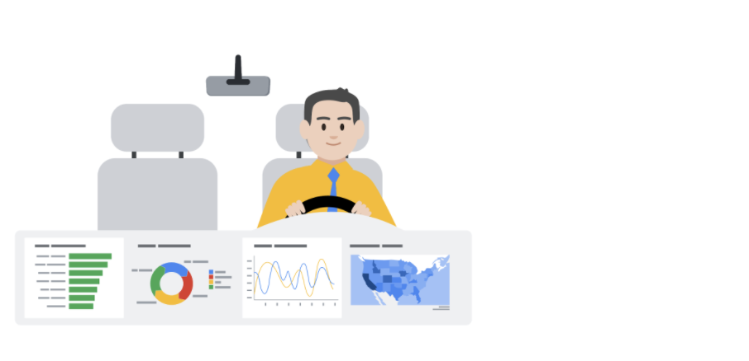

**Live versus static**

Identifying whether data is live or static depends on certain factors:

* How old is the data?
* How long until the insights are stale or no longer valid to make decisions?
* Does this data or analysis need updating on a regular basis to remain valuable?

**Static data** involves providing screenshots or snapshots in presentations or building dashboards using snapshots of data. There are pros and cons to static data.

**PROS**

* Can tightly control a point-in-time narrative of the data and insight
* Allows for complex analysis to be explained in-depth to a larger audience

**CONS**

* Insight immediately begins to lose value and continues to do so the longer the data remains in a static state
* Snapshots can't keep up with the pace of data change

**Live data** means that you can build dashboards, reports, and views connected to automatically updated data.

**PROS**

* Dashboards can be built to be more dynamic and scalable
* Gives the most up-to-date data to the people who need it at the time when they need it
* Allows for up-to-date curated views into data with the ability to build a scalable “single source of truth” for various use cases
* Allows for immediate action to be taken on data that changes frequently
* Alleviates time/resources spent on processes for every analysis

**CONS**

* Can take engineering resources to keep pipelines live and scalable, which may be outside the scope of some companies' data resource allocation
* Without the ability to interpret data, you can lose control of the narrative, which can cause data chaos (i.e. teams coming to conflicting conclusions based on the same data)
* Can potentially cause a lack of trust if the data isn’t handled properly

**Key takeaways**

Analysts need to familiarize themselves with the business and data so they can recommend when an updated static analysis is needed or should be refreshed. Also, this data insight will help you make the case for what sorts of analyses, visualizations, and additional data are recommended for the types of decisions that the business needs to make.

Keep this [customer survey spreadsheet](https://docs.google.com/spreadsheets/d/1DWIKPvtci3Gq6Qbz15SjjY6l4wbc_4I-CpVaFDPneDA/template/preview?resourcekey=0-OOpDEJqur_5qsHXNIt2Bqg) on hand as it will be useful for the next video.

So far, we've focused a lot on understanding our audience.

Whether you're trying to engage people with data storytelling or

creating dashboards designed for a certain person or group,

understanding your audience is key.

As you've learned, you can make dashboards that are tailored to meet different

stakeholder requirements.

To do this, it's important to think about who will be looking at the data and

what they need from it.

In this video, we'll continue exploring how to create

compelling visuals to tell an interesting and persuasive data story.

One great tool for doing this is a filter. You've learned about filters and

spreadsheets and queries, but as a refresher, filtering means showing only

the data that meets a specific criteria while hiding the rest.

Play video starting at ::50 and follow transcript0:50

Filtering works the same way with dashboards—you

can apply different filters for different users based on their needs.

Play video starting at ::59 and follow transcript0:59

Tableau lets you limit the data you see based on the criteria you specify.

Maybe you want to filter data and the data set to show only the last six months, or

maybe you want to see information from one particular customer.

You can even limit the number of rows or columns in a view.

To explore these options, let's return to our world happiness example.

Say your stakeholders were interested in only a few

of the topics that affect overall happiness.

Filtering for just gross domestic product, family, generosity,

freedom, trust, and health, and then creating individual scatterplots for

each would make this possible.

Play video starting at :1:42 and follow transcript1:42

You can also use filters to highlight or hide individual data points.

For instance, if you have a scatterplot with outliers,

you may want to explore what your plot would look like without them.

However, note that this is just an example to show you how filters work;

it's not okay to drop a data point just because it's an outlier.

Outliers could be important observations, sometimes even the most interesting ones,

so be sure to put on your data detective hat and

investigate that outlier before deciding to remove it from your dashboard.

Here's how to do it.

To filter data points from the view, we can choose a single data point or

click and drag in the view to select several points.

Let's choose just one. Then on the tool tip that appears,

we'll select "exclude" to hide it or

we could have chosen to do it the other way by keeping only selected data points.

Play video starting at :2:36 and follow transcript2:36

Here's another example.

If your data is in a table, you can filter entire rows or columns from your view.

To do this, we'll select the rows we want in the view. Then,

on the tool tip that appears, we'll choose to keep only those countries.

Again, we could have also selected the data points we wanted to exclude and

picked that option instead.

Play video starting at :3: and follow transcript3:00

Or if you like, we can even prefilter a Tableau dashboard.

This means that your stakeholders don't have to filter the data themselves.

Basically, by doing the filtering for them, you can save them time and

effort and direct them to the important data you want them to focus on.

Personally, I think the best thing about filters is they let

you zero in on what's important.

Sometimes I'm working with a huge data set, and I want to concentrate only on

a specific area, so I'll add a filter to limit the data displayed on my dashboard.

This cuts the clutter and gives me a simple, clear visual.

I use filters a lot when working with data about advertising campaign performance.

Filters help me isolate specific tactics, such a search or YouTube ads, to see

which ones are working best and which ones could be improved.

By limiting and customizing the information I'm looking at,

it's much easier for me to see the story behind the numbers.

And as I'm sure you've noticed, I love a good data story.

As a data analyst, you'll often be relying on spreadsheets to

create quick visualizations of your data to tell your story.

Let's practice building a chart in a spreadsheet. To follow along,

use the spreadsheet link in the previous reading,

also included in the video.

We'll be using Google Sheets, so this might look a little different in other

spreadsheet platforms, like Excel. We'll begin by filtering just the data on how

many customers purchase basic plus or premium software packages.

To start, select the column for the software package and insert a chart.

The spreadsheet suggests what it thinks is the best type of chart for

our data, but we can choose any type of chart you'd like.

Spreadsheet charts also let you assign different styles,

access titles, a legend, and many other options.

Feel free to explore the different functionality later on.

We'll also cover this more in a reading.

There's lots of different options to choose from.

Let's say we also have data on which countries our customers are from and

their overall satisfaction score for the software they purchased.

First, highlight columns A and B, then click on "insert" and

then "chart" again under "chart type."

You want to select the first map option.

Voila!

Now we have a map that summarizes a customer survey scores by country.

We can also customize this chart by clicking "customize" in the top right

corner.

Let's say we wanted to change our colors from red and green to a gradient so

it's more accessible.

We can do that by clicking "geo" and then change the min color to the lightest

shade of blue, the mid color to the middle shade of blue, and the max color

to the darkest shade of blue to show the spectrum of scores from low to high.

Now we have a map chart that shows where respondents are most satisfied with their

software in dark blue and least satisfied with their software in light blue.

And this will be easier for

anyone in our audience with color vision deficiencies to understand.

Tableau and spreadsheets are common tools for creating data visualizations.

By using their built-in functionalities like filters and charts,

you can zero in on what information is most important and

create compelling visuals for your audience.

And now that we've explored some ways to create visuals,

it's time to start preparing our data narrative. Coming up,

we're going to talk more about telling stories with data and

organizing presentations.

I'll see you soon.

**Create your first Tableau dashboard**

You're going to take what you've learned about data visualizations and create a dashboard.

Tableau contains tons of other functionality to build dashboards that update in real time and include interactive visualizations.

Dashboards are important in data analysis because they enable people to visualize data in dynamic and interactive ways, which can help enhance what you can do with your data presentations. Data visualizations are most useful when they are presented in a dashboard style format to stakeholders because dashboards put all the key information in the same place, making it easier to understand what's really important. Many dashboards also constantly update to reflect new data and can be interactive. No matter what style of dashboard you choose, they can help you present your data to stakeholders in an impactful way.

**Open Tableau**

You'll need to navigate and sign-in to the [Tableau Public](https://public.tableau.com/app/discover) online app. You may also refer back to the reading on how to create an account, a profile, loading, and linking datasets using the Tableau public app - [Using Tableau Public](https://www.coursera.org/learn/visualize-data/supplement/bMjvq).

**Accessing the Dataset**

Click on the link to create your own copy of the [CO2 Dataset](https://docs.google.com/spreadsheets/u/1/d/1LwGHDgJkXSm8b0ziSDyC8pQGqjYVGpX9mAEVPs2KQgY/copy).

If you do not have a Google account, you may directly download the CO2 dataset by clicking below:

[CO2 Dataset](https://d3c33hcgiwev3.cloudfront.net/EVkUZEQBRjS6Vbihr3z6aQ_eb9289d2c49e46d697fc919a582119f1_CO2-Dataset.xlsx?Expires=1706918400&Signature=Wo0V708VVxYFVc8RS4pqPXf3Lgu1oARqnaOsUARZQoTI9DrNZH8LXq8yxv-NszOpWo4-j33CD1h~YKOizOM8w8Pc63qCyfzQAD-DtNMxDR4~GJ9oftuAxyOrXjneZrklAV-C2k9zlrtPdJ75jj037P1RApBJhaZ1~ShVtAGneqE_&Key-Pair-Id=APKAJLTNE6QMUY6HBC5A" \t "_blank)

[XLSX File](https://d3c33hcgiwev3.cloudfront.net/EVkUZEQBRjS6Vbihr3z6aQ_eb9289d2c49e46d697fc919a582119f1_CO2-Dataset.xlsx?Expires=1706918400&Signature=Wo0V708VVxYFVc8RS4pqPXf3Lgu1oARqnaOsUARZQoTI9DrNZH8LXq8yxv-NszOpWo4-j33CD1h~YKOizOM8w8Pc63qCyfzQAD-DtNMxDR4~GJ9oftuAxyOrXjneZrklAV-C2k9zlrtPdJ75jj037P1RApBJhaZ1~ShVtAGneqE_&Key-Pair-Id=APKAJLTNE6QMUY6HBC5A" \t "_blank)

**Load the Dataset**

1. Now that you have logged into Tableau Public, access the data source dashboard by clicking on the **Create tab**, then the **Web Authoring** option at the top of the landing page. Next, click on the center button, **Upload from computer**, and select the CO2 Dataset that has been downloaded to your device.
2. Once the dataset has been loaded, direct your attention to the bottom of the data source tabs in the bottom left corner of the window. This opens the data sources folder Tableau public has created on your machine by default. Going forward, you should save any datasets you're working with to the data sources folder. Keeping your data files in one place is a best practice that will keep you organized.
3. Make a note that all of the tabs within the dataset are arranged into a vertical toolbar on the left side of the page.
4. Drag the Sheet titled **CO2 Data Cleaned** from the left bar to the middle of the page and click on the button **Update Automatically** option after dragging the sheet icon.
5. Navigate back to the tab titled **Sheet 1** at the bottom of the page and click on it. At this point, a new window with a vertical dashboard titled **Tables** will appear.
6. Drag the *green* **# Year** icon to the **Columns** box located at the top of the page.
7. Drag the *green* **# CO2 (kt)** icon to the **Rows** box located at the top of the page.
8. Drag the *blue* **Abc Region** icon to the **Colors** icon containing the 4-colored dots.
9. You have now created your first basic timeline dashboard, which indicates the level of CO2 (kilotons) emitted by the various parts of the globe from 1960 to 2012.
10. You may also do a preliminary analysis of the number of categories, rows, data ranges, and any null values that appear in the data source page. This will give you a sense of more dashboard types and styles that can be generated from the dataset.

**Create Additional Dashboards**

Directions on how to create additional dashboard types with Tableau are [here](https://help.tableau.com/current/pro/desktop/en-us/dashboards_create.htm).

Great, you've created your first basic dashboard!

**1.**

Question 1

What are the key objectives of using a dashboard to organize information from multiple datasets into one central location? Select all that apply.

1 point

Analyze data

Track data

Visualize data

Protect data

**2.**

Question 2

Fill in the blank: Dashboard visuals should be \_\_\_\_\_, which means that they are balanced and make good use of space.

1 point

cohesive

interactive

informative

symmetrical

**3.**

Question 3

What type of layout should you choose if you want your Tableau dashboard to automatically resize itself based on the overall dashboard size?

1 point

Floating

Tiled

Filtered

Summarized

**4.**

Question 4

For what reasons might a data analyst choose to use filters when creating a dashboard view? Select all that apply.

1 point

Put data in chronological order

Highlight individual data points

Zero in on what is important to stakeholders

Remove outliers that don't conform to their hypothesis

Businesses everywhere know the power of using data to solve problems and

achieve goals.

But all the data in the world won't get you anywhere if your stakeholders can't

understand it or if they can't stay focused on what you're telling them.

So you want to create presentations that are logically organized,

interesting, and communicate your key messages clearly.

An effective presentation supports your narrative by making it

more interesting than words alone.

Play video starting at ::28 and follow transcript0:28

It starts with how you want to organize your data insights.

The narrative you share with your stakeholders needs characters,

a setting, a plot, a big reveal, and an "aha moment," just like any other story.

The characters are the people affected by your story.

This could be your stakeholders, customers, clients, and others.

When adding information about your characters to your story,

you have a great opportunity to include a personal account and bring more human

context to the facts that the data has revealed—think about why they care.

Next up is a setting, which describes what's going on,

how often it's happening, what tasks are involved, and other background

information about the data project that describes the current situation.

Play video starting at :1:17 and follow transcript1:17

The plot,

sometimes called the conflict, is what creates tension in the current situation.

This could be a challenge from a competitor, an inefficient process that

needs to be fixed, or a new opportunity that the company just can't pass up.

This complication of the current situation should reveal the problem your analysis

is solving and compel the characters to act.

The big reveal, or

resolution, is how the data has shown that you can solve the problem

the characters are facing by becoming more competitive, improving a process,

inventing a new system, or whatever the ultimate goal of your data project may be.

Finally, your "aha moment" is when you share your recommendations and

explain why you think they'll help your company be successful.

When I'm working on a presentation, this is where I like to start, too.

Using these basic elements to outline your presentation could be a great place

to start, and they can help you organize your findings into a clear story.

And once you decided on these five key parts of your story,

it's time to think about how to pair your narrative with interesting visuals

because as you're learning, an interesting and

persuasive data story needs interesting and persuasive visuals. Coming up,

you'll learn even more about how to be an expert data storyteller.

Welcome back. Now that you know

how to prepare the key parts of your data story—the

character, setting, plot,

big reveal, and the aha moment—it's

time to think about the visuals

and how your slideshow should look.

It's always good to remember that

your presentation reflects on you.

If it's messy, disorganized,

or full of images that don't support your story,

your audience could easily lose

confidence in your results and recommendations.

On the other hand, if

your slideshow looks professional and appealing,

you've got a better chance to capture

your audience's attention and

keep them focused on your main points.

Themes are a great tool for this.

They control the color,

font types and sizes,

formatting, and positioning of text and visuals.

Some themes are fun or creative,

while others have a more professional look.

By choosing a theme that matches

the tone and information you're communicating,

your presentation will have

a consistent look and

support the argument you are trying to make.

Next comes the title.

It's good to include a title and subtitle

that describe what you're about to present.

You should include the date of your presentation too,

especially if you're including

data that's likely to change over time.

Specifying a date, such as a "date created" or "date last

updated," gives anyone viewing

your presentation important context.

A good slideshow guides

the audience through your main communication points,

but it doesn't repeat every word you

say or give a lot of written information.

Part of your job is to

choose what information to include.

This might be a description of

what's being shown in a visual,

the first step in a process,

a set of directions,

or an important message that you want to

be sure your audience understands and remembers.

Also, be sure to adjust

the font size so your audience

can easily read what you've written.

A good rule is to keep texts to

less than five lines and 25 words per slide.

Basically, you want your audience

focused on what you're saying,

not busy reading the slides.

Also, choose your words carefully.

It's always smart to avoid slang terms,

abbreviations that people might not know,

and words or phrases that are

specific to one particular region.

Now let's discuss visuals.

Visuals help the audience quickly

understand the content of each slide.

They can help you make a point in a way that

words might not be able to alone.

Great visuals don't leave room for

interpretation because

the meaning is instantly understood.

When you include visuals on a slide,

try not to share too many details all at once.

Choose just the data points that support your points,

especially your key message.

I like to ask myself,

"What's the single most important thing I want

my audience to learn from my analysis?"

That helps me decide

which visuals will be

most likely to get the point across.

If you have several important things you need to include,

don't cram them all on one slide;

instead, create a new visual for each point.

Then add an arrow, a call-out,

or another clearly-labeled element to direct

your audience's attention toward

what you want them to look at.

Finally, when you get to your big reveal and aha moment,

your visuals must communicate

these messages with clarity and excitement.

These are the most powerful discoveries

from your analysis—make

it feel that way.

Before you go, there's one last thing I'd like to share.

It's a quick tip for knowing when to copy and paste,

link, or embed a visual into a slideshow.

This can be challenging for new data analysts,

but there are some simple points to keep in mind.

When you copy and paste a visual into your presentation,

you can edit it directly within your slideshow.

If your visual or its data points exist

in other places, such as a Tableau dashboard,

any changes you make will not affect them there.

Now, this also means your visuals won't

be updated if the original dataset changes.

This means your visual might not

be reflecting the latest information,

but if you link your visual within your presentation,

the visual lives within its original file,

and the slideshow connects to it with the visual's URL.

Because the two files are now linked,

when you make changes to the original file,

say a spreadsheet, the changes will

automatically appear in your presentation.

This can be useful if

the data is likely to change over time.

Your slideshow will always be up-to-date.

Finally, an embedded object

also lives in the original source file,

but the difference is that it doesn't get

automatically updated if the source file changes.

The embedded copy is completely independent.

Similarly, you can make

changes to it in your presentation

without affecting the visual or data points

from the original source file.

The main difference between pasted, linked,

and embedded objects has to do with where you store

them and how you update

them after you place them in your slideshow.

Now that you're beginning to

understand how to make great slideshows,

take a few minutes to practice what you've learned.

Create a new slideshow and select an appropriate theme.

Add your text, visuals, and an exciting reveal at the end.

Try pasting, linking, and embedding

visuals from different sources

to see how they behave differently.

You can design a presentation about

any dataset that interests you.

It doesn't need to be long or have a ton of information.

Just take the first steps and

have fun telling your own data story.

[MUSIC] Hi, my name is Sundas, and

I'm analytical lead at Google, my role is turning data

into powerful stories that influences business decisions.

I have an untraditional background where I have a six year gap between

my high school and my college career.

So for me when I was trying to start all over again, so

I started at a community college, that was my first exposure to online learning,

and it was perfect because, I was managing kids at home.

So at Google, we talk a lot about imposter syndrome, and

I personally relate to it quite a bit, being the first female in my family

to graduate university and also being an immigrant,

a lot of times I'm surrounded by people who do not look like me.

For example,

there was one time where I was presenting to a senior leaders in my org, and

I was so nervous presenting to them, I was like I'm going to totally blow this up,

and they're going to figure out that I'm just a totally a fraud and a fake.

One of the things that I changed is that, even though I was the only female in my

team, I started networking, I started expanding my network.

And I met a lot of women who are from the country where I am from and they were also

immigrant, they also struggled with English and they also looked like me and

they were doing very well in their career, they were being successful.

So when I looked at them, I was like, okay, if they can do it, then so can I, so

that for me was a very a big confidence boost to kind of like get over that

imposter syndrome feeling.

But I struggle from it day to day, I'm struggling with it right now, standing

in front of you, do I even deserve to be talking about my journey and my skills?

So it's completely normal, there are few things that I like to do,

one is that I like to give myself a pep talk, pep talk definitely works,

just saying you're totally worth it, you you deserve it,

it does wonders for me personally.

The second thing I like to do is, I like to keep a log off my success and failures.

So when I am at a down point, when I'm feeling down or

feeling I do not belong here, I look at all the things that I have

achieved from that log, and that kind of helps me.

That's a good reminder of the hard work that I put in to kind of get here,

so I did not get here because of luck,

I got here because I worked hard and I earned it.

My family is actually really proud of me, after seeing me go to school and

graduate, the two kids, my younger brother,

he actually went to school with two kids as well, and he graduated.

He finished his master's program and my sister in law, who also had two kids and

she was managing, and after seeing me that I could do it,

they had somebody to look up to.

And so my sister in law went back to school and she finish her degree as well.

So I think just being the first in my family was really hard,

because I don't have anybody to look up to.

But now I am that person that people in my family can look up to specifically girls

and they can pursue whatever they put their minds to.

**1.**

Question 1

A new challenge from a competitor, a process that needs to be improved, or a potential business opportunity could all represent which aspect of data storytelling?

1 point

Aha moment

Setting

Big reveal

Plot

**2.**

Question 2

What slideshow tool is used to control color, font types and sizes, formating, and positioning of text and visuals?

1 point

Patterns

Schemes

Motifs

Themes

**3.**

Question 3

Fill in the blank: To ensure your audience is focused on what is being said, rather than reading slides, keep text to fewer than \_\_\_\_\_ per slide.

1 point

three lines and 10 words

15 lines and 15 words

five lines and 25 words

10 lines and 100 words

**4.**

Question 4

What method should be used to add a presentation visual that will automatically update to reflect the latest information whenever the original dataset changes?

1 point

Screenshotting

Embedding

Copying and pasting

Linking

# Glossary terms from module 3

## ****Terms and definitions for Course 6, Module 3****

**Data storytelling:** Communicating the meaning of a dataset with visuals and a narrative that are customized for an audience

**Engagement:** Capturing and holding someone’s interest and attention during a data presentation

**Live data:** Data that is automatically updated

**Spotlightling:** Scanning through data to quickly identify the most important insights

**1.**

Question 1

A junior data analyst at a manufacturing company analyzes product quality data to identify potential issues. While reviewing a scatterplot of product defect rate versus production batch, the analyst notices a data point far above the average defect rate. What should they do with this outlier?

1 point

Drop it from the scatterplot

Determine whether it is an important observation

Move it closer to the main trendline

Hide it from the scatterplot

**2.**

Question 2

Fill in the blank: Charts, graphs, and other dashboard elements should be cohesive, which means they make good use of \_\_\_\_\_ and are balanced.

1 point

data filters

available space

incoming data

labels and legends

**3.**

Question 3

You are building a dashboard in Tableau. To create a single-layer grid that contains no overlapping elements, which layout should you choose?

1 point

Tiled

Itemized

Layered

Floating

**4.**

Question 4

A data analyst adds a visual to a presentation. They want to be able to edit the visual without affecting the data points from its source file. In addition, they do not want the visual to update within their presentation if the data changes in the source. Which method should they use when adding the visual to their presentation?

1 point

Screenshot

Copy and paste

Embed

Link

**5.**

Question 5

A data analyst at a hospital uses data to show that patients who receive a certain type of treatment have a significantly better chance of making a full recovery. The analyst shares this information with hospital administrators in a presentation that uses data visualizations and storytelling techniques to make the findings clear and compelling. What aspect of data storytelling does this scenario describe?

1 point

Narrative

Takeaways

Spotlighting

Setting

**6.**

Question 6

What Tableau tool can be used to limit the data displayed on a dashboard in order to focus stakeholders on the most important dashboard data?

1 point

Pre-filtering

Pre-sizing

Pre-sorting

Pre-building

**7.**

Question 7

Which of the following statements correctly describe presentation best practices? Select all that apply.

1 point

An effective presentation supports the data storytelling narrative.

The setting describes what’s going on, how often it’s happening, what tasks are involved, and other background information.

The plot creates tension in the current situation.

The characters are the analytics team members.

**8.**

Question 8

You prepare to communicate to clients about an analysis project. You consider how to connect with them and convince them to view the insights as you do. What aspect of data storytelling does this scenario describe?

1 point

Engagement

Discussion

Theme

Takeaways

You've already learned about creating data visualizations and

how to use data-driven storytelling.

Now it's time to talk about actually presenting the data.

Maybe the idea of presenting your findings of stakeholders makes you nervous,

or maybe you're getting excited just thinking about it.

Either way, these upcoming videos will get you ready to present like a pro.

Coming up, we'll learn about the art and science of presentations,

some best practices you can use for future presentations, and

how to bring multiple data sources together to tell the whole story.

As a data analyst, it's important to find answers and

make new discoveries during your data analysis,

but it's just it's important to share those findings with other people.

So if you're ready, let's get started.

Hi again.

Earlier in this program, you learned how to keep your audience in mind when

communicating your data findings. By making sure that you're thinking about who your

audience is and what they need to know,

you'll be able to tell your story more effectively.

In this video, we'll learn how to use a strategic framework to help your

audience understand the most important takeaways from your presentation.

To make your data findings accessible to your audience,

you'll need a framework to guide your presentation.

Play video starting at ::34 and follow transcript0:34

This helps to create logical connections that tie back to the business tasks and

metrics. As a quick reminder,

the business task is the question or problem.

your data analysis answers.

The framework you choose gives your audience context to better understand

your data.

Play video starting at ::53 and follow transcript0:53

On top of that, it helps keep you focused on the most important information during

your presentation.

Play video starting at :1:1 and follow transcript1:01

The framework for

your presentation starts with your understanding of the business task.

Raw data doesn't mean much to most people, but

if you present your data in the context of the business task,

your audience will have a much easier time connecting with it.

This makes your presentation more informative and

helps you empower your audience with knowledge.

That's why understanding the business task early on is key.

Play video starting at :1:29 and follow transcript1:29

Here's an example.

Play video starting at :1:31 and follow transcript1:31

Let's say we're working with a grocery store chain.

They've asked us to identify trends and online searches for

avocados to help them make seasonal stocking decisions.

Play video starting at :1:43 and follow transcript1:43

During our presentation, we want to make sure that we continue focusing on

this task and framing our information with it.

Let's check out this example slide presentation.

We can begin our presentation by framing it with the business task here.

In this second slide, I've added goals for the discussion.

It starts with "share an overview of historical online avocado searches."

Play video starting at :2:13 and follow transcript2:13

Under that, a more detailed explanation:

"We'll cover how avocado searches have grown year over year and

what that means for your business."

Then we'll "examine seasonal trends in

online avocado searches using historical data."

This is important because "understanding seasonal trends can

help forecast stocking needs and inform planning." And

finally, "discuss any potential areas for further exploration."

Play video starting at :2:43 and follow transcript2:43

This is where we'll address next steps in the presentation.

This clearly outlines the presentation so our audience knows what to expect.

Play video starting at :2:53 and follow transcript2:53

It also lets them know how the information we share is going to be connected to

the business task. You might remember,

we talked about telling a story with data before.

You can think of this like outlining the narrative.

We can do the same thing with our data

viz examples.

If we're showing this visual graph of annual searches for

avocados, we might want to frame it by saying this graph shows the months with

the most online searches for avocados last year,

so we can expect that this interest in avocados will fall on the same

months this year. That can even be used in our speaker notes for the slide.

This is a great place to add important points you want to remember during

the presentation ahead of time.

These notes aren't visible to your audience in presentation mode, so

they're great reminders you can refer to as you present.

Plus, you could even share your presentation with speaker notes ahead of

time to make the content more accessible for your audience.

Play video starting at :3:56 and follow transcript3:56

Using this data, the grocery store can anticipate demand and

make a plan to stock enough avocados to match their customers' interests.

That's just one way we can use the business task to frame our data and

make it easier to understand.

Play video starting at :4:12 and follow transcript4:12

You also want to make sure you're outlining and

connecting with your business metrics by showcasing what business metrics you use.

You can help your audience understand the impact your findings will have.

Play video starting at :4:26 and follow transcript4:26

Think about the metrics we use for our avocado presentation.

We track the number of online searches for avocados from different months over

several years to anticipate trends and demand.

By explaining this in our presentation, it's easy for

our audience to understand how we used our data.

These data points alone—the

dates or number of searches— aren't useful for our audience,

but when we explain how they're combined as metrics, the data we're sharing makes so

much more sense. Here's another potential data viz that we want to use.

We can frame it for our audience by including some of our metrics.

There's an explanation of what time period this data covers:

"Our data shows Google search queries from 2004 to 2018." Where we

gathered this data from: "Search queries are limited to the United States only."

And a quick explanation of how the trends are being measured:

Play video starting at :5:25 and follow transcript5:25

"Google trends scores are normalized at 100."

So now that our audience understands the metrics we use to organize this data,

they'll be able to understand the graph more clearly.

Using a strategic framework to guide your presentation

can help your audience understand your findings,

which is what the sharing phase of the data analysis process is all about.

Coming up, we'll learn even more about how to weave data into your presentations.

Hey, great to have you back.

So we know how to use our business tasks and

metrics to frame our data findings during a presentation.

Now let's talk about how you work data into your presentations to help your

audience better understand and interpret your findings.

First, it's helpful for

your audience to understand what data was available during data collection.

You can also tell them if any new relevant data has come up, or

if you discovered that you need different data.

Play video starting at ::32 and follow transcript0:32

For our analysis, we used data about online searches for

avocados over several years.

The data we collected includes all searches with the word "avocado," so

it includes a lot of different kinds of searches.

This helps our audience understand what data they're actually looking at and

what questions they can expect it to answer.

With the data we collected on searches containing the word avocado,

we can answer questions about the general interest in avocados.

But if we wanted to know more about something specific, like guacamole,

we'd probably need to collect different data to better understand that part of our

search data.

Next, you'll want to establish the initial hypothesis.

Your initial hypothesis is a theory you're trying to prove or disprove with data.

In this example, our business task was to compile average monthly prices.

Our hypothesis is that this will show clear trends that can help

the grocery store chain plan for avocado demand in the coming year.

You want to establish your hypothesis early in the presentation.

That way, when you present your data,

your audience has the right context to put it in.

Next, you'll want to explain the solution to your business tasks using examples and

visualizations.

A good example is the graph we used last time that clearly visualized the search

trend score for the word avocado from year to year.

Raw data could take time to sink in, but a good example or visualization can make it

much easier for your audience to understand you during a presentation.

Play video starting at :2:7 and follow transcript2:07

Keep in mind, presenting your visualizations effectively is just as

important as the content, if not more.

And that's where the McCandless Method we learned about earlier can help.

So let's talk through the steps of this method and

then apply them to our own data visualizations.

The McCandless Method moves from the general to the specific,

like it's building a pyramid.

Play video starting at :2:30 and follow transcript2:30

You start with the most basic information: introduce the graphic you're

presenting by name.

This direct your audience's attention.

Let's open the slide deck we were working on earlier.

We've got the framework we explored last time and our two data viz examples.

According to the McCandless Method, we want to introduce our graphic by name.

The name of this graph, "yearly avocado search trends," is clearly written here.

When we present it, we'll be sure to share that title with our audience so

they know where to focus and what the graphic is all about.

Next, you'll want to answer the obvious questions your audience might have before

they're asked.

Start with the high-level information and

work your way into the lowest level of detail that's useful to your audience.

This way, your audience won't get distracted trying to understand something

that could have easily been answered when the graphic was introduced.

We added in the information about when, where, and

how this data was gathered to frame this data viz.

But it also answers the first question many stakeholders will ask,

"Where is this data from, and what does it cover?"

So going back to the second graph in our presentation, let's think about

some obvious questions our audience might have when they see this graph at first.

This data viz is really interesting, but it can be hard to understand at a glance,

so our audience might have questions about how to read it.

Knowing that, we can add an explanation to our speaker notes to answer these

questions as soon as this graph is introduced.

"This shows time running in a circle with winter months on top and summer on bottom.

The farther elements are away from the center,

the more queries happened around that time for 'avocado.'"

Now some of the answers to these questions are built into our presentation.

Once you've answered any potential questions your audience might have,

you'll want to state the insight your data viz provides.

It's important to get everyone on the same page before you move into the supporting

details.

We can write in some key takeaways to this slide to help our audience understand

the most important insights from the graphic.

Here we let the audience know that this data shows us a consistent seasonal

trend year over year.

We can also see that there's low online interest in avocados from October through

December.

This is an important insight that we definitely want to share.

Play video starting at :4:56 and follow transcript4:56

Even though avocados are a seasonal summer fruit,

searches peak in January and February.

For a lot of people in the United States, watching the Super Bowl and

eating chips with guacamole is popular this time of year.

Now our audience knows what takeaways we want them to have before moving on.

The fourth step in the McCandless Method is calling out

data to support that insight.

This is your chance to really wow your audience,

so give as many examples as you can.

With our avocado graphs, it might be worth pointing to specific examples.

In our monthly trends graph, we can point to specific weeks recorded here.

"During the week of November 25th, 2018, the search score was around 49, but

the week of February 4th the search score was 90.

This shows the rise and fall of online search interest, with the help of some of

the very cool data in our graphs."

Finally, it's time to tell your audience why it matters.

This is the "so what" moment.

Why is this insight interesting or important to them?

This is a good time to present the possible business impact of the solution

and clear action stakeholders can take.

Play video starting at :6:12 and follow transcript6:12

You might remember that we outlined this in our framework at the beginning of our

presentation.

Play video starting at :6:18 and follow transcript6:18

So let's explain what this data helps our grocery store stakeholder do.

First, they can account for

lower interest in avocados between the months of October and December.

They can also prepare for

the Super Bowl surge in avocado interest in late January/early February.

And they'll be able to consider how to optimize stocking practices

during summer and spring.

There's a little more detail under each of these points, but

this is a basic breakdown of the impact.

And that's how we use the McCandless Method to introduce

data visualizations during our presentations.

I have one more piece of advice.

Take a second to self-check and ask yourself, "Does this data point or

chart support the point I want people to walk away with?"

It's a good reminder to think about your audience every time you add data to

a presentation.

So now you know how to present data using a framework, and

weave data into your presentation for your audience. And

you got to learn the McCandless Method for data presentation.

Coming up, we'll learn some best practices for actually creating presentations.

See you soon.

**Review a slide presentation**

You have started learning how to create effective slide presentations to share your findings. In this reading, you’ll develop a rubric to help you evaluate slide presentations. By the end of this reading, you will have a stronger understanding of how to create an effective slide presentation using best practices from this course. This will help you evaluate your own work.

**Your evaluation criteria**

When exploring a slide presentation, use your knowledge of effective presentation practices to evaluate it. This includes reviewing your own work! When you’re checking over slide presentations, there are some best practices you can check for:

* **Include a title, subtitle, and date:** Making sure that your slide deck presentation has a title, subtitle, and date makes sure that your audience knows exactly what you are presenting and when the information was from. That way they know it’s relevant and current to them!
* **Use a logical sequence of slides:** Organizing your slides in an order that makes sense guides your audience through your narrative, building understanding step by step.
* **Provide an agenda with a timeline:** An agenda offers a roadmap of your presentation, allowing your audience to follow along and anticipate key topics.
* **Limit the amount of text on slides:** Keeping text brief ensures clarity and retains the audience’s attention; aim for your audience to scan it within 5 seconds.
* **Start with the business task:** By immediately relating the content to the business task at hand, you contextualize your information, making it relevant and actionable.
* **Establish the initial hypothesis:** Presenting an initial hypothesis gives your audience a starting point for what to expect and frames the subsequent analysis.
* **Show what business metrics you used:** Clarifying which metrics you're analyzing validates your arguments and helps the audience gauge your presentation's relevance to business outcomes.
* **Use visualizations:** Visual aids can illustrate complex data more effectively than text alone, making your message more accessible.
* **Introduce the graphic by name:** A brief introduction to each graphic aids in understanding and retaining information.
* **Provide a title for each graph:** Titles act as signposts, helping the audience quickly grasp the meaning of each visual.
* **Go from the general to the specific:** Starting with a broad overview before diving into details ensures that all audience members are on the same page.
* **Use speaker notes to help you remember talking points:** Notes act as your cue cards, enabling a smoother delivery and ensuring no critical point is missed.
* **Include key takeaways:** Summarizing the main points at the end of your presentation reinforces the message and ensures the audience leaves with the intended takeaways.

Like so many parts of your job as a data professional, creating presentations is an iterative process. Reviewing your work, making changes as needed, and improving it when you can will make your presentations clearer and more useful for stakeholders.

**Create an evaluation table**

Now that you have an understanding of what best practices you are trying to apply to slide presentations, organize your reviews using an evaluation table. An evaluation table essentially gives you a checklist for each slide in a presentation so you can identify any changes that need to be made in an organized fashion. The evaluation table should have a column for the slide number, a column for you to take notes on what worked well, and a column for what could be improved. Here’s an example of a blank evaluation table:

| **Slide #** | **What works well** | **What could be improved** |
| --- | --- | --- |
| 1 |  |  |
| 2 |  |  |
| 3 |  |  |
| 4 |  |  |
| 5 |  |  |
| 6 |  |  |
| 7 |  |  |

You can use evaluation tables to note things you liked about a presentation as well as things you would like to improve!

**Key takeaways**

Refining your skills in evaluating slide decks is an evolving journey. Each aspect of your presentation—from a concise title to a coherent sequence of content, and the conciseness of your text to the accuracy of your visuals—is intentionally designed to elevate the audience's understanding and interest. Documenting your progress and taking time for reflection supports your development and is fundamental to communicating complex data in a clear, impactful narrative. And to improve your presentation skills for the future!

[MUSIC] My name is Brittany, and

I'm an Analytical Lead at Google.

One of the tips that I have is to try to keep things "kindergarten simple."

And what that means is, keep the concepts that you're presenting as simple and

as straightforward as possible.

Whenever you enter a room, there are going to be people within that room

of varying interest levels, varying knowledge levels.

They have different levels of subject matter expertise.

Nobody wants to present to a room whose eyes are glazing over.

My pet peeve about seeing certain presentations with data is that

they often will include what I like to call "eyesore charts."

And what an eyesore chart is, it has way too much data,

has way too many colors, it just looks busy, and you just really

can't figure out what the presenter is actually trying to say.

Another tip that I have is to make your presentation fun.

So nobody wants to be in a room where you are talking for

a full hour, and the only voice that you're hearing is your own.

One of the things that I try to do to break it up is I try to think of little

fun games or quizzes, or I'll play a video or ask questions to the audience just

to make sure that they're fully engaged and that they are talking back to me.

Another tip that I try to incorporate into my presentations is storytelling.

Everybody loves a good story, and when you do it right,

you are able to connect and make your audience engage in a way that they

probably wouldn't if you weren't telling that story.

The last tip that I have is make sure that you have an ally in the room.

Oftentimes before I'm giving a really big data presentation,

I will find one or two people that I know are going to be in the room and

present my content to them ahead of time.

And what that does is it allows me to not only get feedback, but

it also allows me to make sure that someone else is nodding their head and

aligned to the numbers that I'm about to present.

And I can't even tell you how many times that I've been in presentations

where those allies have really come to my rescue.

When the room asks a lot of questions or

are potentially trying to poke holes in the analysis,

those allies are there to speak up, and they really are going to have your back

and lend credibility to what it is that you're presenting.

The most challenging part of my job would be the fact that I am there to

convince people to do something that they might not be fully confident

that they should be doing.

And a lot of times, it takes multiple conversations,

multiple rounds of convincing, for someone to actually come around to what

I was trying to articulate or get them to do. When you have spent maybe six months or

a year building an analysis and building a story and building a narrative for

someone to apply to their strategies, and they actually come around and

they actually do it, that makes the challenges worth it

# tep-by-Step: Critique of a presentation

This reading provides an orientation of two upcoming videos:

* **Connor: Messy example of a data presentation**
* **Connor: Good example of a data presentation**

To get the most out of these videos, you should watch them together (back to back). In the first video, Connor introduces a presentation that is confusing and hard to follow. In the second video, he returns to talk about what can be done to improve it and help the audience better understand the data and conclusions being shared.

## Messy data presentation

In the first video, watch and listen carefully for the specific reasons the “messy” presentation falls short. Here is a preview:

* No story or logical flow
* No titles
* Too much text
* Inconsistent format (no theme)
* No recommendation or conclusion at the end

### ****Messy presentation: people don’t know where to focus their attention****

The main problem with the messy presentation is the lack of a logical flow. Notice also how the data visualizations are hard to understand and appear without any introduction or explanation. The audience has no sense of what they are looking at and why.  When people in the audience have to figure out what the data means without any help, they can end up being lost, confused, and unclear about any actions they need to take.

## Good data presentation

In the second video, numerous best practices are applied to create a better presentation on the same topic. This “good” presentation is so much easier to understand than the messy one! Here is a preview:

* Title and date the presentation was last updated
* Flow or table of contents
* Transition slides
* Visual introduction to the data (also used as a repeated theme)
* Animated bullet points
* Annotations on top of visuals
* Logic and progression
* Limitations to the data (caveats) - what the data can’t tell you

**Tip:** As you watch this video, take notes about what Connor suggests to create a good presentation. You can keep these notes in your journal. When you create your own presentations, refer back to your notes. This will help you to develop your own thinking about the quality of presentations.

### ****Good presentation: people are logically guided through the data****

The good presentation logically guides the audience through the data – from the objectives at the beginning all the way to the conclusions at the end. Notice how the data visualizations are introduced using a common theme and are thoughtfully placed before each conclusion. A good presentation gives people in the audience the facts and data, helps them understand what the data means, and provides takeaways about how they can use their understanding to make a change or do some good.

## Up next

Get started with the messy vs. goodpresentation comparison by viewing the first video: [Connor: Messy example of a data presentation](https://www.coursera.org/learn/visualize-data/lecture/SYW63/connor-messy-example-of-a-data-presentation).

So we're going to dive into specific examples that we have.

So we've built what we call a

messy example of a data presentation.

We'll walk through each slide

and the presentation as a whole to understand

why it doesn't actually

work well for explaining a specific analysis.

We have a title slide:

"The Relationship Between Health and

Happiness Around the World."

Right off the bat, there

is a very generic picture about the world.

It is a very lengthy title.

We know what we're going to be talking about,

but there's nothing here that's

really compelling about the presentation.

The first slide, when we are

looking at a data presentation,

we have immediately put a lot of data

in front of them and a lot of text in front of them.

Right now they don't know what they're looking at.

There was no statement of purpose.

We don't have an introduction slide.

They don't know who I am.

They don't know why they're there.

What are we talking about?

Why are we talking about it?

What should they walk away with?

There's none of that—we've just immediately gone

into the specific data visuals that we are showing them.

Now, an important aspect of

every slide is also to have a title.

Now, title, subtitle, these things

help people understand exactly what

this slide is going to be discussing so that they

know what they're trying to

understand as you are talking.

So immediately getting here,

the audience is going to be lost.

They're going to be trying to read the slide.

They're going to be trying to decipher

what the visuals mean.

It's important for you to

make sure there's not too much going on.

Now if we move on to the next slide,

what we're looking at here —the visual is better,

it's easier to understand.

There's not more than one of them.

We have a map. We have

visual colors to represent

the numeric values within them.

But again, there's nothing for them to really understand.

Now this is where you can explain

within the speaker notes.

But you also have, again,

a lot of words, no title.

What is it that they are really

trying to get from this slide?

Part of a good presentation, as well, is

the theme that you have or a consistent theme.

So you've now switched sides of the specific visual.

You have the text on the other side.

Doesn't mean you can't do it,

but what you're really trying to do throughout

a presentation is build some familiarity,

especially with data analytics.

You're building familiarity with

the visuals that you're showing them—the data.

By the end of the presentation,

they should understand the data or

the concept as much as you do.

Finally, we have the conclusion slide.

This one does have a title:

"Laughter is the best medicine."

We understand again what it is that we're looking at,

but there is no logical flow and how to get here.

Was this overall presentation compelling?

We put two slides on there.

We had too much text.

We didn't really explain anything about it.

Again, there's awkward placement on where

all of these things are within the slide itself.

When you're thinking about building a presentation,

you should think about it from

the audience's point of view.

The only thought that's going through their head is,

"Where should my focus be?

As I'm trying to listen,

as I'm trying to comprehend,

where should I be looking?"

If you have slides like we just showed you,

they don't know where they should be looking

or they're going to spend their time

reading and trying to comprehend

while you're also talking.

It's very important that you are

directing their gaze and directing

the audience so that they know

exactly what they should be listening to,

what they should be trying to understand, and

you are guiding them through to the overall conclusion.

So to sum up in terms of what is wrong

with this overall presentation and

not just what you're going to be talking

about or what you are trying to conclude,

but just the overall placement

of the data visuals and the visuals that you chose.

The main thing is there was no story, no logical flow.

You started with a bunch of

scatterplots and a lot of text and you moved

on to the heatmap of the happiness scores,

but without somebody presenting something,

without any idea of the

concept behind what they are trying to conclude.

You didn't have titles,

there's too much text,

it's very difficult to understand,

and it was uneven and inconsistent.

Even if you had a really good explanation on each slide,

you might have lost

the audience because what they were trying to do,

what they were trying to understand,

is what was the slide trying to tell them?

Finally, the most important part of

any data analytics presentation

is the recommendation or conclusion slide.

You had that, but there was no title.

They didn't know that this was

the end of the presentation,

that this is where they should be

trying to put all the pieces together.

Coming up, we're going to discuss how we

can improve this presentation,

as well as dive into what

the presentation will actually look like

when we're trying to explain

how health and happiness are correlated.

[MUSIC]

So now that you know what not to do,

I'm going to walk you through how I would tackle a presentation.

So to start, you can see the title slide, it's a lot simpler.

We have a title, we have who is presenting, and we have when it occurred.

Now, I do want to talk a little bit about the date at the bottom,

which is an important factor that you shouldn't forget to include.

You may come back to this presentation a few months later, even a year later or

this may be disseminated across your company.

It's important to know when this analysis took place, and

why, and what were the circumstances of it?

And the big part of that is, what were the circumstances of the company at the time

that this was actually presented?

So the next slide is giving an idea of what you're going to be

presenting to everyone and when.

So you start with your purpose statement.

What you're going to be discussing, what are we talking about?

The next aspect is, where you actually tell your story.

And that's an important concept is this overall presentation is a story with data.

And finally, you have your conclusion slide.

You're going to be very clear that this is the conclusion.

This is where you're going to add recommendations if this is in

a business context.

And then you'll have your appendix, where you can have additional

information on data, data visuals, as well as overall context for

the presentation that may not work within the overall flow itself.

So, our transition slide, what are we talking about?

So this is where you let the audience know what we're talking about,

what are we trying to tell them?

What are all the slides that are following this going to be driving towards?

So when we look at this slide, I'm trying to identify if there are geographic,

demographic, and/or economic factors that contribute to a happier life.

That is the purpose of the overall presentation.

So everybody now in the room knows this and that is what they're

going to be thinking about as you present all of the data to them.

Next section on our table of contents, present the data.

It is important to mention these will probably have different titles

as you build them out, but this is the topic that we're moving into.

So you'll recognize this visual from the messy slide, but

it has a different color context.

That's not as important but what is important is when you get here,

you have a title on the slide, you have a visual, but there is no text.

And this is an important aspect to it is what we're trying to do is walk and

introduce the audience to the overall data that you're going to be using.

Play video starting at :2:46 and follow transcript2:46

Now, this is the first slide that has any form of content on it,

so it's important that you introduce them to the underlying data.

Play video starting at :2:54 and follow transcript2:54

And seeing as the data is all about geographic, demographic, and economic

data points per each country, it's important that the visual represents that.

If I were to be the presenter on a slide like this, I would start by getting to

this slide and explaining the process and data that we're looking at.

So, we analyzed the data set, consisting of data collected from

residents of European countries between 2015 and 2017.

The data contained demographic and economic data for

individuals within each country, including population, GDP, or

Gross Domestic Product, and the happiness score per person.

Play video starting at :3:38 and follow transcript3:38

So I've now introduced them to the data set.

Play video starting at :3:42 and follow transcript3:42

There's still no text, so they know that they should be looking at the visual and

listening to me.

Now the next aspect which can be over utilized but

I've also seen underutilized is using animations in your presentation.

Animations can be used as a way to direct your audience's attention as you speak.

A way to say, look over here at this area of the slide as I'm talking.

Play video starting at :4:6 and follow transcript4:06

It also allows them not to get too bogged down or

distracted as you're introducing new concepts to them.

Because remember,

as you're introducing data the technical components may be new to a lot of people.

And finally, another way to do this is through annotations on top of visuals that

can be used as another form of directing their gaze and their overall attention.

So putting these together,

we can have something like an annotation appear as you're discussing it.

So, if we were trying to explain what the visual is showing,

we have an annotation that pops up that says "happiness score" and

points to the score within the specific country,

and we can explain exactly what the visual is showing.

So in this way, we could say something like,

we began by creating a heat map of the happiness score for each country.

Where the number within each country represents the overall score and

the colors represent how high or how low the score is on a scale.

So, the darker blue the country is,

the higher the numeric happiness score for that country.

The deeper red that the country is,

the lower the happiness score and overall numeric value.

So what we've done before any text has appeared on the screen is explain

the visual, explain the overall data

that they're going to be looking at throughout the presentation,

so that they now can understand when we dive into this specific analysis.

So it's important that you only use text on the screen in a short and

concise manner to highlight the main points that you're discussing.

So after I introduce the visual, I can now dive into the analysis.

So, we have our first bullet point: Happiness levels vary widely by country.

So with this as it appears, my speaker notes can be something along the lines

of: "However, as high and low scores are spread sporadically throughout the map,

there is little correlation that we find between geographical location and

happiness.

Finally, we concluded that the geographical location alone was not

a strong indicator of happiness."

So as you can see as I'm discussing and

as I'm explaining what we are looking at within the data,

the overall text on the screen only populated as I began to discuss it,

so the audience knew exactly where to look and

exactly what to be listening to when I'm talking.

A very important aspect of the flow of the overall presentation is the transition

from one slide to the next.

So as I'm discussing this, you can use a bullet point,

you can use your speaker notes.

Either way, there should be some transition from one slide to the next so

that the audience knows that this part is over and they know what's coming next.

So, for this slide, I used my speaker notes.

So I'm going to explain the transition, something like: "Our next step was to

identify the demographic and economic differences between the higher and

lower countries to isolate the correlated features between them."

So, we get to the next slide.

Very common theme, it may be a different visual, but the overall title and

where the text is going to show up is going to be in the same place.

So we familiarize them with the overall theme of the presentation within three

slides.

Now, the title immediately tells what we're going to be discussing.

The previous one was geographic; this one is all based on population.

As we move through this slide and as you saw in the messy example,

we use a lot of scatterplots,

and scatterplots may not always be the best option because they are rather

difficult for people to follow within presentations.

But if you explain it to them once so that they understand,

you can use them throughout the presentation because you familiarize them.

So, because it's the first time it popped up,

it's important that you explain the visual in-depth and all the features of it that

you will be talking about later throughout the presentation.

We use animations again.

We talk about what are the axes on the scatterplot.

We created a scatterplot in which we plotted countries based on their happiness

score and the population to see if there was a correlation between the two.

The higher up something is on the scatterplot, the happier the country is.

Play video starting at :8:14 and follow transcript8:14

The further to the right that the country is plotted, the larger the population.

Play video starting at :8:20 and follow transcript8:20

And the line that goes between the two is testing for correlation or

if these two different points are related to one another.

Play video starting at :8:30 and follow transcript8:30

So these annotations and

these animations are there to clarify what the chart is plotting.

Play video starting at :8:37 and follow transcript8:37

Now, the overall purpose is that we are attempting to identify if

there is a relationship between the population size of the country and

the overall happiness score.

Play video starting at :8:46 and follow transcript8:46

So, now that you have explained what this visual is,

you can now dive into the results of it.

Play video starting at :8:53 and follow transcript8:53

Now this slide itself has one bullet point.

It is the results of the overall analysis that you can find just based on

the data visual.

We found that there was little to no correlation between happiness and

population based on the analysis that we ran.

So all discussion and in-depth explanation of the visual

is kept in the speaking notes besides the overall annotations.

Play video starting at :9:20 and follow transcript9:20

And again, the transition is very important to the next slide.

So, you can say something like: "So next, we dove into the specific demographics of

each country to see if we can identify the features that separate or

correlate with the overall happiness of the country."

Again, same thing.

We have the title, we know what we're going to be talking about now.

This is how the health of each country and how it correlates with happiness.

Play video starting at :9:45 and follow transcript9:45

We have a scatterplot again, except the good news is, you've already introduced

what the scatterplot is and what you are comparing on there.

So now the audience has been familiarized with the data set.

You don't have to go through and explain exactly what the visual is representing.

You can dive into the overall differences or

analysis that you're going to be presenting on this slide.

You can have something explaining that we found a positive correlation

between happiness and health, or overall life expectancy of the country.

Play video starting at :10:18 and follow transcript10:18

Now we found this because the correlation coefficient between

the two different factors being happiness and health was 0.50.

Now, you just introduced a new concept.

This is where you have to now explain the new concept because otherwise you may

lose people in the room.

This is a technical component to your overall analysis and

it is an important component so it is critical that you do explain what it is,

but in a simplified way so that everybody understands.

Play video starting at :10:51 and follow transcript10:51

So, you can say something along the lines of: "A correlation coefficient is a measure

of strength and direction of the linear relationship between two variables.

So in other words, the closer to one that the number is,

the more positively correlated they are.

Meaning, when one of the variables goes up, so does the other one.

The closer to negative one that the number is,

the more negatively correlated they are.

Meaning, as one of the variables, such as happiness, goes up

that the other variable like health would go down.

And the closer to zero it is, it means they are not correlated at all,

which is what we saw between population and happiness,

and means that they have no relationship together."

So we've now explained exactly what it is that we use as

an analysis on this specific slide.

And it's important again that we discuss the transition to the next.

So: "We did find that there is a positive correlation between happiness and health,

but the question remains, are happy people healthy or are healthy people happy?

We know that they are related but we don't know what causes the other.

And finally, what contributes to a longer life expectancy?

If we know that longer life expectancy is related to happiness,

what is it that helps create longer life expectancy within a country?"

Now these are the two questions that we need to answer before the end of

the presentation moving on from here.

So again, we are creating a logical flow as we move through this presentation.

Play video starting at :12:32 and follow transcript12:32

Now, we are looking at a new concept: wealth within each country.

Play video starting at :12:37 and follow transcript12:37

Now that you are using such as the scatterplot are

familiar with the audience, it's okay now that you add in additional ones.

So, you can say something along the lines of:

"We then analyzed how GDP or the overall economic

status of the country relates to the overall health of the country.

Because if we know that GDP is related to health and we know that health is related

to happiness, then we can infer additional information through that.

So, we found that there is a strong correlation between gross domestic

product and

the overall health of a specific country with a 0.7 correlation coefficient,

so higher than the overall correlation coefficient for health and happiness.

Next we found an even stronger correlation between GDP and happiness.

So, whereas we first looked at health and happiness and then GDP and health,

we're now looking at GDP and happiness and found that it has the highest

correlation coefficient between all three of those comparisons.

Play video starting at :13:44 and follow transcript13:44

So we have a conclusion within just this slide, which is,

we found that richer countries have a higher average happiness level."

Play video starting at :13:55 and follow transcript13:55

This is a good transition to the overall conclusion of now your

entire presentation.

Play video starting at :14: and follow transcript14:00

So again, you're directing your audience through just presenting the text that

you want them to look at.

Your first conclusion from your overall presentation.

Wealthier countries and ones that have sustained economic growth tend to

have a higher average happiness level.

Play video starting at :14:18 and follow transcript14:18

Your second conclusion:

healthier countries also tend to have a happier population.

However, healthier countries also tend to be wealthy.

Play video starting at :14:28 and follow transcript14:28

And finally, this is where you take it home.

Play video starting at :14:31 and follow transcript14:31

So our evidence suggests that wealth, health, and happiness all go together.

It's important to also discuss any caveats or future analysis that

needs to be ran to answer the questions that may come up based on this analysis.

"So we have said that the evidence suggests that wealth, health, and

happiness all go together, but that does not mean that one causes the other,

So there needs to be future analysis to understand any causal effects

between them."

Play video starting at :15: and follow transcript15:00

And then you have your final slide, and this is where questions would come in.

Play video starting at :15:6 and follow transcript15:06

So it's important to remember that data storytelling is an art.

What we've given you is some high-level overview and examples of what not to do

and an improved version, but don't be afraid to put yourself in there.

The overall presentation style is going to come from your personality and

skill set within data analytics.

You can use the tools that we use to help you build the layout of your presentation,

but it's up to you to really put a lot of yourself into it, and a lot of your

own skills to help people understand the overall analytics that you've run.

[SOUND]

Hey there. So far we've learned about using a framework

to guide your audience through

your presentation and how to weave data in.

Now I want to talk about why

these presentation skills are so important

and give you some simple tips

you can use during your own presentations.

As a data analyst,

you have two key responsibilities:

analyze data and present your findings effectively.

Analyzing data seems pretty obvious.

It's in the title "data analyst," after all.

But data analysis is all about turning

raw information into knowledge.

If you can't actually

communicate what you've learned during your analysis,

then that knowledge can't help anyone.

There's plenty of ways data analysts communicate:

emails, memos, dashboards, and of course, presentations.

Effective presentations start with

the things we've already talked about,

like creating effective visualizations

and organizing your slides,

but how you deliver those things can make

a big difference in

how well your audience understands them.

You want to make sure they leave

your presentation empowered by

the knowledge and ready to make

decisions based on your analysis.

That's why strong presentation skills

are so important as a data analyst.

If the idea of giving a presentation makes you nervous,

don't worry—a lot of people feel that way.

Here's a secret: it gets easier the more you practice.

Now let's look at some tips and tricks

you can use when giving your presentations.

We'll go over some more advanced ones later,

but let's start with the basics for now.

It's natural to feel

your adrenaline levels rise before giving a presentation.

That's just because you're excited to be there.

To help keep that excitement in check,

try taking deep, controlled breaths

to calm your body down.

As a bonus, this will also

help you channel all that excitement into

a presentation style that

shows your passion for the work you've done.

You might remember we talked earlier about using

the McCandless Method to present data visualizations.

Well, it's also a good rule of

thumb for presentations in general.

Start with the broader ideas,

the obvious questions your audience might have,

and what they need to understand to

put your findings in context.

Then you can get more specific about

your analysis and the insights you've uncovered.

Let's go back to our avocado example and

imagine how we'd start that presentation.

After we introduce ourselves

and the title of our presentation,

we have a slide with our goals for the discussion.

We start with the most general goals

and then get more specific.

We might say our goal for today is to first provide

you all with the state of the world

on online avocado searches.

Then we'll examine the opportunities and risks of

seasonal trends in online avocado searches.

We'll move into actionable next steps that can

help you start taking advantage of these opportunities,

as well as help to mitigate the risks.

Finally, we'd love to make the third part a

discussion with you about

what you think of these next steps.

What you'll want to notice here is how our presentation

focuses on the general interest in avocados online

before getting into specifics about

what that means for our stakeholders.

We also learned about the five-second rule.

As a quick refresher,

whenever you introduce a data visualization,

you should use the five-second rule

and ask two questions.

First, wait five seconds after showing

a data visualization to let your audience process it,

then ask if they understand it.

If not, take time to explain it,

then give your audience another five seconds to let that

sink in before telling them

the conclusion you want them to understand.

Try not to rush through data visualizations.

This will be the first time some of the people

in your audience are encountering your data,

and it's worth making time in

your presentations for them.

Here's our first data viz in the avocado presentation.

When we get to this slide,

we want to introduce

our yearly avocado search trends graph

and explain the basic background we've included here.

After we wait five seconds,

we can ask, "Are there any questions about this graph?"

Let's say one of our stakeholders asks,

"Could you explain Google search trends?"

Great. After explaining that,

we wait another five seconds,

then we can tell them our conclusion:

Searches for avocados have been increasing every year.

You'll learn more about these concepts later on,

but these are some great tips for starting out.

Finally, when it comes to presenting

data, preparation is key.

For some people, that means doing dress rehearsals.

For others, it means writing out

a script and repeating it in their head.

Others find visualizing themselves

giving the presentation helps.

Try to find a method that works for you.

The most important thing to remember

is that the more prepared you are,

the better you'll perform when the lights

are on and it's your turn to present.

Coming up, we'll cover more best practices for

presentations and also look at

some examples. Looking forward to it.

**Guide: Share data findings in presentations**

Use this guide to help make your presentation stand out as you tell your data story. Follow the recommended tips and slide sequence in this guide for a presentation that will truly impress your audience.

You can also **download this guide as a .pdf**, so you can reference it in the future:

[Sharing your data findings in presentations \_ Tips and Tricks.pdf](https://d3c33hcgiwev3.cloudfront.net/_LwuiIoNSYq8LoiKDUmKxw_e8ff903b66b943ddaea3b8517fe8a3af_Sharing-your-data-findings-in-presentations-_-Tips-and-Tricks.pdf?Expires=1706918400&Signature=fLCUbQkCHwnPII4G9BTHgGr~AeSH~C0vW8yM49eUwsd4dI6w2XrVzquaYNRiEZJf4Nn-IgESI0tDLvVfmyxkc9HcNwu0cyxKXe70-VCC85LEoKlQkE535CNm5Rbd6Zn8CRgI9qeZX13QSq9O21mJOxW49uBoFoq7JiGMtwnDklQ_&Key-Pair-Id=APKAJLTNE6QMUY6HBC5A" \t "_blank)

[PDF File](https://d3c33hcgiwev3.cloudfront.net/_LwuiIoNSYq8LoiKDUmKxw_e8ff903b66b943ddaea3b8517fe8a3af_Sharing-your-data-findings-in-presentations-_-Tips-and-Tricks.pdf?Expires=1706918400&Signature=fLCUbQkCHwnPII4G9BTHgGr~AeSH~C0vW8yM49eUwsd4dI6w2XrVzquaYNRiEZJf4Nn-IgESI0tDLvVfmyxkc9HcNwu0cyxKXe70-VCC85LEoKlQkE535CNm5Rbd6Zn8CRgI9qeZX13QSq9O21mJOxW49uBoFoq7JiGMtwnDklQ_&Key-Pair-Id=APKAJLTNE6QMUY6HBC5A" \t "_blank)

**Telling your data story (tips and tricks to present your data and results)**

Use the following tips and sample layout to build your own presentation.

**Tip 1: Know your flow**

Just like in any good story, a data story must have a good plot (theme and flow), good dialogue (talking points), and a great ending or big reveal (results and conclusions). One flow could be an overview of what was analyzed followed by resulting trends and potential areas for further exploration.

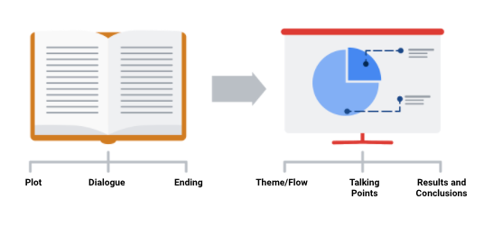

In order to develop the right flow for your presentation, keep your audience in mind. Ask yourself these two questions to help you define the overall flow and build out your presentation.

**Who is my audience?**

* If your intended audience is executives, board members, directors, or other C-level (C-Suite) executives, your storytelling should be kept at a high level. This audience will want to hear about your story but might not have time to hear the *entire* story. Executives tend to focus on endings that encourage improving, correcting, or inventing things. Keep your presentation brief and spend most of your time on your results and recommendations. Refer to an upcoming topic in this reading—Tip 3: end with your recommendations.
* If your intended audience is stakeholders and managers, they might have more time to learn about how you performed your analysis and they might ask more data-specific questions. Be prepared with talking points about the aspects of your analysis that led you to your final results and conclusions.
* If your intended audience is other analysts and individual contributors, you will have the most freedom—and perhaps the most time—to go more deeply into the data, processes, and results.

**What is the purpose of my presentation?**

* If the goal of your presentation is to request or recommend something at the end, like a sales pitch, you can have each slide work toward the recommendations at the end.
* If the goal of your presentation is to focus on the results of your analysis, each slide can help mark the path to the results. Be sure to include plenty of breadcrumbs (views of the data analysis steps) to demonstrate the path you took with the data.
* If the goal of your presentation is to provide a report on the data analysis, your slides should clearly summarize your data and key findings. In this case, it is alright to let the data be the star or speak for itself.

**Tip 2: Prepare talking points and limit text on slides**

As you create each slide in your presentation, prepare **talking points** (also called **speaker notes**) on what you will say.

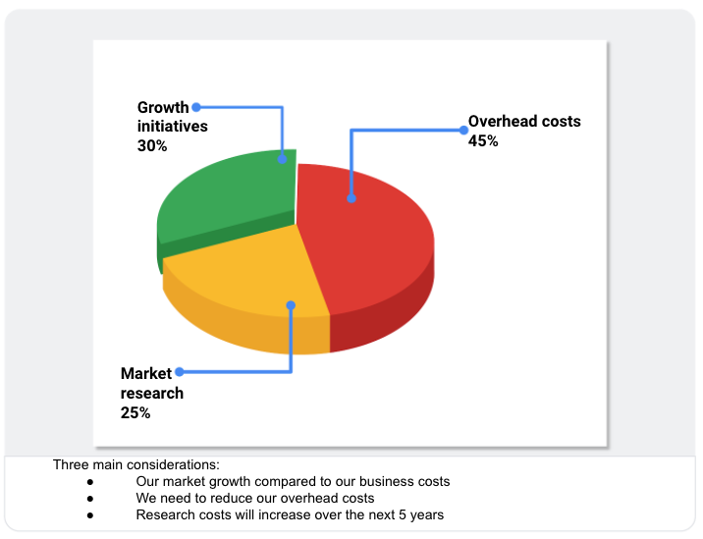

Don’t forget that you will be talking at the same time that your audience is reading your slides. If your slides start becoming more like documents, you should rethink what you will say so that you can remove some text from the slides. Make it easy for your audience to skim read the slides while still paying attention to what you are saying. In general, follow the five-second rule. Your audience should not be spending more than five seconds reading any block of text on a slide.

Knowing exactly what you will say when explaining each slide throughout your presentation also creates a natural flow to your story. Talking points help you avoid awkward pauses between topics. Slides that summarize data can also be repetitive (and boring). If you prepare a variety of interesting talking points about the data, you can keep your audience alert and paying attention to the data and its analysis.

**Tip 3: End with your recommendations**



When climbing a mountain, getting to the top is the goal. Making recommendations at the end of your presentation is like getting to the mountaintop.

* Useone slide for your recommendations at the end. Be clear and concise.
* If you are recommending that something be done, provide next steps and describe what you would consider a successful outcome.

**Tip 4: Allow enough time for the presentation and questions**



Assume that everyone in your audience is busy. Keep your presentation on topic and as short as possible by:

* Being aware of your timing. This applies to the total number of slides and the time you spend on each slide.
* Presenting your data efficiently. Make sure that every slide tells a unique and important part of your data story. If a slide isn’t that unique, you might think about combining the information on that slide with another slide.
* Saving enough time for questions at the end or allowing enough time to answer questions throughout your presentation.

**Putting it all together: Your slide deck layout**

In this section, we will describe how to put everything together in a sample slide deck layout.

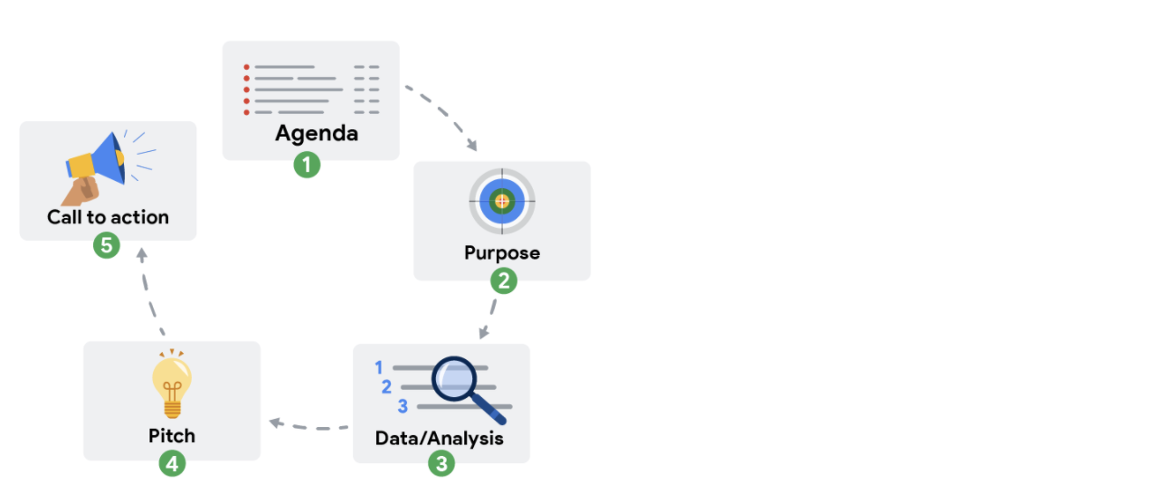

**First slide: Agenda**

Provide a high-level bulleted list of the topics you will cover and the amount of time you will spend on each. Every company’s norms are different, but in general, most presentations run from 30 minutes to an hour at most. Here is an example of a 30-minute agenda:

* Introductions (4 minutes)
* Project overview and goals (5 minutes)
* Data and analysis (10 minutes)
* Recommendations (3 minutes)
* Actionable steps (3 minutes)
* Questions (5 minutes)

**Second slide: Purpose**

Everyone might not be familiar with your project or know why it is important. They didn’t spend the last couple of weeks thinking about the analysis and results of your project like you did. This slide summarizes the purpose of the project and why it is important to the business for your audience.

Here is an example of a purpose statement:

*Service center consolidation is an important cost savings initiative. The aim of this project was to determine the impact of service center consolidation on customer response times.*

**Third slide: Data/analysis**

First, It really is possible to tell your data story in a single slide if you summarize the key things about your data and analysis. You may have supporting slides with additional data or information in an appendix at the end of the presentation.

But, if you choose to tell your story using more than one slide, keep the following in mind:

* Slides typically have a logical order (beginning, middle, and end) to fully build the story.
* Each slide should logically introduce the slide that follows it. Visual cues from the slides or verbal cues from your talking points should let the audience know when you will go on to the next slide.
* Remember not to use too much text on the slides. When in doubt, refer back to the second tip on preparing talking points and limiting the text on slides.
* The high-level information that people read from the slides shouldn’t be the same as the information you provide in your talking points. There should be a nice balance between the two to tell a good story. You don’t want to simply read or say the words on the slides.

For extra visuals on the slides, use animations. For example, you can:

* Fade in one bullet point at a time as you discuss each on a slide.
* Only display the visual that is relevant to what you are talking about (fade out non-relevant visuals).
* Use arrows or callouts to point to a specific area of a visual that you are using.

**Fourth slide: Recommendations**

If you have been telling your story well in the previous slides, the recommendations will be obvious to your audience. This is when you might get a lot of questions about how your data supports your recommendations. Be ready to communicate how your data backs up your conclusion or recommendations in different ways. Having multiple words to state the same thing also helps if someone is having difficulty with one particular explanation.

**Fifth slide: Call to action**

Sometimes the call to action can be combined with the recommendations slide. If there are multiple actions or activities recommended, a separate slide is best.

Recall our example of a purpose statement: *Service center consolidation is an important cost savings initiative. The aim of this project was to determine the impact of service center consolidation on customer response times.*

Suppose the data analysis showed that service center consolidation negatively impacted customer response times. A call to action might be to examine if processes need to change to bring customer response times back to what they were before the consolidation.

**Wrapping it up: Getting feedback**

After you present to your audience, think about how you told your data story and how you can get feedback for improvement. Consider asking your manager or another data analyst for candid thoughts about your storytelling and presentation overall. Feedback is great to help you improve. When you have to write a brand new data story (or a sequel to the one you already told), you will be ready to impress your audience even more!

# Evaluate your presentation

Earlier in this course, you practiced creating, giving, and evaluating your own presentation for the [Hands-on Activity: Presenting practice](https://www.coursera.org/learn/visualize-data/quiz/uLhnv/hands-on-activity-presenting-practice). You also learned some best practices for slide presentations and how you can evaluate presentations using them. In this reading, you will take a moment to reflect on how much your presentation skills have developed and create a presentation checklist for yourself to use in the future. This will help you prepare for future presentations as a data analyst and give you a tool to review your own work.

## Presentation evaluation checklist

The ability to deliver compelling presentations is just as important as your analyses. Consider your presentation skills and how integral they are to your professional growth. Each time you present, you're not just sharing data; you're telling its story. This requires clear, jargon-free language, especially when addressing an audience not specialized in data analysis. A well-crafted presentation bridges the gap between complex data and actionable insights.

You can enhance your presentation skills by using a presentation checklist. Use it as a personal guide to ensure your message is delivered clearly and effectively. The checklist can be tailored to meet your style and objectives to ensure that it resonates with your audience.

### ****Create your own checklist****

As you review your presentation style, focus on the clarity and engagement of your content. Incorporate visuals that complement your narrative and use pauses to let your insights sink in. Every piece of feedback is valuable, offering you a chance to learn and improve. Treat your presentation like a dialogue, not a monologue, and tailor it to foster a connection with your audience.

While using your presentation checklist, pay attention to the effectiveness of your visual aids. They should not only represent data accurately but also highlight the key takeaways in a manner that reinforces your message. Through critical self-review, use this checklist to refine both your verbal and visual communication, turning data into compelling stories. Here are some questions you can incorporate into your checklist:

* Do I use an attention-grabbing opening?
* Do I start with broad ideas and later talk about specific details?
* Do I speak in short sentences?
* Do I pause for five seconds after showing a data visualization?
* Do I pause intentionally at certain points?
* Do I keep the pitch of my sentences level?
* Do I stand still and move with purpose?
* Do I have good posture?
* Do I look at my audience (or camera) while speaking?
* Do I keep my message concise?
* Do I end by explaining to my audience why the data analysis matters?

You can also add checklist items that help you refine your slide deck:

* Do I include a good title and subtitle that describes what I’m about to present?
* Do I include the date of my presentation or the date when my slideshow was last updated?
* Does my font size let the audience easily read my slides?
* Do I showcase what business metrics I used?
* Do I include effective visuals (like charts and graphs)?

## Key takeaways

Embracing a cycle of practice, feedback, and refinement underpins professional development in data analysis. A well-crafted presentation checklist can be a key growth accelerator, helping you present complex data simply and captivating your audience. Make it a habit to use this checklist to evaluate your work and welcome constructive criticism. Approach every presentation as a chance to improve your ability to tell a compelling story and become a more skilled and persuasive communicator.

Hey, good to see you again.

By now you've learned some ways to organize and

incorporate data into your presentations.

You've also covered why

effective presentation skills are

so important as a data analyst.

Now you're ready to start presenting like a pro.

Coming up, I'll share some pro tips and

best practices with you. Let's get started.

We've talked about how important

your audience is throughout

this program, and it's

especially important for presentations.

It's also important to remember that

not everyone can experience

your presentations the same way.

Sharing your presentation via email

and putting some forethought into how accessible

your data viz is before your presentation can

help ensure your work is accessible and understandable.

But during the actual presentation,

it can be tempting to focus on

what's most interesting and exciting to

us and not on what the audience actually needs to hear.

Sometimes, even the best audiences

can lose focus and get distracted,

but here's a few things you can do during

your final presentation to help you

stay focused on your audience and keep them engaged.

First, try to keep in mind that your audience

won't always get the steps

you took to reach a conclusion.

Your work makes sense to you because you did it—this

is called the curse of knowledge.

Basically, it means that because you know something,

it can be hard to imagine your audience not knowing it.

It's important to remember that

your audience doesn't have the same context you

do, so focus on

what information they need to

reach the same conclusion you did.

Earlier, we covered some useful things you

can add to your presentations to help with this.

First, answer basic questions

about where the data came from and what it covers:

How is it collected?

Does it focus on a specific time or place?

You can also include

your guiding hypothesis and

the goals that drove your analysis.

Adding any assumptions or methods you

used to reach your conclusions can also be useful.

For example, in our avocado presentation,

we grouped months by season and looked at overall trends.

And finally, explain your conclusion

and how you reached it.

Your audience also has a lot on their mind already.

They might be thinking about

their own work projects

or what they want to have for lunch.

They aren't trying to be rude, and it

doesn't mean they aren't interested;

they're just busy people with a lot going on.

Try to keep your presentation focused and

to the point to keep their minds from wandering.

Try not to tell stories that take

your audience down into unrelated line of

thinking, and try not to go into

too much detail about things

that don't concern your audience.

You might have found a really exciting new SQL database,

but unless your presentation is about databases,

you can probably leave that out.

Your audience can also be easily

distracted by information in your presentation.

For example, the more you include in a chart,

the more your audience will need to explore it.

Try to avoid including

information in your presentations that

you don't think will be productive to

discussions with your audience,

sharing the right amount of content to keep

your audience focused and ready to take action.

It's also good to note that how

you present information is just as

important as what you present, and I

have some best practices for delivering presentations.

First, pay attention to how you speak.

Keep your sentences short.

Don't use long words where short words will work.

Build in intentional pauses to give

your audience time to think about what you've just said.

Try to keep the pitch of

your sentences level so that

your statements aren't confused for questions.

Also, try to be mindful of any nervous habits you have.

Maybe you talk faster,

tap your toes, or touch your hair when you're nervous.

That's totally normal—everyone does—but

these habits can be distracting for your audience.

When you're presenting, try to stay

still and move with purpose.

Practice good posture and make

positive eye contact with the people in your audience.

Finally, remember that you can

practice and improve these skills with

every presentation. Accept and

seek out feedback from people you trust.

Feedback is a gift and an opportunity to grow.

With that, you've completed another module.

The presentation skills you've learned here,

like using frameworks,

weaving data into your presentation,

and best practices you can apply during

your actual presentations, are going to help you

communicate your findings with audiences effectively.

**1.**

Question 1

What techniques can be helpful to prevent nervousness before a presentation? Select all that apply.

1 point

Channel your excitement

Describe each graph in-depth

Speak quickly so you don’t run out of time

Take deep breaths

**2.**

Question 2

Fill in the blank: When presenting, begin by discussing the \_\_\_\_\_, the obvious questions your audience might have, and the information they need to understand your findings in context.

1 point

business task

broader ideas

solution to the business problem

specific details about your analysis

**3.**

Question 3

What practices are helpful for keeping an audience focused on your presentation? Select all that apply.

1 point

Add intentional pauses

Make frequent gestures

Make eye contact

Be mindful of nervous habits

**4.**

Question 4

Fill in the blank: During the \_\_\_\_\_ of a presentation, a data analyst presents clear actions and their potential business impact.

1 point

goal statement

question-and-answer session

“so what?” moment

introduction

**Prepare for the Q&A**

A question-and-answer session, or Q&A, is a valuable opportunity for stakeholders and audience members to ask you any questions they might have about your findings. They can be challenging because you don’t always know what to expect, they require purposeful listening, and it's challenging to keep everyone involved. So, in this part of the course, you will discover some best practices to help you master the Q&A.

In this reading, you will work on the first step: preparing questions to ask **before** planning your data gathering and presentation. There are many things to consider before you begin asking and answering possible questions—including the objective, stakeholder expectations, and if there are any limitations. Make sure you have everything covered before you begin. The checklist below identifies 10 tasks that you should engage in to be prepared for your Q&A:

**Before the presentation**

1. Assemble and prepare your questions.
2. Discuss your presentation with your manager, other analysts, or other friendly contacts in your organization.
3. Ask a manager or other analysts what sort of questions were normally asked by your specific audience in the past.
4. Seek comments, feedback, and questions on the deck or the document of your analysis.
5. At least 24 hours ahead of the presentation, try and brainstorm tricky questions or unclear parts you may come across- this helps avoid surprises.
6. It never hurts to practice what you will be presenting, to account for any missing information or simply to calm your nerves.

**During the presentation**

1. Be prepared to respond to the things that you find and effectively and accurately explain your findings.
2. Address potential questions that may come up.
3. Avoid having a single question derail a presentation and propose following-up offline.
4. Put supplementary visualizations and content in the appendix to help answer questions.



**Practice makes perfect**

Preparing for a presentation or a meeting doesn’t have to be intimidating. If you invest time into knowing your audience, crafting your notes, doing necessary research and organizing your data, then there is very little reason why your audience will not be engaged, even impressed.

Hello. So let's talk about

how you can be sure you're prepared for a Q &amp; A.

For starters, knowing the questions

ahead of time can make a big difference.

You don't have to be a mind reader,

but there's a few things you

can do to prepare that'll help.

For this example, we'll go back to the presentation

we created about health and happiness around the world.

We put together these slides,

clean them up a bit,

and now we're getting ready for the actual presentation.

Let's go over some ways we can

anticipate possible questions before

our Q &amp; A to give us more time to think about the answers.

Understanding your stakeholder's expectations will

help you predict the questions they might ask.

As we previously discussed,

it's important to set

stakeholder expectations early in the project.

Keep their expectations in mind while you're

planning presentations and Q &amp; A sessions.

Make sure you have

a clear understanding of the objective and what

the stakeholders wanted when

they asked you to take on this project.

For this project, our stakeholders were interested in

what factors contributed to

a happier life around the world.

Our objective was to identify if there were geographic,

demographic, and/or economic

factors that contributed to a happier life.

Knowing that, we can start thinking about

the potential questions about

that objective they might have.

At the end of the day,

if you misunderstood your stakeholders' expectations

or the project objectives,

you won't be able to correctly

anticipate or answer their questions.

Think about these things early and

often when planning for a Q &amp; A.

Once you feel confident that you fully understand

your stakeholders' expectations and the project goals,

you can start identifying possible questions.

A great way to identify audience questions

is to do a test run of your presentation.

I like to call this the "colleague test."

Show your presentation or

your data viz to a colleague who has

no previous knowledge of

your work, and see what questions they ask you.

They might have the same questions

your real audience does.

We talked about feedback as a gift,

so don't be afraid to seek it out and

ask colleagues for their opinions.

Let's say we ran through

our presentation with a colleague,

we showed them our data visualizations,

then asked them what questions they had.

They tell us they weren't sure how we were

measuring health and happiness

with our data in this slide.

That's a great question.

We can absolutely work

that information into our presentation.

Sometimes the questions asked during

our colleague tests help us revise our presentation.

Other times, they help us anticipate

questions that might come up during the presentation,

even if we didn't originally want to build

that information into the presentation itself.

It helps to be prepared to go into detail about

your process, but only if someone asks.

Either way, their feedback can

help take your presentation to the next level.

Next, it's helpful to start with zero assumptions.

Don't assume that your audience is

already familiar with jargon,

acronyms, past events, or

other necessary background information.

Try to explain these things in

the presentation, and be

ready to explain them further if asked.

When we showed our presentation to our colleague,

we accidentally assumed that

they already knew how health and

happiness were measured and

left that out of our original presentation.

Now, let's look at our second data viz.

This graph is showing

the relationship between health, wealth,

and happiness, but includes GDP to measure the economy.

We don't want to assume that

our audience knows what that means,

so during the presentation,

we'll want to include a definition of GDP.

In our speaker notes,

we've added gross domestic product:

total monetary or market

value of all the finished goods and

services produced within a country's borders

in a specific period of time.

We'll fully explain what GDP

means as soon as this graphic comes up;

that way, no one in

our audience is confused by that acronym.

It helps to work with your team to

anticipate questions and draft responses.

Together, you'll be able to include

their perspectives and coordinate answers

so that everyone on your team is prepared and

ready to share their unique insights with stakeholders.

The team working on the world happiness project with

you probably have a lot of great insights about the data,

like how it was gathered

or what it might be missing.

Touch base with them so you

don't miss out on their perspective.

Finally, be prepared to consider and

describe to your stakeholders

any limitations in your data.

You can do this by critically analyzing

the patterns you've discovered

in your data for integrity.

For example, could the correlations

found be explained as coincidence?

On top of that, use

your understanding of the strengths

and weaknesses of the tools

you use in your analysis to

pinpoint any limitations they may have introduced.

While you probably don't have

the power to predict the future,

you can come pretty close to predicting

stakeholder and audience questions

by doing a few key things.

Remember to focus on

stakeholder expectations and project goals,

identify possible questions with your team,

review your presentation with zero assumptions,

and consider the limitations of your data.

Sometimes, though, your audience might raise

objections to the data

before and after your presentation.

Coming up, we'll talk

about the kind of objections they might

have and how you can respond. See you next time.

Welcome back. In this video, we'll talk about how you can handle objections about

the data you're presenting.

Stakeholders might raise objections during or after your presentation.

Usually, these objections are about the data, your analysis, or your findings.

We'll start by discussing what questions these objections are asking and

then talk about how to respond.

Objections about the data could mean a few different things.

Sometimes, stakeholders might be asking where you got the data and

what systems that came from, or they might want to know what transformations

happened to it before you worked with it, or how fresh and accurate your data is.

You can include all this information in the beginning of your presentation

to set up the data context. You can add a more detailed breakdown in your

appendix in case there are more questions.

When we're talking about cleaning data,

you learned keeping a detailed log of data transformations is useful.

That log can help you answer the questions we're talking about here, and

if you keep it in your presentation's appendix, it'll be easy to reference if

any of your stakeholders want more detail during a Q & A.

Now, your audience might also have questions or

objections about your analysis.

They might want to know if your analysis is reproducible, so

it helps to keep a change log documenting the steps you took. This way, someone else

could follow along and reproduce your process.

You can even create a slide in the appendix section of your presentation

explaining these steps, if you think it will be necessary.

And it can be useful to keep a clean version of your script if you're working

with a programming language like SQL or R, which we'll learn all about later.

Also, be prepared to answer questions like,

"Who did you get feedback from during this process?"

This is especially important when your analysis reveals insights that

are the opposite of your audience's

gut feelings about the data.

Making sure to include lots of perspectives throughout your analysis

process will help you back up your findings during your presentation.

Finally, you might be faced with objections to the findings themselves.

Play video starting at :2:12 and follow transcript2:12

A lot of the time these will be questions like, "Do these findings exist

in previous time periods, or did you control for the differences in your data?"

Your audience wants to be sure that your final results accounted for

any possible inconsistencies and that they're accurate and useful.

Now that you know some of the possible kinds of objections your audience

might raise,

let's talk about how you can think about responding. First,

it can be useful to communicate any assumptions about the data,

your analysis, or your findings that might help answer their questions.

For example, did your team clean and format your data before analysis?

Telling your audience that can clear up any doubts they might have.

Second, explain why your analysis might be different than expected.

Walk your audience through the variables that change the outcomes to help them

understand how you got there.

And third, some objections have merit,

especially if they bring up something you hadn't thought of before.

If that's true, you can acknowledge that those objections are valid and

take steps to investigate further.

Following up with more details afterwards is great, too.

And now you know some of the basic objections you might run into.

Understanding that your audience might have questions about your data,

your analysis, or your findings can help you prepare responses ahead of time, and

walking your audience through any assumptions about the data or

unexpected results are great approaches to responding.

Play video starting at :3:43 and follow transcript3:43

Coming up, we'll go over even more best practices for

responding to questions during a Q & A.

Bye for now.

**1.**

Question 1

What steps are involved with considering data limitations? Select all that apply.

1 point

Understand the strengths and weakness of tools

Critically analyze the correlations

Think about the context

Refresh the data

**2.**

Question 2

A colleague test involves showing a presentation to coworkers who are \_\_\_\_\_ with the subject matter in order to get their feedback.

1 point

proficient

acquainted

unfamiliar

expert

**3.**

Question 3

You are a junior data analyst at a home improvement store presenting to stakeholders about hardware orders for next season. When you finish, your stakeholders express concern about how your recommendations compare to previous years. Which type of objection does this scenario describe?

1 point

Analysis

Presentation skills

Data

Findings

**4.**

Question 4

After your presentation, a stakeholder is concerned about whether your data comes from a reputable source. What actions should your response include? Select all that apply.

1 point

Follow up with details about the source

Acknowledge the objection is valid

Question why the stakeholder is concerned

Take steps to investigate the source further

Hello again. Earlier we talked about some ways that

you can respond to objections

during or after your presentations.

In this video, I want to share

some more Q & A best practices.

Let's go back to

our world happiness presentation example.

Imagine we finished preparing for a Q & A,

and it's time to actually

answer some of our audience's questions.

Let's go over some ways that we can be

sure that we're answering questions effectively.

Will start with a really simple one:

listen to the whole question.

I know this sounds like a given,

but it can be really tempting to start

thinking about your answer before

the person you're talking to has

even finished asking their question.

On slide 11 of our presentation,

we outline our conclusions.

After explaining these conclusions,

one of our stakeholders asks,

"How was happiness measured for this project?"

It's important to listen to

the whole question and wait

to respond until they're done talking.

Take a moment to repeat the question.

Repeating the question is

helpful for a few different reasons.

For one, it helps you make

sure that you're understanding the question.

Second, it gives the person

asking it a chance to correct you if you're not.

Anyone who couldn't hear the question

will still know what's being asked.

Plus, it gives you a moment to get your thoughts together.

After listening to the question and

repeating it to make sure you understand,

you can explain that

participants in different countries were

given a survey that asked them to rate

their happiness, and just like that,

your audience has a better understanding of

the project because you took

the time to listen carefully.

Now that they know about the survey,

they're interested in knowing more.

At this point, we can go into

more detail about that data.

We have a slide built in here called the appendix.

This is a great place to keep

extra information that might not be necessary

for our presentation but could

be useful for answering questions afterwards.

This is also a great place for us to

have more detailed information

about the survey data so we can reference it more easily.

As always, make sure you understand

the context questions are being asked in.

Think about who is your audience and

what kinds of concerns or backgrounds they might have.

Remember the project goals

and your stakeholders' interests in them,

and try to keep your answers

relevant to that specific context,

just like you made sure your presentation

itself was relevant to your stakeholders.

We have this slide with data about

life expectancy as a metric for health.

If you're presenting to a group of

stakeholders who are in the healthcare industry,

they're probably going to be more interested in

the medical data and the relationship

between overall health and happiness.

Knowing this, you can tailor your answers to focus on

their interests so that

the presentation is relevant and useful to them.

When answering, try to involve the whole audience.

You aren't just having a one-on-one conversation

with the person that's asked the question;

you're presenting to a group of

people who might also have

the same question or need to know what that answer is.

It's important to not

accidentally exclude other audience members.

You can also include other voices.

If there's someone in your audience or

team that might have insight,

ask them for their thoughts.

Keep your responses short and to the point.

Start with a headline response that

gives your stakeholders the basic answer.

Then if they have more questions,

you can go into more detail.

This can be difficult as a data analyst.

You have all the background information and

want to share your hard work, but

you don't want to lose your audience

with a long and potentially confusing answer.

Stay focused on the question itself.

This is why listening to

the whole question is so important.

It keeps the focus on that specific question.

Answer the question as directly as

possible using the fewest words you can.

From there, you can expand on your answer or

add color, contexts, and detail as needed.

Like when one of our stakeholders asked

how the data measuring happiness was gathered.

We started by telling them

that a survey was used to measure

an individual's happiness, and only when they are

interested in hearing more about

the survey did we go into more detail.

To recap, when you're

answering questions during a presentation Q & A,

remember to listen to the whole question,

repeat the question if necessary,

understand the context, involve your whole audience,

and keep your responses short.

Remember, you don't have to

answer every question on the spot.

If it is a tough question that will

require additional analysis or research,

it's fine to let your audience

know that you'll get back to them;

just remember to follow up in a timely manner.

These tips will make it easier to answer

questions and make you seem prepared and professional.

Now that your presentation-ready,

it's time to wrap up.

We covered a lot about how to

consider questions before a Q & A,

how to handle different kinds of objections,

and some best practices you

can use in your next presentation.

That's it for now. See you in the next video.

Throughout my journey, and something that you'll

probably move through as you

become further and further

along in your career in data analytics, is it's

not the data itself that

is really important to the company—it's

the understanding of

the data and the impact that it can take.

A lot of business leaders don't have

the technical expertise to

understand the data in its raw form,

so you as the analyst are the translator.

So the most important part of the data is

you, as the translator of

the data, for the business leaders.

And I've found throughout my career

that presenting data is

probably the most important aspect

of being a data analyst because it doesn't matter how

compelling the analysis is or how accurate it is;

if people don't understand it,

then it doesn't offer value

to the business and it doesn't

offer value to anyone.

I've devoted a lot of my time and a big part of

my current job is really to help business leaders

understand their data and taking

something that's very technical and

simplifying it so that people understand

what it means and how they can

use it to impact the business.

It's an art form—it's a skill

to really be able to take something that's

highly technical and simplify it down so that

everybody in the room

understands what it's saying and how to use it.

A lot of times when I'm

looking at somebody's presentation

or building one myself,

a really important aspect to

a presentation is to define your purpose.

Define exactly what it is that you are

going to be talking about and why it's important.

Why is everybody in the room there and what are

they going to take away from this presentation?

The next aspect to

a really good presentation is to keep it concise.

You don't want things to be too wordy.

You don't want a lot of text on

the screen, and you don't want it to be too long.

It's not that everybody is too busy to be in the room,

but you really want to make sure that you're making

your point without losing everybody's focus.

The next one is,

have some logical flow to your presentation.

You don't want everybody's focus bouncing

around from different ideas

as you're trying to make your point.

You want a very concise and logical flow so

that they know what's coming

next and what you're talking about currently.

The next aspect to think about is

making the presentation visually compelling.

You want somebody to

know what they're looking at and understand it.

So the visuals that you choose,

the theme that you have for

the overall presentation should be appealing, and it

should draw people in so that they know

exactly what they're getting out of the presentation.

All of these things roll up to

the one main concept that you should

be thinking about when building a presentation, which is,

how easy is it to understand?

You are trying to make something that is

very technical data analysis and

simplify it down so that it doesn't matter

what the technical background or

even business background of the person,

but they understand what it is

that you are trying to explain to them.

Question 1

After you finish a presentation, an audience member asks for additional information. As you are providing a thorough response, the rest of the audience seems disinterested. How can you re-engage them? Select all that apply.

1 point

Ask a question to the audience

Repeat the question

Redirect to a new question

Interrupt yourself during your response

**2.**

Question 2

Fill in the blank: A presentation’s \_\_\_\_\_ slide is a place to include information that is too detailed for the presentation, but could be useful for answering people’s questions.

1 point

appendix

transition

title

closing

**3.**

Question 3

What steps can you take to ensure you answer questions thoroughly? Select all that apply.

1 point

Listen to the full question

Repeat the question to clarify

Provide more context

Elaborate more on the topic

**4.**

Question 4

After a presentation, you are asked a complex question during the Q&A session. It will require a few hours of research for you to answer effectively. How should you proceed?

1 point

Follow up promptly after the Q&A session

Ask for some time to find the answer

Provide a brief response to the question during the Q&A session

Politely explain that the question is irrelevant to your findings

# Glossary terms from module 4

## ****Terms and definitions for Course 6, Module 4****

**Dashboard filter:** A tool for showing only the data that meets a specific criteria while hiding the rest

**Data blending:** A Tableau method that combines data from multiple data sources

**Framework:** The context a presentation needs to create logical connections that tie back to the business task and metrics

**Professional relationship building:** Building relationships by meeting people both in person and online (Refer to Networking)

**Static data**: Data that doesn’t change once it has been recorded

**Statistics:** The study of how to collect, analyze, summarize, and present data

**WITH:** A SQL clause that creates a temporary table that can be queried multiple times

**1.**

Question 1

You perform a colleague test prior to a presentation. Several coworkers ask for the meaning of an acronym used in one of your charts. What strategies might help you improve your presentation? Select all that apply.

1 point

Move the chart to a later slide

Define the acronym on the slide containing the chart

Remove the chart to avoid confusion

Add a speaker note to include the definition during your presentation

**2.**

Question 2

Fill in the blank: A \_\_\_\_\_ guides the audience through a presentation, creating logical connections to the business task and metrics.

1 point

graphic

framework

hypothesis

finding

**3.**

Question 3

You show a very technical slide about artificial intelligence advancements to an audience that knows little about the subject. Which McCandless Method concept enables you to prepare your audience for better understanding of the slide?

1 point

Tell the audience why the graphic matters

Answer obvious questions before they’re asked

Call out data to support the insights

State the insight of the graphic

**4.**

Question 4

Which of the following statements accurately describe presentation best practices? Select all that apply.

1 point

Focus on specifics, then move on to general interest topics about your analysis.

A dress rehearsal is an effective way to prepare to present data.

When introducing a visualization, give the audience five seconds to process it.

Begin with broad ideas that help the audience put the findings in context.

**5.**

Question 5

After giving a presentation about social media trends, your stakeholders express concern about the source of your data. They are unfamiliar with the organization that generated the data for the analyses you referenced. Which kind of objection are they making?

1 point

Findings

Data

Presentation skills

Analysis

**6.**

Question 6

Fill in the blank: The second slide of a presentation should state the analysis project’s \_\_\_\_\_, including its objective and why it is important to the business.

1 point

recommendations

analysis

agenda

purpose

**7.**

Question 7

A data professional in market research is asked to explore online shopping. The analyst believes online shopping will continue to grow in popularity. They plan to prove this theory by analyzing sales figures, website traffic data, and shopper surveys. What does this scenario describe?

1 point

Addressing a business task

Disproving a trend

Modifying a statistic

Making a hypothesis

**8.**

Question 8

What strategies can you use to convey confidence during a presentation? Select all that apply.

1 point

Speak to your audience in short sentences

Seek out feedback about your presentation skills from others

Take a long pause between each sentence

Practice your presentation skills

Glossary

Data Analytics

Terms and definitions from Course 6

A

Alternative text: Text that provides an alternative to non-text content, such as images and

videos

Annotation: Text that briefly explains data or helps focus the audience on a particular aspect of

the data in a visualization

Area chart: A data visualization that uses individual data points for a changing variable

connected by a continuous line with a filled in area underneath

AVERAGEIF: A spreadsheet function that returns the average of all cell values from a given

range that meet a specified condition

B

Balance: The design principle of creating aesthetic appeal and clarity in a data visualization by

evenly distributing visual elements

Bar graph: A data visualization that uses size to contrast and compare two or more values

Box plot: A data visualization that displays the distribution of values along an x-axis

Bubble chart: A data visualization that displays individual data points as bubbles, comparing

numeric values by their relative size

Bullet graph: A data visualization that displays data as a horizontal bar chart moving toward a

desired value

C

Calculus: A branch of mathematics that involves the study of rates of change and the changes

between values that are related by a function

Causation: When an action directly leads to an outcome, such as a cause-effect relationship

Channel: A visual aspect or variable that represents characteristics of the data in a visualization

Chart: A graphical representation of data from a worksheet

Circle view: A data visualization that shows comparative strength in data

Cluster: A collection of data points on a data visualization with similar values

Column chart: A data visualization that uses individual data points for a changing variable,

represented as vertical columns

Combo chart: A data visualization that combines more than one visualization type

CONVERT: A SQL function that changes the unit of measurement of a value in data

Correlation: The measure of the degree to which two variables change in relationship to each

other

CREATE TABLE: A SQL clause that adds a temporary table to a database that can be used by

multiple people

D

Data composition: The process of combining the individual parts in a visualization and

displaying them together as a whole

Data storytelling: Communicating the meaning of a dataset with visuals and a narrative that

are customized for an audience

Decision tree: A tool that helps analysts make decisions about critical features of a visualization

Density map: A data visualization that represents concentrations, with color representing the

number or frequency of data points in a given area on a map

Design thinking: A process used to solve complex problems in a user-centric way

Distribution graph: A data visualization that displays the frequency of various outcomes in a

sample

Diverging color palette: A color theme that displays two ranges of data values using two

different hues, with color intensity representing the magnitude of the values

Donut chart: A data visualization where segments of a ring represent data values adding up to

a whole

DROP TABLE: A SQL clause that removes a temporary table from a database

Dynamic visualizations: Data visualizations that are interactive or change over time

E

Emphasis: The design principle of arranging visual elements to focus the audience’s attention

on important information in a data visualization

Engagement: Capturing and holding someone’s interest and attention during a data

presentation

F

Filled map: A data visualization that colors areas in a map based on measurements or

dimensions

Framework: The context a presentation needs to create logical connections that tie back to the

business task and metrics

G

Gantt chart: A data visualization that displays the duration of events or activities on a timeline

Gauge chart: A data visualization that shows a single result within a progressive range of

values

H

HAVING: A SQL clause that adds a filter to a query instead of the underlying table that can only

be used with aggregate functions

Headline: Text at the top of a visualization that communicates the data being presented

Heat map: A data visualization that uses color contrast to compare categories in a dataset

Highlight table: A data visualization that uses conditional formatting and color on a table

Histogram: A data visualization that shows how often data values fall into certain ranges

I

Inner query: A SQL subquery that is inside of another SQL statement

J

K

L

Label: Text in a visualization that identifies a value or describes a scale

Legend: A tool that identifies the meaning of various elements in a data visualization

Line graph: A data visualization that uses one or more lines to display shifts or changes in data

over time

Live data: Data that is automatically updated

M

Map: A data visualization that organizes data geographically

Mark: A visual object in a data visualization such as a point, line, or shape

MAXIFS: A spreadsheet function that returns the maximum value from a given range that meets

a specified condition

McCandless Method: A method for presenting data visualizations that moves from general to

specific information

MINIFS: A spreadsheet function that returns the minimum value from a given range that meets

a specified condition

Movement: The design principle of arranging visual elements to guide the audience’s eyes from

one part of a data visualization to another

N

Narrative: (Refer to story)

O

Outer query: A SQL statement containing a subquery

P

Packed bubble chart: A data visualization that displays data in clustered circles

Pattern: The design principle of using similar visual elements to demonstrate trends and

relationships in a data visualization

Pie chart: A data visualization that uses segments of a circle to represent the proportions of

each data category compared to the whole

Pre-attentive attributes: The elements of a data visualization that an audience recognizes

automatically without conscious effort

Proportion: The design principle of using the relative size and arrangement of visual elements

to demonstrate information in a data visualization

Q

R

R: A programming language used for statistical analysis, visualization, and other data analysis

Ranking: A system to position values of a dataset within a scale of achievement or status

Relativity: The process of considering observations in relation or proportion to something else

Repetition: The design principle of repeating visual elements to demonstrate meaning in a data

visualization

Rhythm: The design principle of creating movement and flow in a data visualization to engage

an audience

S

Scatterplot: A data visualization that represents relationships between different variables with

individual data points without a connecting line

SELECT INTO: A SQL clause that copies data from one table into a temporary table without

adding the new table to the database

Sort range: A spreadsheet menu function that sorts a specified range and preserves the cells

outside the range

Sort sheet: A spreadsheet menu function that sorts all data by the ranking of a specific sorted

column and keeps data together across rows

Spotlightling: Scanning through data to quickly identify the most important insights

Static data: Data that doesn’t change once it has been recorded

Static visualization: A data visualization that does not change over time unless it is edited

Statistics: The study of how to collect, analyze, summarize, and present data

Story: The narrative of a data presentation that makes it meaningful and interesting

Subtitle: Text that supports a headline by adding context and description

Symbol map: A data visualization that displays a mark over a given longitude and latitude

T

Tableau: A business intelligence and analytics platform that helps people visualize, understand,

and make decisions with data

U

Unity: The design principle of using visual elements that complement each other to create

aesthetic appeal and clarity in a data visualization

V

Variety: The design principle of using different kinds of visual elements in a data visualization to

engage an audience

Visual form: The appearance of a data visualization that gives it structure and aesthetic appeal

W

WITH: A SQL clause that creates a temporary table that can be queried multiple times

X

X-axis: The horizontal line of a graph usually placed at the bottom, which is often used to

represent time scales and discrete categories

Y

Y-axis: The vertical line of a graph usually placed to the left, which is often used to represent

frequencies and other numerical variables

Z

Now that you've finished the course challenge,

you're officially ready to move on to the next course.

Nice! Coming up,

Carrie will show you how to use something new:

R. R is a programming language

that you can use to collect,

analyze, and visualize data in new and complex ways.

This is different from the skills we've learned so far—just

one of the reasons why it's so exciting.

You'll also learn more about what programming languages

are and how to use R to work with data.

Before you move on though,

I'd like to thank you for joining me in

this course and taking on this learning opportunity.

Learning should be a lifelong pursuit,

and the work you put into learning opportunities like

this class will make you

better at anything you choose to do.

You have come a long

way from the first videos in this program.

Take a moment to celebrate

your progress and everything you've learned.

After that, head on to the next course.

Carrie is waiting to help you get started.